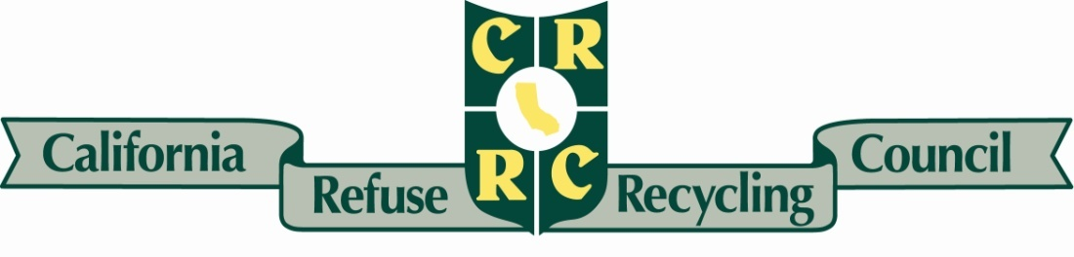
JOINT STATE OFFICE
October 22, 2018

VIA E-Mail and CARB Comment Submittal Form
The Honorable Mary Nichols and
Members of the Governing Board
California Air Resources Board
Post Office Box 2815
Sacramento, CA 95812
cotb@arb.ca.gov

Re: FISCAL YEAR 2018-19 FUNDING PLAN FOR CLEAN TRANSPORTATION INCENTIVES

Dear Chair Nichols and Members of the Governing Board:

The California Refuse Recycling Council (CRRC) is a trade association comprised of over 100 refuse and recycling companies across the State committed to superior management of waste resources, including composting, recycling, anaerobic digestion (AD) and renewable energy production. We want to thank you for this opportunity to comment on the proposed Fiscal Year 2018-19 Funding Plan for Clean Transportation Incentives from the Greenhouse Gas Reduction Fund (GGRF).

Our industry has embraced the complement of goals set forth in AB 32 (Nunez, Chapter 488, Statutes of 2006) and emission reductions across the board. We have been partners with state and local officials in implementing AB 341 (Chesbro, Chapter 476, Statutes of 2011), AB 1826 (Chesbro, Chapter 727, Statutes of 2014), AB 901 (Gordon, Chapter 746, Statutes of 2015), and SB 1383 (Lara, Chapter 395, Statutes of 2016), to name a few. We recognize the important role of the transportation sector in accomplishing these goals.

Currently our members are in the process of inventorying their fleets and working with California Air Resources Board (CARB) to evaluate those fleets. With major changes coming under the Truck and Bus Rule and other regulatory bench points, we want to strongly encourage the Clean Truck and Bus Vouchers program be amended in the proposal to include the low NOx engines that use renewable fuels so that they can be fully subscribed. We believe once this inventory is fully understood, we can leverage that funding to accelerate the retirement of diesel vehicles.

Clean Energy filed a comprehensive letter on October 15, 2018, and we are in alignment with their comments; many of our members also participate in their organization. Specifically, we wish to highlight the research results at UC Riverside CE-CERT which determined that natural gas engines emitted lower NOx emissions than the ARB certified standard. This dovetails with the heavy-duty sector strategy outlined in the 2016 SIP.

Additionally, we believe that the HVIP program should be available for ALL new purchases and repowers, and certainly the refuse and transit sector should not be eliminated. If this program is coupled with the staff recommendation to increase incentives for low NOX engines in the plan, it can assist the deployment of these engines. We urge the board not to put these singular restrictions on the low NOx engine category.

We appreciate the staff approach to increase the maximum voucher amount, but we believe Clean Energy's analysis that the voucher amount for 11.9L at a $60,000 minimum threshold is more likely to result in the shift we all seek and achievement of the goals that are identified in the San Joaquin Valley Supplement to the Revised 2016 State Strategy for the SIP and CARB's Mobile Sources Strategy of 900,00 low NOx heavy duty trucks by 2031 .

We urge careful consideration of the changes requested to allow for full participation by the refuse and recycling industry that has demonstrated leadership and a commitment to all of the goals set forth by the State of California to reduce greenhouse gas emissions. We are working in every local jurisdiction to advance the policy objectives, and the transportation sector is critical to our collective success. We are available to work directly with CARB to advance and implement these changes, and we look forward to this effort.

We thank you again for the opportunity to comment on the Fiscal Year 2018-19 Funding Plan. Please do not hesitate to contact the CRRC regulatory staff with any additional questions or concerns.

Sincerely,

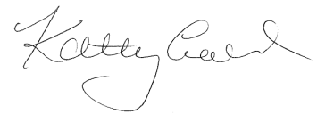
Kathryn Lynch
Regulatory Affairs
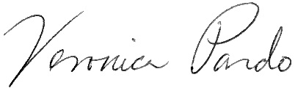
Veronica Pardo
Regulatory Affairs

cc: CRRC State Executive Committee Members

