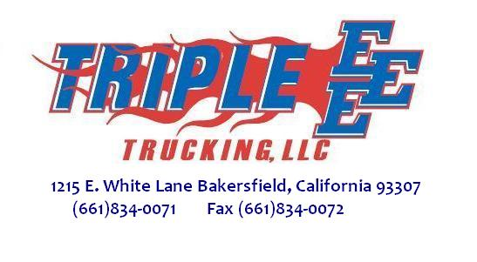

April 3, 2014

RE: The Amendment regarding the scraping of retired trucks

I would like for the Board to consider an amendment regarding scraping of retired trucks.

As it stands now a company must turn in its retired truck to an approved recycler in order to qualify and receive incentive funding for a new replacement truck.

The approved recycler must then cut the frame in half behind the cab and cut a hole in the engine block. This is to assure that the engine can never be reused again.

My problem with this is that there are still hundreds of usable parts left on the now inoperable truck. These parts do not pollute. However, they can and will help to reduce pollution. Now you’re wondering how this could be possible. How can a simple switch, gauge, mirror or any one of the hundreds of other parts possibly reduce pollution? The answer is simply to leave the inoperable retired truck with the owner if he elects to keep it. The frame is still cut, the engine is still destroyed just leave the truck with the company.

Pollution would be reduced in several ways:

- The Dismantler doesn’t have to send out a tow truck or lowbed (both of which pollute) to pick up the retired truck. Fewer pollutants in the air. WIN!
- The company now can get good parts off of these inoperable retired trucks. This will reduce the need for a delivery truck to bring a new part out for the company. Fewer pollutants in the air. WIN!
- If the parts supplier doesn’t deliver the new part it will in turn reduce the need of a larger delivery truck from the parts warehouse to replenish the parts suppliers’ inventory. Fewer pollutants in the air. WIN!
- The warehouse now will reduce orders from parts manufacturers that deliver to them. Fewer pollutants in the air. WIN!

- The company already has and owns the inoperable trucks. All the parts are readily, available and free for the taking. This cuts costs and now the company can invest more money in less time to purchase new clean air trucks. Instead of new parts for older trucks. This simple step will have a huge impact and with zero cost and zero effort. This step alone puts NO pollutants in the air and with new clean trucks keeps future pollutants to near zero. That’s a double WIN!

The last but by no means the least important impact will be that it shows trucking companies the California Air Resources Board is willing to implement real world solutions to this real world problem. This in turn will help to change the perception of the Board from one of being the biggest bully on the block, to one of a team member interested and willing to work together and solve a problem that affects us all.

