October 14, 2021

Mr. Richard Corey
Executive Director
California Air Resources Board
1001 I Street
Sacramento, CA 95814

Submitted Electronically to zevfleet@arb.ca.gov

Dear Mr. Corey:

Following are comments from the California Forestry Association (Calforests) regarding the “Draft Regulatory Language and Updated Cost Assumptions for Advanced Clean Fleets Regulation”.

Calforests is a trade association whose membership includes nearly all the remaining sawmills in California, all the veneer mills, several biomass powerplants, and timber landowners. Transportation of forest products, including logs and chips is a major component of California’s forestry industry.

CFA Comments:

Class 8 Trucks in Forestry Application

Class 8 Trucks (log trucks and chip vans) often travel 350 miles per day with much of that mileage in rural counties that have minimal infrastructure to support electric-based transportation. Clearly a 150-mile battery life will not be efficient or cost-effective.

Cost Scenarios

As near as I can determine, staff has not conducted an economic impact analysis for a log truck or chip van that normally operate seasonally, which in the best-case scenario would equate to 8 months per year (about a 180-day season due to pressures associated with weather conditions). The total cost of ownership for a diesel Class 8 truck under these circumstances will be far less than the examples your staff include and have considered in the economic analysis for an all-electric Class 8 truck.

Power Outages

Rural areas of California frequently suffer power outages during the winter months and power shutoffs during summer months due to wildfire season. These outages would make battery charging impossible.

Rural County Federation

Calforests hereby incorporates Rural County Representatives of California’s (RCRC) September 24, 2021, comments by reference.

Conclusion

Calforests appreciates the opportunity to comment. If you or your staff have any questions, please feel free to contact Steve Brink at steveb@calforests.org.

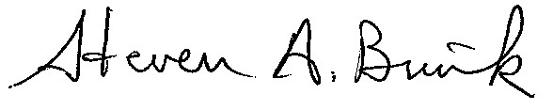

STEVEN A. BRINK
Vice President – Public Resources

