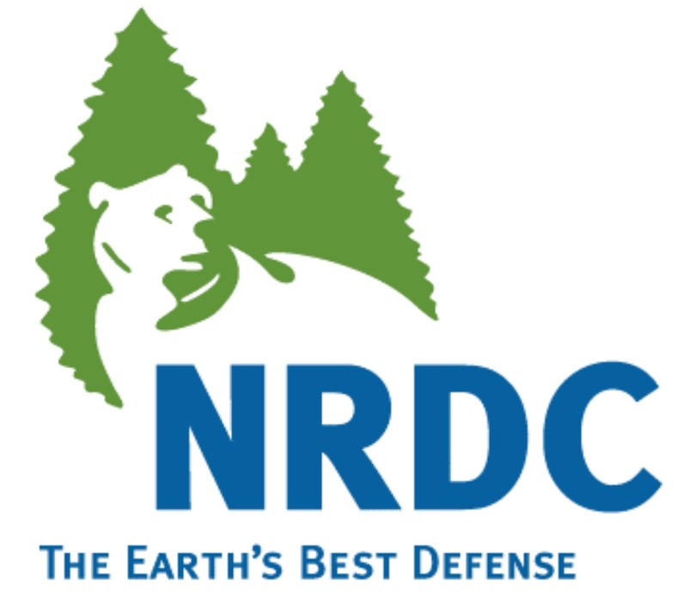

April 23, 2013
Steve Cliff, Branch Chief
Climate Change Program Evaluation Branch

Rajinder Sahota, Manager
Climate Change Program Operating Section

California Air Resources Board
1001 “I” Street, Sacramento, CA, 95812

Re: Comments on Proposed Addition of Coal Mine Methane and Rice Cultivation Offset Protocols to the Cap-and-Trade Program.

Dear Mr. Cliff and Ms. Sahota:

On behalf of the Natural Resources Defense Council (NRDC) and our more than 80,000 members in California, we appreciate the opportunity to comment on the proposed addition of coal mine methane and rice cultivation offset protocols to the cap-and-trade regulations.

Over the past six months, the ARB has made very substantial progress on developing and adopting the regulatory infrastructure necessary to incorporate compliance offsets into the cap and trade program, including the approval of two offset registries, and continued advances in verifier training and accreditation. The ARB is to be commended for providing advance notice of consideration of two new offset protocols, holding a public workshop, and convening technical working groups. This clear and informative public process will build confidence and credibility in the program.

In general, we believe that the proposed rice cultivation protocol offers a good opportunity to expand the array of offset project types eligible for use for compliance in the cap-and-trade program. In addition to offering emission reductions which can meet the requirements of AB32, the rice protocol provides an opportunity to explore issues associated with agricultural offsets. Emission reductions in the agricultural sector are often different from other protocol project types, because of the high level of temporal and spatial variability and complex chemistry associated with nitrogen and soil carbon. While these issues present challenges, the potential for co-benefits from the rice cultivation protocol is significant and there is a substantial opportunity for in-state projects.

In contrast, we believe that the proposed coal mine methane protocol raises a number of difficult issues and concerns relative to its use in the cap-and-trade program. First, by providing additional revenue to active coal mining operations, the availability of offset credits has the potential to make coal-mining more profitable and thereby increase the amount of coal mining and combustion. ARB staff recognizes this possibility and has proposed to consider inclusion of a leakage discount factor to account for increased production, but the effectiveness of the factor – as yet undeveloped – in deterring potential leakage is by no means assured.. Second, even if the emission reductions were fully additional, coal mine methane offsets do not provide any co-benefits, unlike the rice cultivation protocol (and, if leakage occurs, could in fact exacerbate co-pollutant emissions). Third, because there is no coal mining in California, the coal mine methane protocol would not generate any in-state projects or associated in-state co-benefits. Finally, we appreciate ARB’s exclusion of mountaintop removal mines from the list of eligible projects, but the inclusion of any active mines – in particular surface mines – presents serious environmental concerns. ARB must consider the implications of proposing to allow offsets generated from projects at out-of-state surface mines to be used for compliance with its landmark climate change statute. These issues are exacerbated due to the very large volume of potential offset credits, estimated by staff at 50-100 million tons CO2e cumulative by 2020. While we look forward to evaluating the proposal under development by the technical working group, NRDC is skeptical that the coal mine methane protocol is a good fit for California’s AB32 cap-and-trade program.

Sincerely,

Peter Miller
Senior Scientist

Alex Jackson
Legal Director, California Climate Project

