June 18, 2015

Mary D. Nichols
Chair
California Air Resources Board
P.O. Box 2815
Sacramento, CA 95814
Submitted via electronic mail.

Re: Written comments from the National Biodiesel Board on the Proposed Re-Adoption of the Low Carbon Fuel Standard.

Dear Chair Nichols:

Thank you for the opportunity to comment on this regulation. We sincerely value the job you and all ARB board members and staff undertake in protecting the state’s environment and public health.

By way of background, the National Biodiesel Board (NBB) serves as the trade association for the U.S. biodiesel and renewable diesel industries. The NBB represents more than 90 percent of domestic biodiesel and renewable diesel production. In addition to governmental affairs activities, the association coordinates the industry’s research and development efforts.

Our comments on this matter are brief, reflecting broad agreement with the work staff have done in crafting the regulation. Listed below are a few relatively minor matters we hope can be clarified or addressed before the regulation receives final approval.

Tier 1 and Tier 2 Classifications
Biodiesel is unique. While it is an established technology, having been in commercial production for more than a decade, the industry is, at the same time, continuing to evolve and advance in exciting ways—both in terms of feedstock development and processing technology. In addition, numerous feedstocks and processes exist for creating ASTM grade biodiesel. For these reasons, we believe that ARB should include Tier 1 pathways for integrated oil and biodiesel producers, or integrated biodiesel producers should be able to utilize the Tier 2 GREET model, should circumstances merit it. Two specific examples are provided below.

Used Cooking Oil (Cooking Not Required)
It appears that the pathway for “uncooked” used cooking oil (UCO) has been removed and is therefore not available under Tier 1. This pathway is particularly relevant for California biodiesel producers, some of whom collect grease directly from restaurants and do not “cook” or otherwise refine the product before inputting the UCO into their biodiesel production processes. Therefore, using the proposed Tier 1 (cooked) UCO pathway would result in a double counting penalty for these producers equating to several carbon intensity points.

We also believe integrated operations should be accounted for in the Tier 1 pathways. For example, a biodiesel production facility that is attached to a canola processing facility should be able to input its specific feedstock processing values rather than being forced to rely on default inputs. This would provide the most accurate carbon intensity value for the fuel.

Hydrochloric Acid (HCL)
It appears that staff may develop numerous methods for HCL recording. Typically, we support this type of flexibility for a diverse industry such as ours. In this particular case, however, we think the matter sufficiently simple as to not warrant such an approach. Instead, we recommend providing guidance in the regulation that HCL should be recorded as if it were 100% HCL rather than the actual volume of diluted HCL.

Thank you, in advance, for your consideration of our views. We very much appreciate the continued excellent work of ARB staff. If I may be of any assistance, please feel free to contact me at any time at (573) 635-3893.

Sincerely,

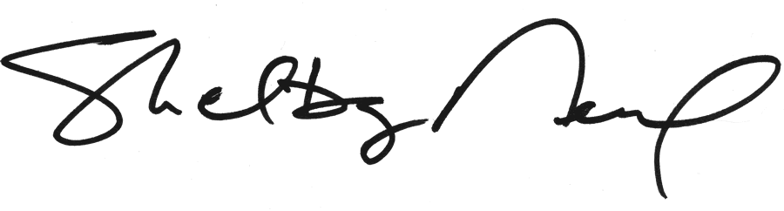
Shelby Neal
Director of State Governmental Affairs

