8/14/2015

Mary D. Nichols, Chairman
Richard Corey, Executive Officer
California Air Resources Board
1001 I Street
Sacramento, CA 95814

RE: Investment Plans

Dear Chairman Nichols and Executive Officer Corey,

As a practitioner of carbonizing business practices, I was very much intrigued by this opportunity. In alignment with the stated goal of providing opportunities for businesses, public agencies, nonprofits, and other community institutions to participate in and benefit from statewide efforts to reduce greenhouse gas emissions, I would like to add that universally the management process of this initiative would be best served with the inclusion of Federal and State grant-funded technology and business development programs such as CCAT, SDADT and NEST. This underserved segment of the training and education component of the investment plan is a main driver of solidifying our Cap and Trade program. Without the diffusion of knowledge by programs as such as these, the relevancy and objectiveness of the plan could come into question. As evidenced by the efficacy of performance for such programs, it makes perfect sense to continue the longstanding support of such programs. Please consider these programs as vital to the relevancy of the investment plan.

Sincerely,

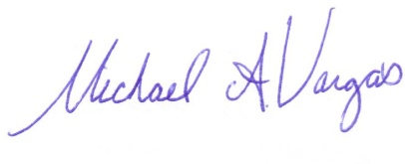
Michael Vargas
Atlas Project Support
619-865-9687
MVargas@myatlasproject.com

