Boise Wood Products
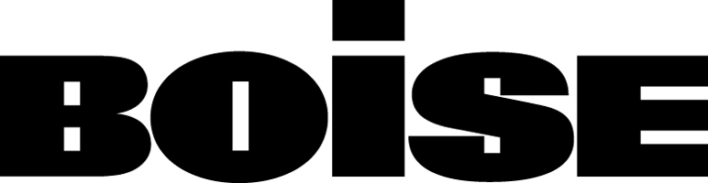

Particleboard Sales and Marketing
1111 West Jefferson Street PO Box 50 Boise, ID 83728
T 888 264 7372 F 208 384 6647

April 23, 2007

Dr. Robert Sawyer, Chairman
California Air Resources Board
1001 I Street
P.O. Box 2815
Sacramento, CA 95812

Dear Dr. Sawyer:

RE: Comments on the Proposed Air Toxic Control Measure for Formaldehyde in Composite Wood Products

Boise Cascade Corporation is a direct stakeholder given the scope and nature of one of our business, manufacturing particleboard. We are disappointed in the current proposed ruling. In our opinion, and those shared by others, we feel the North American Industry stands to be severely damaged, the cost to customers raised, and the door would be opened for more off shore imports that may not be compliant with the rule.

We appreciate CARB working with industry to provide the citizens of California with a regulation that meets the agency’s public health objective while at the same time calling for requirements that are both technologically possible and economically feasible. The proposal to be considered by the Board this week is close, but still falls short in the latter respect.

Specifically, we support the California Wood Industries Coalition (CWIC) recommendation to adjust the Phase II emission level limits as follows:

- Particleboard – a ceiling of 0.10 ppm rather than 0.09 recommended by agency staff

- MDF – a ceiling of 0.13 ppm rather than 0.11 as recommended by agency staff

- Thin MDF – a ceiling of 0.15 ppm rather than 0.13 as recommended by agency staff

The meeting of these levels recommended by industry by 2011-12 would represent the most substantial emission reduction by the North American composite panel industry at any time in its history.

A critical aspect of this regulation is the understanding that the use of ceiling values requires manufacturers to produce at substantially lower emission targets than required because of the inherent variability in raw materials, production processes and the repeatability of the compliance test itself. Modest changes in the range of 1/100th to 2/100^{ths} of a part per million (ppm) are essential in the Phase II ceiling levels if CARB expects the regulation to be met on an industry-wide basis, not just by a limited few or for a niche application.

Even with the changes recommended by industry, the ARB rule will still be the most comprehensive, toughest formaldehyde control measure in the world thanks to its rigorous enforcement protocols.

Throughout this rulemaking process, ARB staff has been intrigued by one company’s touting of soy adhesives as BACT, and questions have repeatedly been posed as to its applicability for all products covered in the scope of the rule. Notwithstanding that various aspects of the technology and its cost remain in dispute, one thing is absolutely clear: ARB cannot make the case that soy technology is transferable from hardwood plywood production to particleboard and MDF production. This is clear to everyone in the industry except the company that is seeking market advantage by having ARB bless its proprietary technology as a vehicle for achieving BACT. Simply put, soy adhesive technology is incompatible with MDF and is commercially unproven for particleboard.

In summary, this regulation, with the emission levels proposed in Phase II, will be the most expensive ATCM in terms of cost per pound of reduced emission that ARB has ever promulgated. There is no measurable contribution to public health by adopting the emission levels currently in the rule as opposed to those recommended by industry. Therefore, we urge the Board to amend the Phase II limits as presented above to assure that the proposed regulation accomplishes its objective without placing unrealistic and unnecessary mandates on industry.

Sincerely,

Steve Stoler,
Sales and Marketing Manager Particleboard

