
April 19, 2007
Ted Lempert
President

Board of Directors

Chair
Jane K. Gardner

Partner, Harbour Consulting

Vice Chair
Peter D. Bewley

The Clorox Company (Retired)

Neal Baer, M.D.

Wolf Films/
Universal Television

Geoffrey Cowan
USC, Annenberg School for Communication

John Garcia

Kaiser Permanente

David G. Johnson
Investor

Suzanne Nora Johnson
Goldman, Sachs & Co.

Allan K. Jonas

Jonas & Associates

Donald Kennedy
President Emeritus
Stanford University

Daniel Luevano

Attorney

Lenny Mendonca
McKinsey & Company

Theodore R. Mitchell
New Schools Venture Fund

Molly Munger

English, Munger & Rice

Craig Parsons

Communications Consultant

Hon. Cruz Reynoso

UC Davis, School of Law

Jennie Ward Robinson, Ph.D.
The Institute for Public Health
and Water Research

Karen R. Schievelbein

UnitedHealth Group

Katharine Schlosberg

Educational Consultant

James P. Steyer
Common Sense Media

Michael Tollin
Tollin/Robbins Productions

Gloria Tristani
Benton Foundation

Grace Won
Farella, Braun + Martel LLP

Of counsel
Holly L. Sutton
Farella, Braun + Martel LLP

. . . . . . . .

1212 Broadway, 5th Floor
Oakland, CA 94612
Tel: 510.763.2444
Fax: 510.763.1974

1127 11th Street, Suite 452
Sacramento, CA 95814
Tel: 916.443.1869
Fax: 916.443.1204

childrennow.org
info@childrennow.org

Dr. Robert F. Sawyer, Chairman
California Air Resources Board
Headquarters Building
1001 I Street
P.O. Box 2815
Sacramento, CA 95812
Fax: (916) 445-5025

RE: Proposed Airborne Toxic Control Measure to Reduce Formaldehyde Emissions from Composite Wood Products – SUPPORT

Dear Chairman Sawyer:

Children Now enthusiastically joins the Formaldehyde-Free Coalition in support of the California Air Resources Board’s (CARB) proposed Airborne Toxic Control Measure (ATCM) to reduce formaldehyde emissions from composite wood products. Children Now is a nonpartisan research and advocacy organization working to raise children’s well-being to the top of the policy agenda. As a member of the 100% Campaign, we are committed to ensuring that all of California’s children are able to grow up healthy and strong.

For this reason and in light of our mission, Children Now urges CARB to adopt regulations to reduce formaldehyde from composite wood products. Formaldehyde used in composite wood products contaminates our air and environment creating serious health effects for all people. In 1992, formaldehyde was formally listed by CARB as a Toxic Air Contaminant with no safe level of exposure. Since then, the International Agency for Research on Cancer has labeled formaldehyde as a carcinogen and has formally recognized the chemical’s direct contribution to eye, ear, nose and throat irritation – all of which exacerbate the effects of asthma. Of far greater concern, formaldehyde is linked to nasal carcinoma and even leukemia.

Formaldehyde emissions particularly prey on the health of the most vulnerable members of society, our children. Recent OEHHA studies suggest that formaldehyde likely presents differential health impacts on infants and children, from carcinogenicity to respiratory effects, including decreased lung function and exacerbated asthma. As Children Now will soon report in our California County Data Book 2007, 16% of California’s children (over 1.5 million youth) have been diagnosed with asthma. Moreover, it is estimated that health risks from total daily average formaldehyde exposures in California from all sources are estimated to range from 23 to 63 excess cancer cases per million for children.

What is especially tragic about this disproportionate health impact is that children have very little control over their environment. They seldom exercise any choice as to where to live, where to attend school, and what materials are utilized or located in their surroundings. They must breathe in the environment in which others place them. The many children in our state from low income families are far more likely to be exposed to environments with higher levels of formaldehyde emissions, which raises the profound issue of environmental justice.

Children Now earnestly encourages CARB to put in place formaldehyde emissions reduction regulations as an overdue health prevention measure, to protect all people, including our children.

Sincerely,
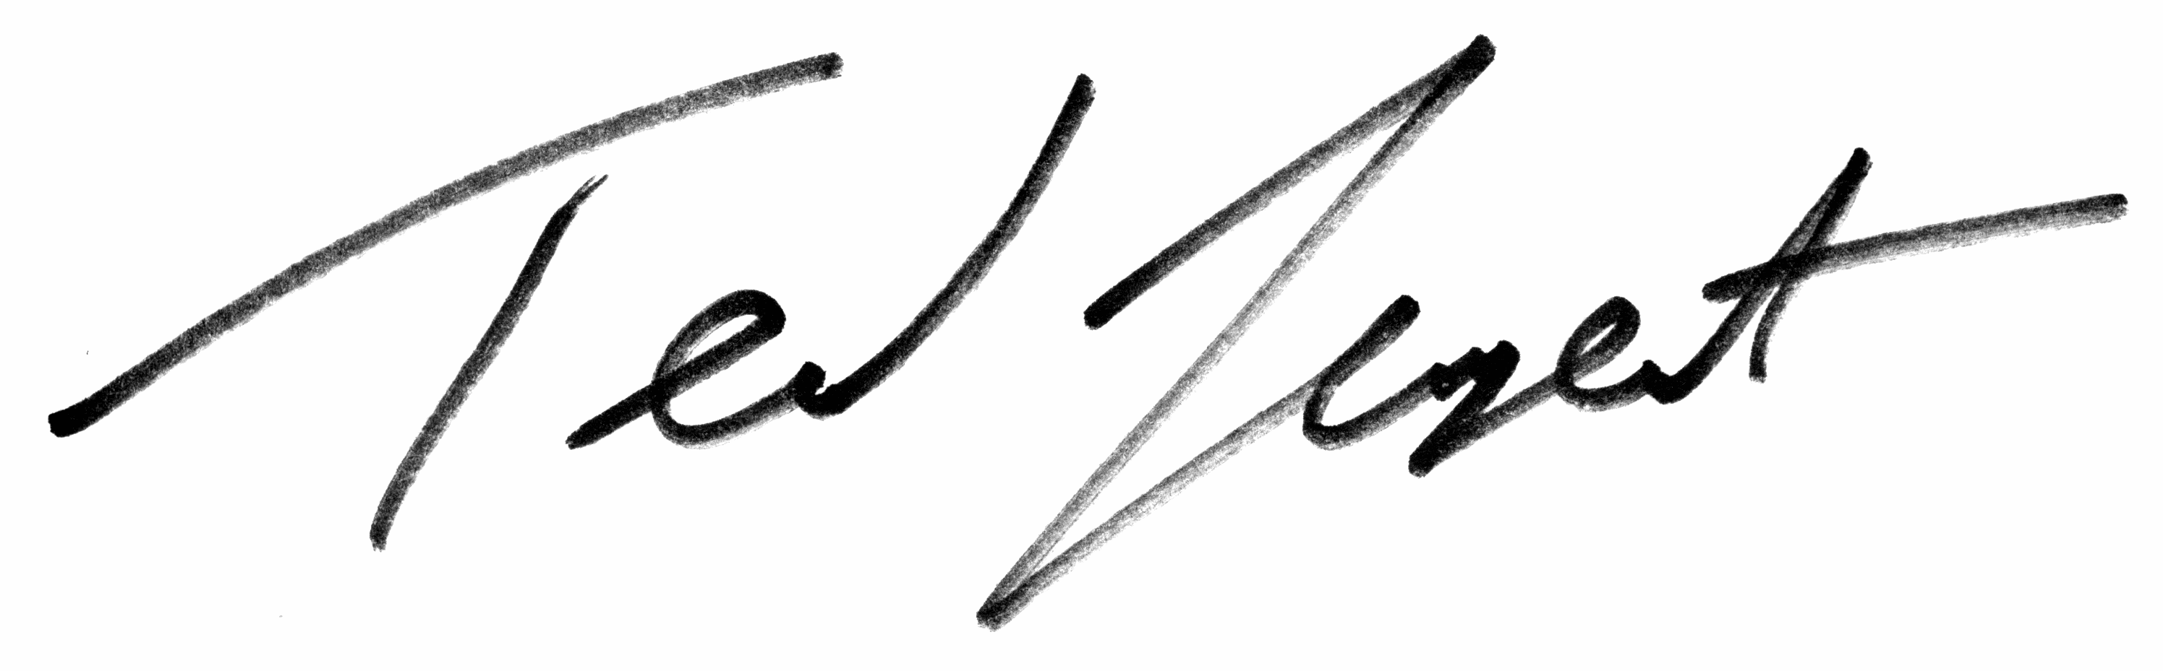
Ted Lempert
President

