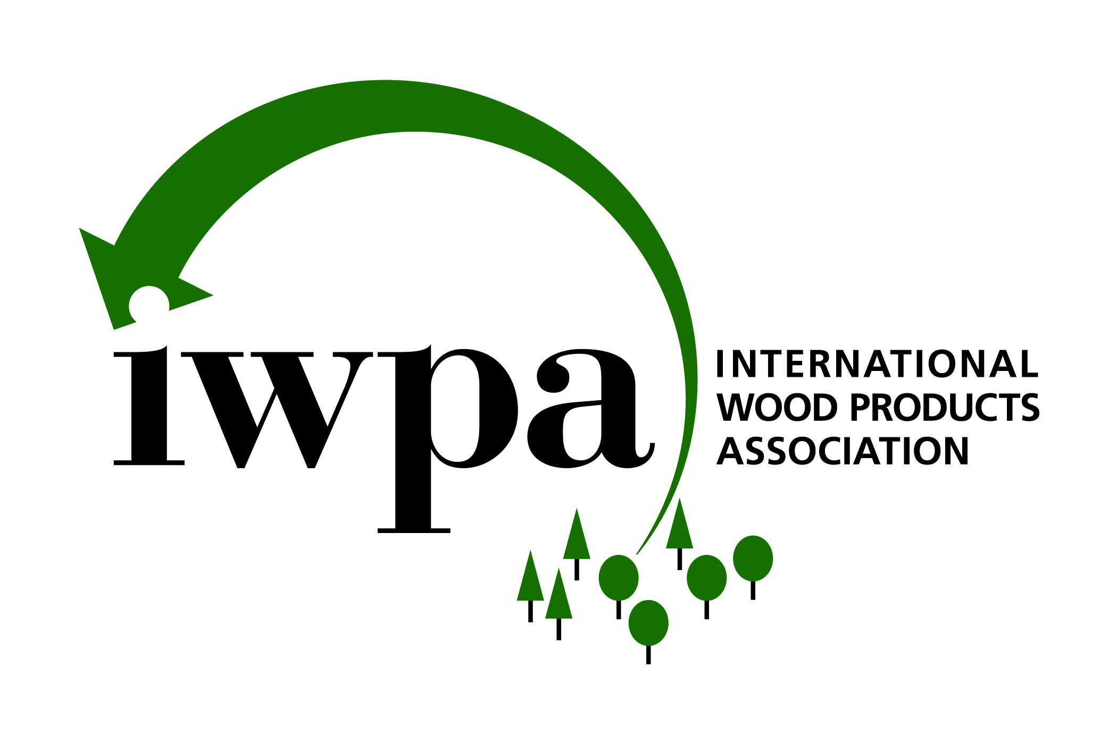

April 24, 2007

Dr. Robert Sawyer, Chairman
California Air Resources Board
1001 “I” Street
P. O. Box 2815
Sacramento, CA 95812

Re: Airborne Toxic Control Measure to Reduce Formaldehyde Emissions from Composite Wood Products; Release Date: March 9, 2007

Dear Dr. Sawyer:

The International Wood Products Association (IWPA) appreciates the opportunity to comment on the March 9, 2007, draft of the Airborne Toxic Control Measure to Reduce Formaldehyde Emissions from Composite Wood Products (ATCM).

IWPA is the only association in the United States committed to the promotion and enhancement of sustainable trade in the imported hardwood and softwood products industry. Our diverse membership includes 220 U.S. importers, manufacturers, transportation companies, port authorities, customs brokers, and overseas producers of quality hardwood plywood, lumber, and other wood products. Many of our members import or manufacture hardwood plywood (HWPW) for distribution in California and the rest of the United States. Their businesses and customer bases would be directly impacted by the proposed regulation.

Imported woods are enhancing the U.S. wood products industry with a quality, value-added complement to the marketplace. Leading manufacturers and distributors in the U.S. are easily incorporating imported woods alongside domestically produced woods as these wood products meet all existing quality standards.

IWPA applauds the California Air Resources Board’s (ARB) intentions to reduce human exposure to toxic air contaminants as mandated by state law. We, like you, hope for an attainable and efficient process providing a measurable benefit for the consumer.


We offer the following comments to minimize the unintended consequences of limiting the access of quality and imported hardwood plywood to California manufacturers, distributors, and retailers.

GENERAL COMMENTS

Eliminate Third-Party Testing Requirement
Imports of wood products are already saddled with extensive and cumbersome documentation required by the exporting countries and U.S. government entities for importation into a U.S. port. IWPA urges ARB to reconsider the requirement for third-party testing and chain of custody. This regulation can be just as effective as a performance-based standard only. Material in California must meet the standard, or there are consequences – period. As it is currently written, product can meet the standard, but if certain chain-of-custody documentation is not met showing third-party testing, then enforcement would still occur.

Modify Chain-Of-Custody Requirement to Use Existing Paperwork
We suggest that even if the third-party testing requirement is kept within the regulation, the regulation should be redrafted to utilize the existing required paperwork, such as the bill of lading, to verify compliance with applicable emission standards and the name of the third-party certifying agency. The bill of lading is already identified in Section 93120.6(c)(2)(B) as an option for product labeling for modified finished goods containing hardwood plywood.

Proposed Regulation Implementation Dates Must Be Delayed: Phase 1 to July 1, 2010: Phase 2 to January 1, 2012
IWPA’s long history of collaborating with the U.S. government on outreach to foreign governments regarding implementation of new regulations and policies suggest that the time window for implementation of this regulation is much too quick.

As previously mentioned, this regulation places a significant requirement for third-party certification – a requirement that does not currently exist in any widespread form anywhere around the globe.

A large majority of the more than 20 countries that export significant quantities of HWPW to the U.S do not have existing large-scale chamber testing facilities as required by the regulation. In fact, none of these countries (other than China) has been contacted by ARB to determine existing capacity. Building new facilities will take time, as will the process for applying and becoming an ARB-approved third party certifier.

Furthermore, the requirements for third party certifiers – as detailed in 93120.4 (b)(1) – to show evidence of past field experience is not workable given that there was not a need for this volume of third-party certifiers prior to the ATCM. They cannot have a proven track record when there was no previous need, to this extent, for this type of business.

We recommend the following initial steps to enhance implementation of regulation:

- Translate the regulation and staff report into, at a minimum, Mandarin, French, Spanish, Portuguese, and Japanese.

- Work with the U.S. Department of State, overseas embassies, and other appropriate organizations on an education campaign to inform foreign governments, foreign trade associations, and foreign laboratory testing facilities on the process to become an ARB-approved certifier.

- Develop a database of existing laboratories with sufficient facilities for testing to the standards of the new regulation.

- Conduct training sessions for overseas auditors to bring these companies up to speed on the requirements of the ATCM.

- Eliminate the previous work experience requirement for third party certifiers. This regulation creates a new global standard for producers wanting to sell to California and, therefore, new laboratories will need to be built in all countries wanting to do business with California. New third-party certification companies will need to be established and trained. It is unreasonable to expect these new businesses to have past work experience.

We feel strongly that implementation of Phase I should not begin prior to July 1, 2010, to allow sufficient testing facilities to be built and third party certifier applications to be submitted and approved. Phase II could then move forward as soon as January 1, 2012.

Equivalent Test Methods Are Important
Given that several overseas laboratories are already certifying product that is meeting the stringent requirements of Japan and Europe, it is important that equivalent test methods are endorsed by CARB. Overseas product that meets the requirements of this proposed regulation should not be discriminated against due to language or procedure.

Database of Exempted Adhesives
In addition to maintaining an online database of approved certifying testing agencies and laboratories, ARB’s compilation of all exempted adhesives will allow companies to better understand compliance options.

Gross Underestimate of Cost
We appreciate the extensive effort conducted to obtain an approximate cost of the regulation. We feel additional work is required to properly value the true cost of this regulation.

Some of the items not properly valued in the staff report include:

- Construction of new laboratories, development, and training of new third-party certifying businesses. New overseas laboratories and additional testing capacity, including the hiring and training of new staff, would now be required in every country interested in selling product to California.

  - One of the factors not considered within the regulation is the extent of third-party certification currently conducted for other international standards. While these standards exist, they are not extensively audited, used, and applied in the marketplace, certainly not to the level required by the regulation. The fact remains that this standard creates a new global requirement on producers throughout the world if they are interested in selling to the California marketplace. For example, Europe and Japan both have different formaldehyde emission standards depending on grades or product usage. In addition, both the European and Japanese standards allow for variances above their targeted emission levels. None of these levels are ceilings nor are they simple pass/fail grading systems.

  - The time to develop the necessary framework and produce compliant product (in some cases using yet-to-be-developed technology and adhesives) and the total costs of this regulation are grossly underestimated.

- Inventory costs. This regulation effectively doubles the required inventory for U.S. importers. These companies will now need to maintain duplicate inventory for material destined for California and product available for sale to the rest of the U.S., Canada, and Mexico.

- Paperwork and new database systems. New systems will need to be developed to track the burdensome new paperwork requirements for chain-of-custody documentation that do not currently exist in the marketplace. The FSC chain-of-custody referenced in the staff report is an interesting system but plays an insignificant role within the global forest products trading marketplace. FSC chain of custody is untested on a global scale, and initial feedback suggests that the full cost for individual third-party certification of forest products is only supported in high-end and niche architectural plywood applications.

- Changes in manufacturing processes. The specific technical requirements of new manufacturing processes require changes in production, ultimately slowing down the manufacturing process and raising unit costs dramatically.

The staff report tries to suggest a minimum effect on prices by tying increases to the effect on home prices. However, within the report itself, the staff report suggests increased manufacturing costs of 30 percent or more. Even though it is our view that the staff report grossly underestimates the total cost to the industry, a 30-percent increase in cost is not insignificant. Imagine a regulation increasing the cost of a car or home by that amount!

Enforcement – include de minimus clause exemption
Despite all the best intentions and due diligence, exceptions will always occur. There are numerous opportunities for a few panels of non-compliant material to be overlooked in inventory and subsequently found at a later date. There needs to be a de minimus exemption that eliminates liability from companies that have shown they have undertaken best practices but end up with a small amount of non-compliant material. Many warehouses have tens of thousands of crates of plywood, so the occasional crate should not rise to the level of enforcement.

COMMENTS SPECIFIC TO THE REGULATORY LANGUAGE

Section 93120.1(a)(17) – Definitions

We would ask for a clearer, more inclusive definition of vehicles as referenced in this paragraph which defines “Hardwood Plywood” (HWPW). According to the Recreational Vehicle Industry Association (RVIA), an RV is a vehicle that combines transportation and temporary living quarters for travel, recreation, and camping. The two main categories of RVs are motorhomes (motorized) and towables (towed behind the family car, van, or pickup). Types of towable RVs are folding camping trailers, truck campers, conventional travel trailers, and fifth-wheel travel trailers.

Section 93120.12(c) – Sell-through Dates that Apply to Importers of HWPW, PB, and MDF

IWPA understands the broad range of feedback ARB is receiving related to sell-through dates for importers. We appreciate and applaud ARB’s understanding that the difference in sell-through dates for imported wood products is justified because of the different “path to market” and the very nature of international distribution. However, we believe the proposed regulation should extend the sell-through period for importers from the proposed 5 months to a minimum of 12 months for the following reasons:
- Imported HWPW undergoes a series of stages before reaching U.S. shores.
  - Order placed
  - Material produced overseas (if not already in inventory)
  - Material shipped (after awaiting availability of shipping vessel)
  - Material arrives in the U.S. (after 4 to 5 weeks in transit – longer if shipped via breakbulk)
  - Material is held at U.S. port until cleared by U.S. government (1 week or longer depending on backup at U.S. port)
  - Material held at warehouse until purchased (time variable, potentially long)
  - Material ships to wholesale distributor or U.S. manufacturer

- Importers purchase goods on speculation, not knowing when or to which customers the product will ultimately sell. These importers purchase in very large quantities to take advantage of discounted pricing. When market conditions change, importers can be stuck with a large inventory of slow-moving product, many times having to carry inventory in select items for a year or longer. While their ultimate goal is to turn inventory as quickly as possible, twelve months is the minimum sell-through that should be allowed. This process differs significantly from domestic production that produces to market demands and can ship to a customer the same day or week of production.

IWPA would be happy to discuss further the above concerns or other requirements in the proposed regulation at your convenience. Please do not hesitate to contact me at 703-820-6696 or at Suzanne@iwpawood.org.

Sincerely,

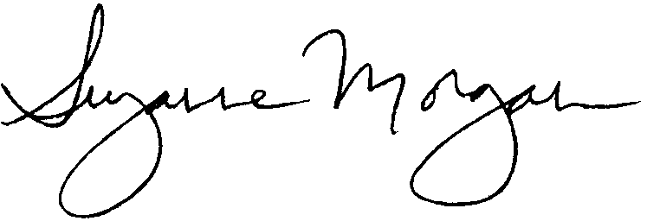

Suzanne Morgan
Manager, Government Affairs and Membership Relations

