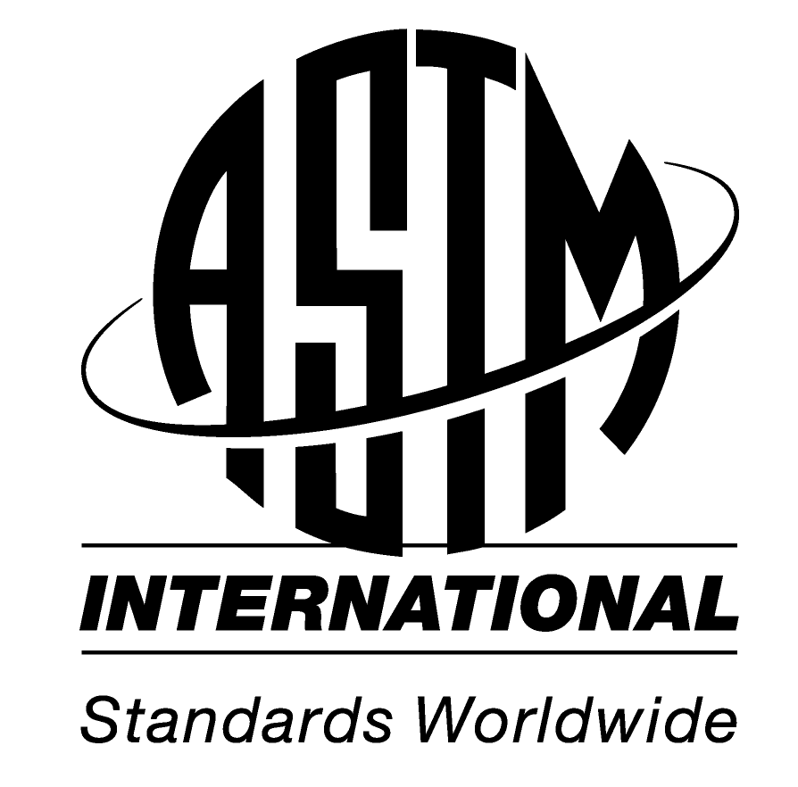 |  | Manager, Global Cooperation | Jessica A. Hychalk
 |  | Address 100 Barr Harbor Drive  PO Box C700  W. Conshohocken, PA  19428-2959 | USA | Phone 610.832.9693  Fax 610.832.9599  e-mail jhychalk@astm.org  Web www.astm.org/GLOBAL

Name: Jessica A. Hychalk
Company Name: ASTM International
Contact Name at Company: Jessica A Hychalk
Date Submitted: 3 June 2008
Notification commented on: Proposed Amendments to the Regulation for Reducing Emissions from Consumer Products

Issue Statement:

I am writing to address a concern regarding the document, “Proposed Amendments to the Regulation for Reducing Emissions from Consumer Products”.

Please note on page 4 of regulation, the use of the name American Society for Testing and Materials is incorrect. Since 2001, the official name of our standards organization has been “ASTM International” and should be referenced accordingly.
Additionally, please note the following standards listed on pages 18, 26, and 68 of the document are not the most recent versions of the ASTM standards. Any information that is referenced from these documents should be updated accordingly in order to reflect the most current standard and information. ASTM International’s standards change frequently. It is more effective to cite the ASTM standard without a date or provide some language to insure the use of the most current version.

Standard referenced in, “Proposed Amendments to the Regulation for Reducing Emissions from Consumer Products ” | Current ASTM version
D 4359-90 | ASTM D4359 - 90(2006) Standard Test Method for Determining Whether a Material Is a Liquid or a Solid
E 260-91 | ASTM E260 - 96(2006) Standard Practice for Packed Column Gas Chromatography
D 86-01 | ASTM D86 - 07b Standard Test Method for Distillation of Petroleum Products at Atmospheric Pressure
D 850-00 | ASTM D850 - 03 Standard Test Method for Distillation of Industrial Aromatic Hydrocarbons and Related Materials
D 1078-01 | ASTM D1078 - 05 Standard Test Method for Distillation Range of Volatile Organic Liquids
D 2879-97 | ASTM D2879 - 97(2007) Standard Test Method for Vapor Pressure-Temperature Relationship and Initial Decomposition Temperature of Liquids by Isoteniscope
D 2887-01 | ASTM D2887 - 06a Standard Test Method for Boiling Range Distribution of Petroleum Fractions by Gas Chromatography
E 1719-97 | ASTM E1719 - 05 Standard Test Method for Vapor Pressure of Liquids by Ebulliometry

We appreciate your cooperation, and hope that with your help this issue can be resolved in an efficient and productive manner.

Sincerely,

Jessica A. Hychalk
Manager, Global Cooperation
ASTM International

Phone: +1 610-832-9693
Fax: +1 610-832-9599
Web: http://www.astm.org

