September 22, 2009 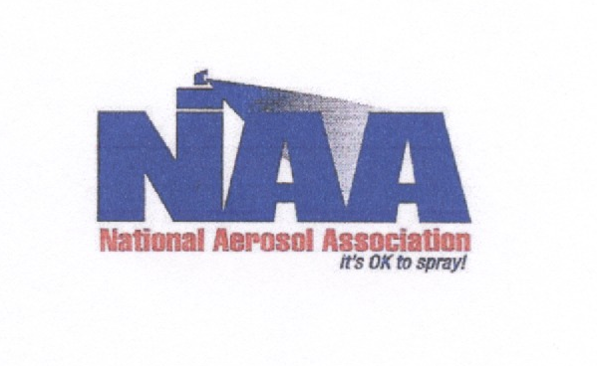

Clerk of the Board
California Air Resources Board
1001 I Street
Sacramento, California 95814
http://www.arb.ca.gov/lispub/comm/bclist.php

Subject: Comments on Consumer Product Amendments Board Agenda #09-8-4

Dear Clerk of the Board,

The National Aerosol Association (NAA) represents marketers, manufacturers and suppliers in the US aerosol industry. NAA is the only national trade association focused solely on the aerosol product form. The NAA has a long history of working cooperatively with the Air Resources Board (ARB) on past rulemakings dealing with Consumer Products. NAA’s goal is to provide ARB staff with the required emission reductions while maintaining safe and efficacious aerosol products for the consumer.

NAA appreciates the opportunity to comment on the ARB’s proposed amendments to the Consumer Products Regulation. After reviewing the proposed amendments, the NAA has the following comments in four areas of concern that need to be addressed. Our comments will focus on the following areas.
- Lack of a Reactivity Regulation for Multi-purpose Solvents and Paint Thinners.
- The inclusion of an “aromatic” restriction.
- Restriction of Global Warming Potential for Double Phase Air Freshener aerosol.
- Increased Fire Risk to consumers for the 3% VOC limit.

Reactivity Concept
NAA has been an active supporter of the science of reactivity. NAA was the first association to support ARB in the adoption of the Aerosol Coating regulation in 2000. While the Multi-purpose Solvent and Paint Thinner amendments do not effect aerosols, NAA is disappointed that the concept of reactivity was not used when regulating these categories. The use of reactivity would have provided known emission reductions while providing flexibility to the manufacturer.

NAA Comments on Board Agenda Item #09-8-4
September 21, 2009
Page Two

Aromatic Compounds Restriction
The inclusion of the aromatic compounds restriction would not be necessary if the concept of reactivity was utilized. In addition, the aromatic compounds restriction does not accomplish the staff goal of reducing all high reactive alternative compounds. While some aromatic compounds are high in reactivity, there are numerous other compounds which are high in reactivity and are not aromatic. Lastly, the definition for aromatic compounds is overly broad and will be difficult to verify through testing. Staff should remove this restriction and focus on improvements for a reactivity regulation.

Global Warming Potential (GWP)
Staff has proposed a GWP restriction on Double Phase Air Freshener aerosols. Currently only one non flammable propellant remains that could be utilized in this category. That propellant is HFC-134a. The GWP restriction eliminates the possible use of this compound. If there is a need for a non-flammable product in this category, industry has no alternatives. Staff should consider language to provide an exemption for this situation if it were to occur in the future.

Increased Fire Risk from 3% VOC Limit.
NAA supports other commenters that the staff’s 3% proposed VOC limit will force manufacturers to use the exempt compounds which are extremely flammable. These compounds when added to a coating product will create an extremely flammable mixture and drastically increase the fire hazard to the consumer.

Recommendations
Staff should remove the 3% limit and aromatic compounds restriction and focus on adopting reactivity based regulation. A reactivity regulation will also remove the increased fire risk issue.

In addition, staff should include wording to exempt Double Phase Air Freshener products which may need to use a non-flammable propellant in the future.

NAA appreciates the opportunity to comment and I can be reached at 440-474-4999 or at djraymond@reg-resources.com with any questions.

On behalf of NAA

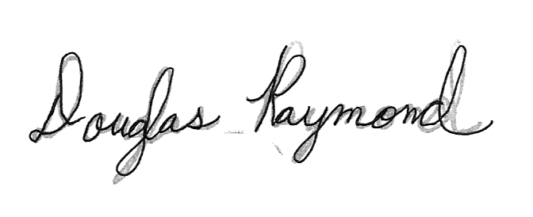

Doug Raymond

