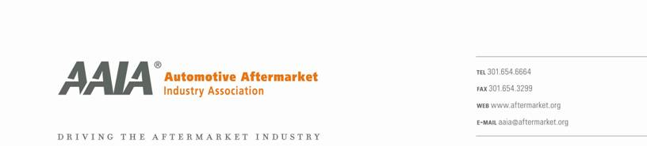

October 13, 2006

David Mallory, P.E.
Manager, Measures Development Section, Stationary Source Division
California Air Resources board
P.O. Box 2815
Sacramento, CA 95812

Dear Mr. Mallory:

The Automotive Aftermarket Industry Association (AAIA) is extremely concerned with the VOC emission standards for four automotive maintenance product categories that are contained in the proposed CONS-2 regulations slated for consideration by the Board at their November meeting. AAIA is a national trade association whose more than 8,000 member companies and affiliates manufacture, distribute, sell and install motor vehicle parts, accessories, service, tools, equipment, materials and supplies. Through its membership, AAIA represents more than 100,000 repair shops, parts stores and distribution outlets.

Both our parts manufacturer and our service facility members are concerned that the 10% VOC standard for brake cleaners, carburetor or fuel-injection air intake cleaners, engine degreasers, and general purpose degreasers could negatively impact the ability of technicians to effectively clean and maintain vehicles. Proper vehicle system maintenance is essential to ensure the proper operation and durability of numerous engine and brake components. We further are concerned that CARB in developing the 10% proposal has failed to consider the potential hazards that may be caused by residues on automotive brake parts or the safety benefits of effective brake maintenance, replacement and repair.

AAIA’s chemical specialty producers and packagers have made extensive efforts over the past several decades to reduce the VOC emissions of these products and have recently offered to make additional reductions that will provide for significant environmental benefits while also ensuring product’s efficacy and safety. AAIA strongly urges that ARB consider this compromise prior to the upcoming November board meeting. Such action would protect California’s air quality without having a negative impact on our member’s ability to provide car owners with maintenance services that ensure the safe and effective operation of their vehicle.

Thank you for your consideration and please feel free to contact me should you have any questions regarding our position.

Sincerely,
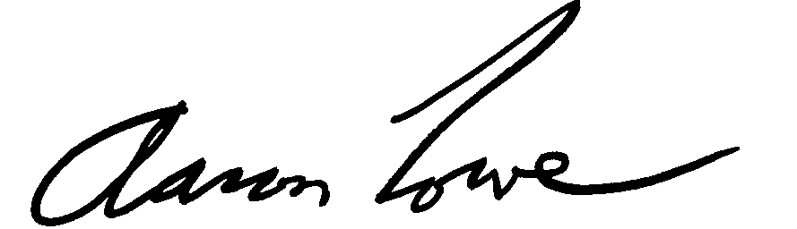

Aaron M. Lowe
Vice President
Government Affairs

