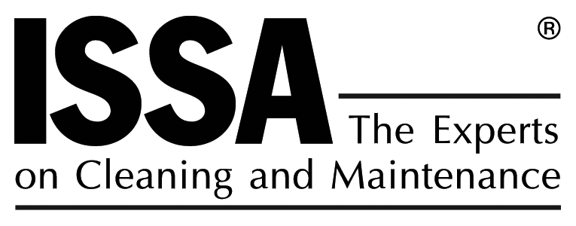

October 27, 2006

Mr. David Mallory
Manager, Measures Development Section
Stationary Source Division
California Air Resources Board
1001 I Street, 6th Floor
P.O. Box 2815
Sacramento, California 95812
dmallory@arb.ca.gov

Re: Comments on ARB’s Proposed Amendments to the California Consumer Products Regulations

Dear Mr. Mallory:

As always, ISSA appreciates the opportunity to comment on ARB’s proposed amendments to the California Consumer Products Regulations. ISSA remains encouraged by the willingness of ARB to work directly with industry to develop a reasonable, efficient rulemaking.

ISSA is a non-profit trade association that is comprised of over 4,600 member companies, many of who are engaged in the manufacture and distribution of cleaning products, including numerous products that will be subject to the proposed limits and regulatory requirements. Although we remain troubled by a number of the proposed limits, we appreciate ARB’s mandate to achieve the greatest possible reductions. The proposed 1% limit for the Floor Polishes/ or Waxes Category is not technologically or commercially feasible, however, and ARB should consider an alternative that will achieve reasonable reductions while allowing effective products in this all-important product category to continue to be sold in the state of California.

Simply stated, a 1% VOC limit for Floor Polish or Wax is not technologically or commercially feasible for all products in the category. That said, ISSA urges ARB to establish a sub-category for those products that cannot meet the 1% limit. Specifically, we support the proposal that has been offered by the Consumer Specialty Products Association and others, which would create a sub-category for floor polish or wax products that must be regularly burnished. Further, ISSA, on behalf of its 4,600 members, supports the CSPA proposal in so far as it seeks to set a 3% VOC limit for that subcategory.

Our support for the proposal further includes all definitions recommended to be created and/or amended, including those for “floor polish or wax,” “burnishable floor polish,” and “wood floor wax.”

Finally, ISSA supports ARB’s current proposal to set a December 31, 2010 effective date for the Floor Polishes/ or Waxes Category. No matter what the new VOC limit is for such products, formulators of such products are going to need the additional time to prepare for its mandate.

ISSA, once again, appreciates the opportunity to comment on ARB’s proposed new limits. Should you wish to discuss, please do not hesitate to contact me at 800-225-4772 or daniel@issa.com.

Very truly yours,
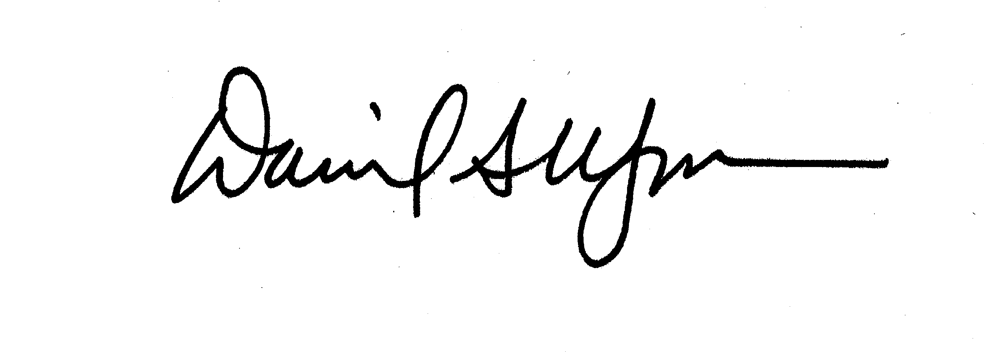
Daniel S. Wagner
Manager of Regulatory Compliance: ISSA

