
Response to
Request for Information:
CA Air Resources Board Market Tracking System
10 June 2010

Jane Lloyd
Vice President
Markit
620 8th Avenue
35th Floor
New York, NY 10018
Jane.Lloyd@markit.com
+1 212 931 4903
Contents

1 Executive Summary 3
1.1 Overview 3
1.2 Capabilities 3
1.3 Feedback 3
1.4 Costs and timeframe 3
1.5 Other information 3
2 Capabilities 4
2.1 About Markit 4
2.2 About Markit Environmental Registry 5
2.3 Design and implementation experience 5
2.4 Key capability metrics 6
2.4.1 Years in operations 6
2.4.2 Number and location of key employees 7
2.4.3 Expertise of key staff 7
2.4.4 Markit Accolades 7
2.5 Markit has fully functioning existing systems similar to the Market Tracking System 8
2.6 Markit can meet and exceed the experience considerations 8
3 Feedback and Additional Considerations 9
3.1 Overview 9
3.2 Availability of current systems that meet requirements of Appendices A and B 9
3.3 Additional Considerations to the System Concept 9
3.4 Additional Considerations beyond the System Concept 10
4 Cost and Timeframe 11
4.1 Summary 11
5 Other considerations 12
5.1 Operations 12
5.2 Pre-trade services and products to facilitate efficient low-risk trading 12
5.2.1 Environmental and Counterparty identifiers 12
5.2.2 Corporate Tools 12
5.3 Post-trade services and products to facilitate efficient low-risk markets 13
5.3.1 Trade processing 13
5.3.1.1 Documentation 13
5.3.1.2 Confirmation of Trades 13
5.3.1.3 Trade Repository 13
5.3.2 Data 14
5.3.3 Distribution 14
5.3.4 Indices 15
5.3.5 Research and Reports 15
5.4 A broad global partner network will be key to implementation 15
Appendix A: Market Tracking System Overview 16
Appendix B: Additional System Design Considerations 25
Appendix C: Cap-And-Trade Market Flow 30
Appendix D: Additional Information and Resources 31
Markit Group Ltd Disclaimer 32

Executive Summary

Overview
Markit Group Ltd. (“Markit”) is delighted to provide the California Air Resources Board (“ARB”) with a response to ARB’s Request for Information (“RFI”) on the draft requirements and potential market offerings for the Market Tracking System to help meet the implementation requirements of California’s cap-and-trade program.
As the world’s leading provider of environmental markets infrastructure services, Markit understands that a successful cap-and-trade market must have a properly designed market tracking system that provides all stakeholders and participants maximum confidence in the integrity of greenhouse gas reductions.
For carbon to truly trade like a commodity and be priced transparently on a daily basis, the development of market design and infrastructure is essential. Markit understands the key requirements essential for the growing carbon markets and has invested heavily to foster the evolution of this market. Markit’s registry, Markit Environmental Registry, provides compliance and voluntary buyers and sellers with a world-class, robust, global registry that is essential to providing transparency and credibility to the management of environmental assets whilst satisfying rigorous legal requirements.
Markit is a preeminent global financial information service provider and has a proven track record of identifying, defining and delivering solutions for the marketplace across all asset classes. Markit’s core objectives center around creating transparency, enhancing operational efficiency, and providing risk management into emerging markets and increasingly environmental markets. These three tenets form the basis of our infrastructure design and commercial products and services for these markets.

Capabilities
Founded in 2001, Markit services have become global standards for enhancing transparency across credit, equities, structured finance, commodities markets and the broader Over-The-Counter derivative universe.
Over the past 3 years, Markit has developed the necessary capability and experience in designing, implementing and operating market tracking systems for carbon markets and has a United States centric, strong team focused solely on tracking, supporting and growing these state, regional, national and international markets as they are emerging.
Section 2 of this Response to Request for Information (“RRFI”) outlines Markit’s capabilities in this area.

Feedback
Markit’s extensive local and international experience in greenhouse gas markets enables us to provide further feedback on the draft requirements proposed by the ARB.
Section 3 of this RRFI outlines Markit’s feedback on these requirements.

Costs and timeframe
Section 4 of this RRFI outlines information regarding Markit’s prospective cost and expected timeframe for the Market Tracking System.

Other information
Section 5 of this RRFI outlines further information Markit wishes to highlight to ARB in its consideration of the requirements of the Market Tracking System and the broader California cap-and-trade program.

Capabilities

About Markit
Markit is a leading, global financial information services company with over 1,800 employees. The company provides a broad spectrum of services across all asset classes in order to enhance transparency, reduce risk and improve operational efficiency for our clients.
Markit was founded in 2001 as the first independent source of credit derivative pricing. Today, our independent pricing, reference data, portfolio valuations, trade processing and desktop solutions are regarded as a market standard in the global financial markets.
Markit is an active contributor to the critical debates shaping each of the markets in which we participate. We are a proud member of the leading associations that foster the dialogue and organised decision-making that ensure market transparency and orderly evolution.
Our client base consists of the most significant institutional participants in the financial marketplace today, including the largest investment banks, hedge funds, asset managers, central banks, regulators, rating agencies and insurance companies. We provide round-the-clock support from our offices in London, New York, Dallas, Toronto, Amsterdam, Frankfurt, Luxembourg, Tokyo and Singapore.
Markit’s products and services focus on satisfying pre- and post-trade requirements and are represented in dark blue in the diagram below. Additionally, the broad range of asset classes and institution types where Markit has a leading presence is outlined on the right hand side of the diagram below.
In Markit, environmental markets sit within Markit’s commodities group. This enables the mindset, skills-base and creativity that brings transparency, operational efficiency and risk management to the commodities markets to be extended to existing and emerging environmental markets. While Markit’s primary focus is on carbon, each of the services extends to other environmental commodities such as water and biodiversity.

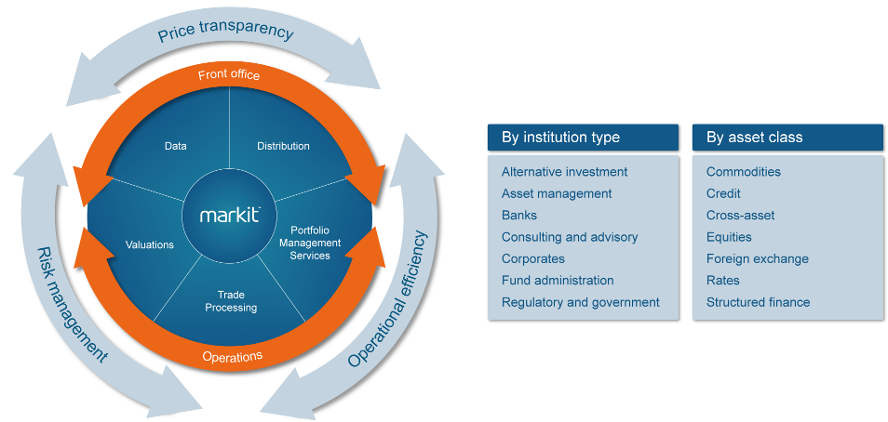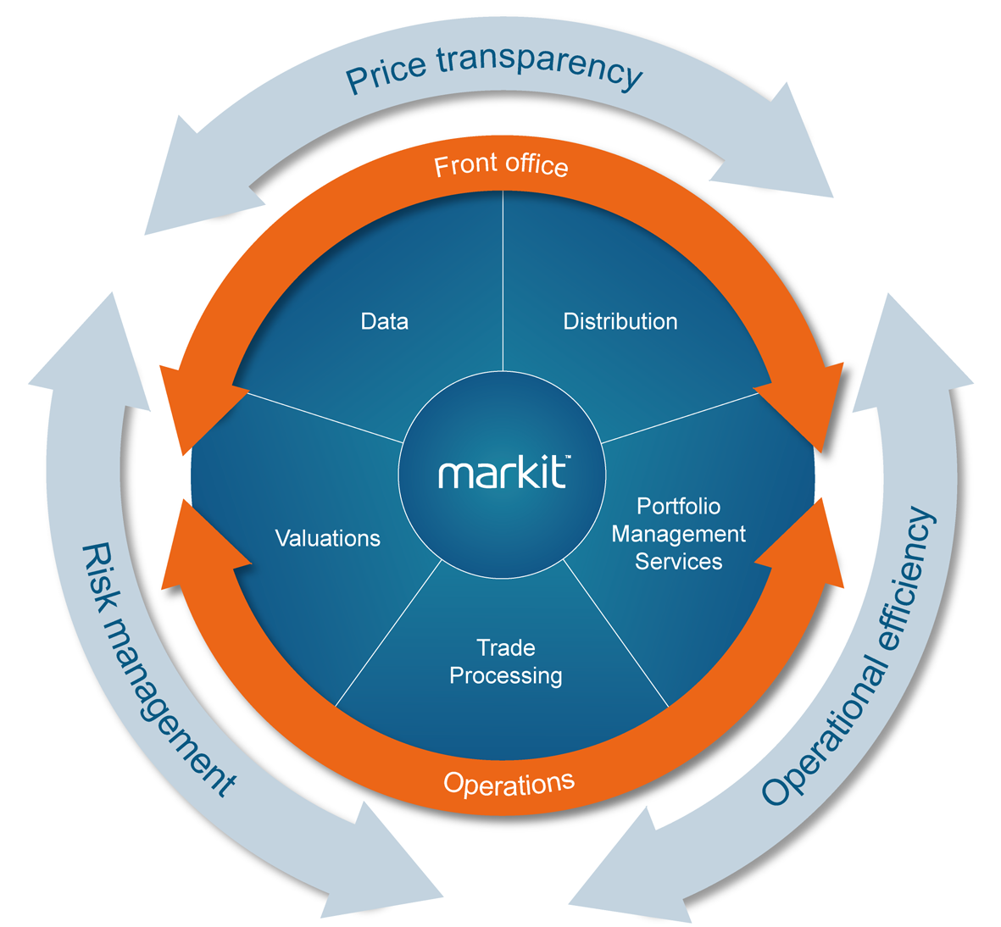

About Markit Environmental Registry
Three years in research and development by its parent company NZX, a regulated securities exchange, the Registry business (known then as TZ1 Registry) launched in early 2008. On 30 June 2009, Markit acquired 100% of TZ1 Registry from NZX and re-branded it as Markit Environmental Registry.
Today the Registry is the largest US and global voluntary carbon markets registry in both volume and number of customers, and was recently selected by the readers of Environmental Finance as the Best Registry Provider in the publication’s 2009 voluntary carbon market survey.
As the carbon markets continue to evolve, and with increased demand from compliance market operators for fully functional and flexible registries, the Markit Environmental Registry (alongside the broader Markit organization) continues to invest in high performing and adaptable infrastructure.
Carbon registries are no longer about just project registration and credit listings. Increasingly, Markit Registry is designing new functionality, new products and streamlining processes and technology to enable the leaders in these markets to have the most flexible and enabling infrastructure at their fingertips.
This leading edge, world-leading full-service environmental infrastructure is now being utilized for most of the major global carbon standards, establishing a trend of many carbon trading schemes consolidating the registry infrastructure and operations processes into the capable hands of the Markit team.

Design and implementation experience
Markit is a financial information services company whose core business focuses on delivering innovative infrastructure to market participants in order to enable a more efficient, transparent and risk-managed marketplace.
Markit's forward-thinking management team has a long history of operational expertise and a proven ability to run innovative business lines that meet industry requirements.
As illustrated in the diagram overleaf, Markit has a vast range of products and services. All of these depend on fully functioning, timely and robust technology. The highest quality pre-trade and post-trade infrastructure is key to a properly functioning market, and Markit’s experience in this field surpasses that of any other provider in financial or environmental markets.
Having designed infrastructure and operations processes to enable implementation of various carbon, biodiversity and water markets standards into the Registry, Markit has very apt design and implementation expertise to help ARB implement an optimal Market Tracking System for the California greenhouse gas market.
To Markit, implementation of a carbon standard is not just about technology; it involves a deep understanding of the Standard, its history, objectives, legislative context, structure, key focus areas and market context. Markit then designs the infrastructure (technology, rules and processes) around this information working alongside the Regulators or Standards body throughout.

Markit’s range of products and services in addition to environmental markets are set out below:
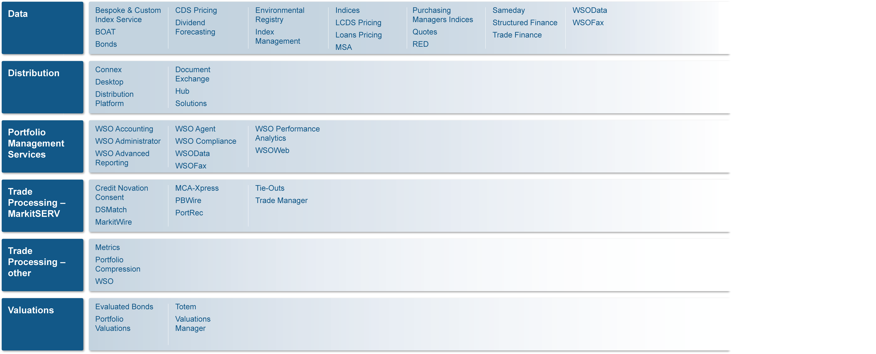

Key capability metrics
Markit Environmental Registry is the largest voluntary carbon registry in the world with an 85% market share (excluding CCX) with:
- 600 registry account holders; and
- 75 million credits and pending issuance units listed.
Markit Environmental Registry lists credits for eight primary market standards of these, and four of these are on an exclusive basis. Listings include:
- Voluntary Carbon Standard (VCS), Climate & Community Biodiversity Alliance (CCBA), ISO14064, Plan Vivo, Social Carbon, Carbon Fixand Carbon Fix
In 2008, the Voluntary Carbon Standard (VCS) in 2008 had 48% market share; Markit has 65% of VCS share. The 2009 voluntary carbon market report is due to be published this month, and Markit’s VCS market share is expected to be higher that in 2008.
Markit was voted Best Registry Provider in the Environmental Finance publication’s 2009 Voluntary Carbon Market Survey and winner of the Financial Sector Technology Awards 2010 Environmental Initiative of the Year.

Years in operations
Markit was founded in 2001 and today, our data, valuations and trade processing services are regarded as a market standard in the global financial markets.

The Registry business that Markit operates was launched in April 2008 after three years in research and development. Markit acquired the Registry business on 30 June 2009.

Number and location of key employees
Markit is a truly global company with 20 offices around the world with over 1,800 staff. The key Registry technology and operations team operates from the New York office together with our US registry sales and business development team. We also have business development teams in Canada, the United Kingdom, Europe, Asia, and Australasia.

Expertise of key staff
Helen Robinson, Managing Director, Markit Environmental Registry, founding CEO of the TZ1 Registry has an impressive background in leading technology companies, and arguably one of the most experienced leaders in carbon and environmental markets worldwide. Robinson continues to head the Markit Environmental Registry responsible for strategy, governmental relations, sales and marketing.
Kathy Benini, Managing Director, Markit, joined Markit in 2009 from Goldman Sachs where she worked for 25 years and most recently was Vice President and Regional Manager of Commodity Operations. Kathy is responsible for product development for Markit's Global Commodities business and oversees all product design and development, technology and operational risks related to the Markit Environmental Registry.
Jane Lloyd, Vice President, Markit Environmental Registry, is responsible specifically for environmental markets strategic engagement across the Americas. With an extensive background in sales and marketing in the financial services sector Lloyd has been instrumental in building carbon strategies for regional and voluntary market activity.
Liza Logounova, Business Analyst, Markit Environmental Registry, joined Markit in 2010 from Goldman Sachs where she worked for 10 years and most recently was Vice President and Regional Manager of Commodity Technology. Liza is responsible for analysing business requirements and providing technical specifications documents to the Markit Environmental Registry development team.

Markit Accolades
The diagram below illustrates the numerous accolades Markit has earned. More recently, as noted above, Markit was voted Best Registry Provider in Environmental Finance’s 2009 Voluntary Carbon Market Survey and winner of the FST Awards 2010 Environmental Initiative of the year.

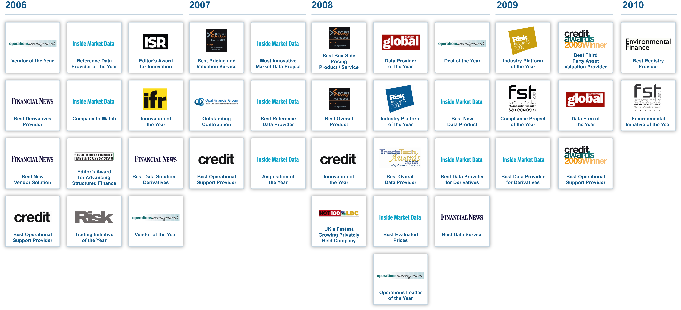

Markit has fully functioning existing systems similar to the Market Tracking System
Markit has an existing extensive product suite similar to the Market Tracking System that includes a fully functional and utilized registry and data repository services as outlined above and as demonstrated by our current market share.
Appendix A of this RRFI outlines in further details the existing infrastructure Markit operates to support the system concept outlined in Appendix A of the RFI.
Markit is confident that any infrastructure required by the Market Tracking System not already delivered by Markit, can, subject to detailed discussions, be implemented within the timeframes required.
This is outlined further in Appendix A to this RRFI.

Markit can meet and exceed the experience considerations
As a provider of financial markets infrastructure to major global financial institutions, Markit meets the experience considerations set out in Appendix B of the RFI.
Further information is provided in Appendix B of this RRFI.

Feedback and Additional Considerations

Overview
As the leading global environmental markets registry provider, Markit’s existing system will perform most of the system functions listed in Appendices A and B. Extending the system to meet all of these functions is possible and easy to implement.

Availability of current systems that meet requirements of Appendices A and B
Appendices A and B of this RRFI set out the availability of Markit’s current system to meet the requirements of Appendices A and B.
As noted above in section 2, Markit is confident that any infrastructure required by the Market Tracking System not already delivered by Markit can, subject to detailed discussions, be implemented within the timeframes required. This is outlined further in Appendix A to this RRFI.

Additional Considerations to the System Concept
Markit suggests the following modifications to the system concepts listed in Appendices A and B.
- Matching of inventory reporting information in the CA Greenhouse Gas emissions reporting tool with the regulated entity’s actual retirements in the Registry:
  - Markit provides this service for a number of customers and would be happy to provide further information.
  - Markit has recently launched Markit Eco a full suite carbon management platform. Markit Eco is versatile platform and can incorporate the main Greenhouse Gas Emission reporting tools such as Misys (Climate Registry) etc. Markit Eco allows companies to calculate their footprint, capture the purchase/sale of offsets, integrate into a risk system to monitor positions and run risk reports, and finally, to integrate with the registry for delivery and retirement instructions and into the reporting tools.
  - Markit can provide an array of solutions from providing an integrated platform for all CA Greenhouse Gas emissions in an ‘all in one system’ through Markit Eco to directly uploading information from the registry.
  - Markit is happy to discuss the various options that we are able to offer that would best suit CA Air Resources Board.
- A Regulator log-in enabling a different level of regulator access from those with day-to-day operations of the Market Tracking System:
  - Markit currently has this functionality established and would be very willing to provide a demonstration and further information.
- A requirement for master account / sub account structure within the Market Tracking System for regulated entities to manage their portfolio efficiently:
  - Markit has such a registry accounting structure for portfolio management and would be happy to provide further information.
- Capacity to connect to clearing houses or custodians to enable Delivery Versus Payment for larger and / or higher risk transactions:
  - Markit has a number of such connections being agreed for 2010 and would be happy to provide further information.

Additional Considerations beyond the System Concept
Markit suggests the following additional considerations beyond the system concept outlined in Appendices A and B:
- An introductory platform for buyers and sellers to meet (until there is liquid transacting on exchanges):
  - Markit has such a platform, known as the Request for Information Platform (RFI Platform).
  - The objective of the RFI Platform is to facilitate anonymous listing of credits for sale with indicative pricing so that potential purchasers use the platform to contact sellers.
  - We would be happy to provide a demonstration and further information.
- A tool to track the lifecycle of credits that is expected to be delivered but not yet verified:
  - Such a tool would allow market participants to track forward sales and provide full transparency in the transacting of credits prior to their issuance.
  - Markit has developed a tool that serves this function. A Pending Issuance Unit (PIU) is a unit that represents a contractual right to the future delivery of an emission reduction credit. These units can now be listed, held and tracked on the Markit Environmental Registry.
  - This tool could apply to all credit types, whether they are allocated or offset credits.
  - This is an ideal feature to enhance market participants’ credibility while they secure a forward pipeline. PIUs are a world first for carbon and have the potential to unlock funding, transaction visibility and real value for the carbon and other environmental markets.
  - The PIU Registry provides users of the Markit Environmental Registry with comfort about the transparency and traceability of contractual rights to the future delivery of emission reduction credits.
  - Markit would be happy to provide further information.
Markit has suggested additional considerations in section 5 of this RRFI.

Cost and Timeframe

Summary
Markit works closely with major global financial organizations to delivery timely cost effective products and has complete confidence that it will deliver an optimal MTS solution for ARB.
Markit provides a wide range of infrastructure services (systems, processes and operational services) for many organizations worldwide. Each client has specific needs that Markit works to meet fully.
Based on the information provided, there are a variety of options within the three major systems solutions that are available to ARB regarding the deployment of a robust Market Tracking System as related to the use of the Markit Environmental Registry and other Markit services.
System Type | Description
Fully Customized Markit Hosted Solution | Markit can build out a highly customized comprehensive solution and act as a service provider for Market Tracking System
Fully Customized ARB Hosted Solution | Markit can build out, package and sell comprehensive solution for Market Tracking System and provide on-going maintenance and support
Markit’s Existing Product Suite Solution | Markit can package together a variety of existing services (such as MarkitServ, Markit Document Exchange, Markit Environmental Registry and more), customize the solution to accommodate Market Tracking System needs. This solution can be housed in Markit or sold to ARB, whereby Markit will provide on-going support and maintenance.

Based on this Markit would be pleased to work with ARB to determine the exact structure of services needed and come to an agreement as to appropriate mutually agreeable costs.

Other considerations

Operations
Markit currently provides full registry services for the standards for which it lists credits. These include registry technology, processes preparation and operations processing of all activity on the Registry that is not (for risk reasons) automated e.g. credit issuance.

While Markit’s system could be extended to enable ARB (and other regulators and agencies) to have necessary administrative features in order to maintain regulatory and administrative control of the MTS, Markit would suggest that ARB consider having an experienced third party provider such as Markit deliver the account opening, administration and full registry operations required for the MTS.

As an entity providing these services for other standards and governments, Markit will have exposure to other standards, programs and regulatory approaches. This would enable Markit to bring to ARB, the MTS and the broader CA marketplace, learnings from these new other standards and programs and incorporate into the daily MTS operations increased operational efficiencies, lowering risks and costs for the ARB and the market participants using the MTS.

Pre-trade services and products to facilitate efficient low-risk trading
Markit offers a range of pre-trade services and products which, when applied to new markets from the outset, can lower risks while increasing efficiencies. Two of the most relevant products are outlined below.

Environmental and Counterparty identifiers
Environmental Identifiers are unique identifiers that define characteristics of products. This will facilitate trading, position and trade reporting for:
- Carbon Credits and Allowances
- Vintage
- Project type
Counterparty Identifiers are needed to uniquely identify every counterparty trading in the marketplace. This ensures accurate credit monitoring and trade reporting and facilitates clearing and settlement.
Additionally, underlying documents required to prove the accuracy of the identifier can be captured in an electronic document exchange platform that enables storage/update/retrieval of relevant documents.

Corporate Tools
Markit has a full suite of environmental infrastructure tools and services to help facilitate flow of information and to provide a centralized portal that can integrate with other technologies and information sources.
The primary Markit corporate tool is Markit Eco, an environmental desktop to enable corporate and compliance users to meet their regulated and strategic objectives. This solution delivers a central hub to organizations which mitigates their emissions legislation risks and decreases the operational expense associated with executing emissions management programs and disclosing their emissions status to internal and external stakeholders.
More information about Markit Eco is available upon request.

Post-trade services and products to facilitate efficient low-risk markets
Markit offers a range of post-trade services and products which, when applied to new markets from the outset, can increase transparency, operational efficiency and participation while lowering risks and costs.

Trade processing
The entire carbon trade lifecycle, from initiation to settlement, is a complex labyrinth of manual processes, which can take up to several months. In other asset classes, Markit’s trade processing product has standardized and automating these processes. Trade processing ensures that trades get completed most efficiently within the regulatory prescribed timeframes i.e. the more quickly and accurately, the lesser the degree of operational risk.

Documentation
Given the focus on efficiency within the ARB cap-and-trade program, documentation is extremely important. Since counterparty documentation and agreements are part of every stage of a trading relationship these must be handled in an efficient and automated manner i.e. compliance documentation matters such as: tax, legal, and credit agreements.
Markit Document Exchange (MDE) is a central online platform for counterparties to exchange documentation securely and efficiently that decreases the reliance on email and paper-based interaction. MDE would automate the secure uploading of required documentation prior to issuing environmental assets. MDE provides audit functions that allow firms to verify the source and destination of documents on the system.
In addition, publicly available definitions and standardized master agreements are in development for the carbon emissions markets.

Confirmation of Trades
Dramatic market growth in OTC derivatives and regulatory concerns has created a major need for the industry to achieve greater operational efficiency. In response to the industry need, MarkitSERV was formed by Markit and the Depository Trust & Clearing Corporation (DTCC).
MarkitSERV combines the flagship electronic trade confirmation, position reconciliation and related workflow platforms from its parent companies to provide a single gateway for OTC derivative transaction processing globally. MarkitSERV also connects dealers and their clients to central clearing counterparties (CCPs), trade repositories and third-party administrators.
Based on this RFI, ARB is aware of the value that MarkitSERV delivers to the marketplace. We would be happy to provide further information for you on this service. Alternatively, for more information, visit www.markitserv.com.

Trade Repository
Our strategic business partner DTCC who along with Markit formed MarkitSERV is creating a trade repository. This will be a central repository for all trades i.e. the single place for all carbon allowances and credits post trade. MarkitSERV’s confirmation tool, MarkitWire, will be equipped to drop OTC trades to the repository after execution.
Regulatory access to the trade repository ensures accurate reporting for regulators from a single source. With a full audit trail of new and changed positions, access allows for creating specialized regulatory and public reports as well as identifying concentration of risk.

Data
Markit’s pricing, reference data products and services use contributions from global institutions. Our independent information for a growing set of asset classes is used throughout the industry for mark-to-market, research, reference, risk control and forecasting activities.
Operating the largest OTC trade reporting venue for the European cash equity market (Markit BOAT) together with other real time, same day or mark-to-market data products and services, Markit can assist the ARB in bringing genuine price transparency to the California greenhouse gas market.
For more information on some of Markit’s data products, see the Data section of the website.

Distribution
Markit’s data can be accessed via multiple channels including desktop, internet and custom built feeds. Markit would be able to work closely with the ARB to identify the optimal format and method that is best suited to ARB’s individual needs and those of participants in the Californian market.
Example products include:
- Markit Document Exchange: An industry standard platform that allows the buy-side and sell-side to exchange key counterparty documentation securely and efficiently
- Markit Connex: A secure, real-time, easy-to-use communication tool combining instant messaging (IM), identity management, discussion forums, content (structured and unstructured), alerts and directory services.
- Markit Desktop: A powerful cross-asset display for viewing data, analyzing the markets and supporting sales and trading decisions. Markit Desktop can combine a client’s dealer runs with Markit’s real-time, daily and historical price data across the key derivative asset classes with over 200 additional sources of third-party content – from leading brokers, to equity exchanges and news – all within a fully customizable desktop with full Excel integration via real-time data.
- Markit Solutions: This product provides standard and bespoke cross-asset data feed solutions that address the challenges associated with the integration, management and utilization of market data, news, analytics and research.
An example of data distribution for ARB could be a Public notice board for ARB – facilitated by Markit to deliver a web-based browser to all information that must be made available to the public:
- Mission statement for the ARB and overall governance
- Market overview – today and tomorrow
- Membership – the market participants
- Size of market – volume of what allowances and offsets there are, where or location of trades and how much can be / is traded
- Allowances monitoring (positions, changes, retirements)
- News as applied to government events, corporate events, project, trade highlights
- Relevant Carbon Market Indices – why, what, how, rules, etc.
For more information on some of Markit’s distribution tools, see the Distribution section of the website.

Indices
Markit has an extensive index business that adheres to a strong governance framework, which includes an external index advisory board, and oversight and technical committees.
Markit has already created a range of indices for carbon markets to facilitate information distribution on activity in the marketplace including the Markit CER Success Rate Indices that measure how CER projects around the world are performing compared to the targets stated in their Project Design Document, the key document involved in the validation and registration Clean Development Mechanism projects.
For more information on some of Markit’s index products, see the Indices section of the website.

Research and Reports
Markit provides tools to help users create a variety of reports based on key market data.
For more information on some of Markit’s research and reports, see the Research and Reports section of the website.

A broad global partner network will be key to implementation
The high quality supply of financial information services is critical to the efficient functioning of the carbon markets.
Markit is in a unique position to offer its strategic insight on what financial information services will be required to support the functioning of an effective and efficient carbon market.
The service suppliers who can become involved are diverse and best depicted by the below wheel:
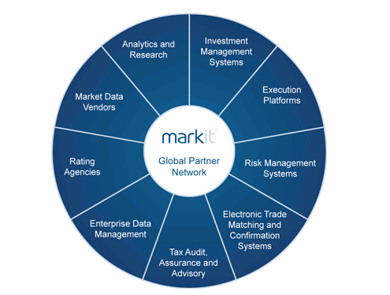
Financial information is the market foundation which must be collected, processed and accessed by regulators and all market participants

Appendix A: Market Tracking System Overview

Reference | Item heading | Item detail | Markit Comment
I Opportunity | Market Profile and magnitude | 1000 entities will be utilizing the Market Tracking System (MTS) with varying types of participants. 3 billion or more compliance instruments may be tracked by the MTS. | Markit’s Registry can handle well over 4000 account holders The volume of instruments being tracked is well within the capabilities of the Markit Registry.  Markit understands philosophically and infrastructurally that to have the necessary impact, climate markets must have scale and that therefore, the underlying technology supporting the markets must be capable of supporting the growth to scale. Therefore, the volumes required by the ARB are well within Markit’s capacity.
 | Efficient and effective market oversight services | Transparency, oversight, compliance and enforcement are vital functions. Need access to comprehensive, current and historical data (specific and aggregated) | As noted above, Markit’s core business centers around enhancing transparency, reducing risk and improving operational efficiency in financial markets. Therefore, our tools are designed to provide access to data that is critical to maintain an effective and efficient market.  Markit confirms that ARB would be able to access comprehensive current and historical market data including aggregated market data as well as disaggregated, time-stamped, entity and trade-specific, transactional and positional data.
 | Transparency in market operations | Access to market data. | As outlined above, Markit’s tools are designed to provide access to data that is critical to maintain an effective and efficient market. At the heart of an efficient market is post trade market data, particularly in an environment where much trading will take place initially Over-The-Counter.  Markit confirms that ARB would be able to access market data in the primary, secondary, and derivative markets related to the trading of compliance instruments and contracts.
 | Existing ARB administrative systems | ARB has some established components, namely an emissions reporting and verification mechanism and established regulatory enforcement procedures. | We understand that these established components do play a vital role in the overall system that ARB will have in place. Furthermore, we believe there is an opportunity for the data in this inventory to track through to the MTS so that account holders, regulators, members of the public, market analysts and commentators can all ascertain the status of each regulated entity (if desired by the ARB). See section 3 for further information.
II Project Goals |  | Markit full supports the MTS preliminary project goals which in short appear to be:  - Transparent  - Regulated  - Functional  - Efficient  - Ready for deployment | Both locally in the US and internationally Markit is recognised as a key player in early stage market establishment. We are an active contributor to the critical debates shaping each of the markets in which we participate (references available upon request) and we have taken a particularly involved role in contribute to the debate of the evolving compliance and voluntary carbon markets.  Based on our participation in these dialogues, we would suggest that some other preliminary project goals could be:  - Liquid (willing pool of sellers and buyers able to access each other together with active financial market participants helping provide liquidity and capital)  - Effective (the market helps find abatement at lowest cost)  - Scalable (processes, tools and infrastructure are not idiosyncratic and able to be applied and scaled up across California, and other states and regions across the US as applicable)
 | Transparency | Post trade transactional data | Transparency is key to confidence and successful markets. Whether traded Over-The-Counter or on exchange, transacting in commodities and other financial products needs to be transparent in order to ensure the market has sufficient information and confidence to participate.  Markit confirms that the MTS would be able to collect and record (or be capable of linking using standard markets infrastructure to selected trading facilities to collect and record) pre and post-trade transactional data.  Core to Markit’s business model is accurate, timely data delivery to the market. The MTS if operated by Markit would provide timely and accurate information to market participants and the public.
 | Regulated | Trade data collection for oversight agencies | Markit has experience working with regulators and regulatory framework and currently operates environmental registry services for US regulators (US Fish & Wildlife Service for conservation banking).  Therefore, Markit understands the importance of being able to access registry data to enable instrument tracking and administration by regulators.  Markit has created a tailored log-in facility which could easily be extended to support substantially more data collection, reporting, record-keeping and audit features for oversight agencies.
 | Functional | User accounts and compliance instrument tracking for the cap-and-trade program | Markit has over 500 customers with accounts on the Registry at present all of whom have user accounts, secure passwords, and the ability to manage their various assets across a master/sub-accounting structure.  While Markit operates these accounts for the customers and standards bodies currently, these accounts could be operated and / or accessed by ARB as part of its cap-and-trade scheme administration.  The Markit Registry is designed to serve exactly as outlined in this RFP i.e. to be an electronic depository for all authorized instruments held by market participants enabling access, retrieval, reporting and storage of all key documents and instrument information.
 | Efficient | Leveraging existing platforms, low cost program | Operational efficiency is about reducing time, paper and costs. Markit’s tools are all aimed to increase efficiency and speed up market participation while keeping costs to a minimum. Markit currently automates, to the extent possible, market registry, trade data repository, and public reporting of market information. We aim to leverage existing platforms – both technological and institutional – where appropriate and economical and create new platforms where necessary.
 | Ready for deployment | Aligned with legislative deadlines and operational by January 1, 2012 | The Markit Environmental Registry has a comprehensive platform enhancement plan to ensure that the most flexible, robust and updated infrastructure is applied to the environmental markets. Therefore, Markit will be more than able to have the ARB system in operation aligned with legislative and regulatory deadlines, including being fully operational by January 1, 2012.
III System Functional Concept | Market Registry Functions | a. A system for qualification and registration of market participants | Markit already has such a system in place including Know Your Client and ID checks. We would be happy to extend these checks to include those necessary under Californian legal requirements.
 |  | b. A system of accounts and registry access for all registrants | Accessing the platform in a secure (user and password) is an inherent part of all Markit platforms including the Registry. The ready-built Registry meets the stated needs.
 |  | c. A method to regularly create compliance instruments (offsets and allowances) in the registry. ARB would create billions of compliance instruments that would be serialized according to a standard format | Credits and Allowances (and any other potential future environmental asset) can be created in the Markit Environmental Registry.  Applying a unique identifier to these is in-built into the Registry technology. These serial numbers can be set up to be automatically formatted to the requirements of ARB.
 |  | d. A process to allocate compliance instruments to account holders per Executive Officer direction and authority | We have researched allocation of instruments and understand the high level requirements.  Given our existing regulatory log-in functionality and our research in this area, Markit believes it can easily create an efficient and effective system to support the allocation process of compliance instruments to account holders.
 |  | e. A connection to auction platforms to update the registry with auction results. | Markit has established connection to regulated trading platforms and works today with many auction houses (including World Green Exchange and Climex).  In addition, Markit offers auctioning capacity in other asset classes and can provide stand alone auctioning capacity and connectivity to auction platforms (assuming standard messaging is used) as needed.
 |  | f. A connection to existing emission reporting databases to receive emissions data | Markit has already established connection to an emission reporting databases and therefore connectivity to subsequent platforms (assuming standard messaging is used) could be easily facilitated.
 |  | g. The ability to update account holdings and information from clearinghouses, both secondary market and derivative data | Markit Registry has already established connection to regulated trading and settlement platforms and together with Markit’s broader connectivity to financial markets platforms, the ability to update account holdings and information from clearing houses could be easily facilitated.
 |  | h. A mechanism for both registrants and administrative agencies to move allowances among accounts through automatic and manual transfers | The Markit Environmental Registry has full transfer facilities in the core infrastructure. This includes manual and automated mechanisms to move allowances among accounts.
 |  | i. A mechanism to surrender or voluntarily retire compliance instruments | The Markit Environmental Registry has a full Retirement facility in-built into the core platform.  Markit invested heavily in the Rules of the Registry which ensure rigor is applied to all aspects of registry use including retirement. It is critical that Retirement ensures the permanent legal removal of assets out of circulation. Please refer to our Rules of Registry for more information.
 |  | j. The ability to limit or restrict allowance transfers or surrenders by including regulatory requirements in the system (e.g. a limit on number of offsets surrendered). | When implementing registry services for any regulated or standards body Markit works alongside that organisation to ensure that all rules and processes needed are implemented. This will include any limitations or restrictions that ARB requires.
 |  | k. Scalability to support large numbers (1,000,000+) of potential system registrants. | On acceptance of the Markit proposal, Markit commits to providing the desired scalability and support for 1,000,000+ potential system registrants.
 |  | l. Scalability and information sharing features to support California linkage with WCI, national and regional trading programs, and external offset crediting systems. | Markit is already working with a number of regional and national trading programs and external offset crediting systems both in North America and further afield. Core to this work is a clear vision of the various inter-registry and interconnectivity requirements necessary for trading markets to reach scale. This needs to be balanced with trade restrictions and credit /allowance fungibility across national and state/provincial boundaries.
 |  | m. Reliable, secure, real-time communication with the clearing and settlement processes of relevant secondary and derivative markets, including electronic confirmation service providers or other sources of OTC derivative transaction details. | Markit has an agreement with the Bank of New York Mellon for the provision of clearing and settlement services to Registry clients. Markit will work with ARB to ensure that relevant automation and connectivity is provided establishing such communication with the clearing and settlement processes of relevant secondary and derivative markets, including electronic confirmation service providers or other sources of OTC derivative transaction details.
 |  | n. Administrative features available to ARB and other agencies (CFTC, SEC, etc.) to maintain regulatory and administrative control of the Market Tracking System, including the compliance instruments and the accounts held in the registry | Markit currently operates all registry systems for the standards for which it lists credits. However, Markit’s system could be extended to enable ARB (and other regulators and agencies) to have necessary administrative features in order to maintain regulatory and administrative control of the MTS, including the compliance instruments and the accounts held in the registry i.e. Markit could operate a full service MTS for ARB, or a ‘white label’ service whereby ARB and others had the requisite administrative features available to them.
 | Transaction Recording Functions | a. Recording all transaction details related to the auction, allocation or trading of compliance instruments. | The Markit Environmental Registry will provide the recording of all transaction details related to the auction, allocation or trading of compliance instruments.
 |  | b. Collecting transactional details (position and trade data) for all derivatives and over-the-counter (OTC) derivative contracts whose value is contractually related to the value of compliance instruments. | Markit currently provides these services for numerous asset classes.
 |  | c. Maintaining a detailed ownership record of allowances, offsets, physically-settled derivative contracts on compliance instruments, and related OTC derivative contracts. | Markit currently provides these services for offsets, which can also be extended for compliance instruments except for physically-settled derivative contracts. We would note that ownership records of physically-settled derivative contracts are usually maintained by the relevant clearing house.  In addition to the requirements outlined, Markit has a world-leading product known as a Pending Issuance Unit that enables tracking of forward sales of units that represent credits yet to be issued. This is facilitating substantially increased tracking of the forward market.
 |  | d. Recording transaction details needed to link California’s cap and trade program to WCI, national and regional cap and trade programs, including external offset crediting systems | Markit is working with a number of regional and national trading programs and external offset crediting systems both in North America and further afield and included in these discussions is the likelihood of trading program linkages and the roles and opportunities that a registry can provide to facilitate this linking.
 |  | e. Scalability and information sharing features to support California linkage with WCI, national and regional trading programs, and external offset crediting systems. | Further to the above point, in its work with the regional and national trading programs and crediting systems, scalability and the necessary information sharing features are a core component of any deliverable.
 |  | f. Reliable, secure, real-time communication with the trade confirmation processes of relevant secondary and derivative markets | Part of Markit’s core business offerings is trade confirmations and therefore much of this communication is already in place.
 |  | g. Record keeping of the retiring (surrender) of compliance instruments by market participants | The Markit platform provides full record keeping of all financial instruments it holds on behalf of market participants.
 |  | h. Provide transaction data to enable market oversight agencies to conduct price mitigation operations | Markit has transaction data recording mechanisms in place.
 |  | i. Provide transaction data to enable market oversight agencies to conduct market oversight and enforcement operations | Markit provides a multitude of transaction data services across multiple financial asset classes to enable market oversight to conduct market oversight and enforcement operations.
 | Market Data Reporting Functions | a. Provide carefully coordinated public disclosure of timely and accurate information regarding market participants’ compliance activities through web based or other standard reporting mechanism | Markit infrastructure is built to provide web based public view screens for full environmental asset market information. Markit will work with ARB to ensure the provision of required public disclosure in an effective and timely manner.
 |  | b. Provide carefully coordinated public disclosure of timely and accurate information regarding the attributes, status, and market value of compliance instruments through web based or other standard reporting mechanism. | Markit infrastructure is built to provide web based public view screens for full environmental asset market information. Markit will work with ARB to ensure the provision of required public disclosure in an effective and timely manner.
 |  | c. Public reporting of California offset credit verification, approval, retirement and trade relating to market participants and external programs. | Please refer to http://www.markitenvironmental.com/aboutpublic.php and then click on an appropriate link as an illustration of the information which Markit currently provides publicly to report credit verification, approval, retirement and transfer information relating to listed credits and participants.
 |  | d. Coordinated distribution of the above information to electronic information distributors and news services. | Markit has a full suite of services to provide appropriate distribution of necessary electronic information and news. This includes an Environmental portal (or desktop) on which users can have information and news automatically distributed.
 |  | e. Provide standardized and ad-hoc reporting for State and Federal oversight agencies. This includes information on registrants, account holdings, and transaction/position details. | Markit provides a range of reporting functions (standardized and ad-hoc capability). We would be pleased to work with ARB to ensure that all reporting requirements are met.

Appendix B: Additional System Design Considerations

Reference | Item detail | Markit Comment
I Forward Compatibility | Smooth integration with infrastructure supporting external and Federal markets  Direct links to electronic confirmation service providers to OTC derivative markets e.g. ICE, MarkitServ | Markit has met with Federal bodies across North America and other internationally recognized trading schemes as well as the other existing and burgeoning emission trading schemes i.e. such as the EU ETS and Environment Canada.  The primary purpose of these discussions is to ensure our understanding of each platform and offer maximum integration, information, alternatives and solutions to ensure the streamlined and singularity of credit and allowances tracking and transfer on registries and tracking systems, as well as facilitating reporting and access to trading platforms and clearing systems.  Markit’s expertise and leadership in OTC derivative markets means that as a business Markit is deeply integrated into a broad range of financial instruments and transactions that will flow from wide participation in the market ARB will be establishing. Together with Markit’s strong market position in electronic trade confirmation (via MarkitServ, its proprietary product with DTCC), Markit has full capacity to support direct links to facilitate electronic trade confirmation.
II Network Connections | Support participation in the CA emissions market by major banks, brokerage firms and investment banks by leveraging financial data processing standards  Accepting and disseminating information from greenhouse gas reporting tools | As noted above, Markit’s client base includes the most significant institutional participants in the financial marketplace. We maintain leading financial data processing standards and our infrastructure would certainly support and enable participation in the CA emissions market by major banks, brokerage firms and investment banks by leveraging financial data processing standards.  When entering new markets, participants always have to assess and bear a high cost of new infrastructure connectivity (internal and external) and in many cases new untested infrastructure can cause delays in market ignition. With many of the major banks and utilities already connected to many of Markit’s tools and infrastructure, these costs will be reduced, barriers to entry will be lower and the market can ignite earlier and with greater participation than in a launch with new untested tools without any existing connected network.  We understand and agree that accepting and disseminating information from greenhouse gas reporting tools would be a fundamental requirement of the MTS. Core to Markit’s data businesses is the acceptance, collation and dissemination of information to the marketplace and this can easily be applied to the MTS for ARB.
III Data Communication and Security Standards |  | Markit is committed to providing the highest standards of data communication and security for our customers and regulators of the various markets.
 | a. Security and Privacy | Markit maintains an Information Security Policy, which addresses but is not limited to:  - Identification and authentication requirements  - Access control and authorisation requirements  - Secure communication for confidential, proprietary, data privacy  - Physical access control  - Computer incident response  - Patching, Anti-virus and Anti-Spyware  - Compliance.  Markit Environmental Registry is implemented as a fully authenticated system, with encrypted user credentials stored in a centralized location with restricted access.  All passwords are encrypted and are visible only to the authenticating party.  Currently, all client-related sensitive documentation is encrypted using GPG encryption software.  During client on-boarding process, registry implements full KYC check cycles.  The Registry implements tiered authorization mechanism, with every layer having access to a specific system sub-component.  Current authorization system supports the following tiers of access: regulator view, client’s view, operation’s view and administrative view.  Markit would willingly work with the CA regulators to understand the nature of security and privacy considerations required by the State of California information policies and standards and implement appropriate security and privacy procedures accordingly.
 | b. High degree of flexibility and security for management of sensitive information including:  - Ability to accommodate multiple industry-standard electronic trade record message formats, such as FpML, SWIFT, FIX, and XML.  - Ability to develop and operate a secure standardized process for registering (“onboarding”) new participants; including establishing User IDs, connectivity, security checks etc.  - Ability to maintain a very high standard of data security and privacy, including ongoing programs of monitoring and threat response.  - Demonstrate that the data will be secured from external attack.  - Ability to support high volumes or a high volume of secure file transfer via the Internet, and to develop/maintain secure internet graphical user interface.  - Ability to comply with applicable anti-terrorism (OFAC) and anti-money laundering standards.  - Ability to establish high-throughput, two data communications with firms using messaging middleware and private lines.  - Ability to operate registry and transaction data recording on redundant, physically secure information processing hardware, and assure disaster recovery in hours or less.  - Ability to link to existing electronic confirmation services such as ICE eConfirm, ConfirmHub, MarkitServ, and EFETnet. | As noted above, given Markit’s expertise in providing fully integrated technology solutions for other asset classes, with products such as MarkitServ, Markit Connex, Market Document Exchange, Markit Environmental Registry is well positioned to build out electronic connectivity to exchanges and settlement houses going forward, adhering to existing industry standards in inter-process communication protocols, such as FpML, XML, SWIFT, FIX.  Markit already has secure “onboarding” systems in place and these already include;  - online application forms, document uploads and communication mechanisms  - corporate and person ID checks, security and Know Your Client checks  - establishing User IDs and passwords for all users  - preparation of user guides and user assistance materials, user training  - communicating account information to users  - testing and ensuring connectivity.  Markit also has in place robust rules of registry prepared by one of the top climate change law firms in the world, Baker McKenzie.  The Registry is implemented as fully secure, scalable and fault-tolerant system. All servers are protected by firewall with restricted IP addresses from outside world.  Markit Environmental Registry provides services registry services for participant firms and institutions, including world renowned project developers as well as large financial institutions. Therefore, security of data and privacy protection is paramount in our operations.  Markit maintains commercially appropriate levels of monitoring, threat response, encryption and other security standards.  As noted above, Markit’s expertise and leadership in OTC derivative markets means that as a business Markit is deeply integrated into a broad range of financial instruments and transactions that will flow from wide participation in the market ARB will be establishing.  Markit Environmental Registry is extremely well positioned to leverage its existing highly recognized MarkitServ product as part of the MTS. MarkitServ is a joint venture between DTCC and Markit, that confirms counterparties, amounts, prices and carbon credit/allowance specifics electronically.  Together with Markit’s strong market position in electronic trade confirmation via MarkitServ, Markit has full capacity to support direct links to facilitate electronic trade confirmation  Markit is an industry leader for the wide variety of technology solutions and can assist the ARB by providing a secure and fully functional market tracking system.
IV Vendor Experience |  | Markit has demonstrated in this RRFI that the Markit Environmental Registry together with the full breadth of existing products, services and expertise offered by Markit qualify it to support the ARB in designing and establishing the MTS. Further evidence of our vendor experience is set out below.
 | a. building and providing shared registry and data repository services | Markit Environmental Registry provides services for large international standard bodies, such as a Voluntary Carbon Standard and provides registry and data repository services for participant firms and institutions, including world renowned project developers (EcoSecurities, BlueSource) as well as large financial institutions, such as Credit Suisse, JPMorgan, etc.
 | b. managing and satisfying diverse stakeholders | Markit is an active contributor to the critical debates shaping each of the markets in which we participate. Therefore, we engage on a daily basis with policy-makers, regulators (in both financial and environmental markets), project developers, project investors, financial market institutions, non-profits and corporations from all over the world to help shape and facilitate transparent and efficient environmental markets.  Equally, as the Registry extends into water and biodiversity markets as well as carbon markets, we work closely with diverse stakeholder groups in the US, developing infrastructure for government agencies and regulated community groups, such as US Fish & Wildlife, Army Corp of Engineers, and state based departments and Environmental Protection Agencies.
 | c. building and operating post-trade processing infrastructure for traded markets | Markit Environmental Registry is extremely well positioned to leverage existing highly recognized MarkitServ product. Markit also offers a wide range of infrastructure to assist with pre and post-trade processing for traded markets. See section 4 for further information.
 | d. existing assets | Markit is an industry leader for the wide variety of technology solutions.
 | e. ability to successfully scale up registry and repository functions to handle high transactional volumes | As noted above, Markit’s Registry can handle well over 4000 account holders and the volume of instruments being tracked is well within the capabilities of the Markit Registry. Markit understands that to have the necessary impact, climate markets must have scale and that therefore, the underlying technology supporting the markets must be capable of supporting the growth to scale.
 | f. maintaining transaction records for OTC derivatives that provide record-keeping, reporting, payment calculation and netting services | As mentioned above, Markit’s product MarkitSERV has proven to be very successful in this space. MarkitSERV offers real-time connectivity that standardizes complex post-trade workflows for trade confirmations and clearing on T+0. Advanced workflow tools allow you to confirm and clear on trade date which significantly reduces operational costs, while at the same time mitigates risk beyond market risk. The service increases client’s ability to track trades electronically through notifications, enabling them to easily manage trade flows across life-cycle events, asset classes and third party processing platforms. MarkitSERV offers tools to get clients through the entire trade life-cycle process – allocate, confirm, cancel, exercise, novate, clear, reconcile and dispute – with notification of trade status tracked in real time.
 | g. ability to access all trade data at the position level, run ad hoc/standard surveillance inquiries and reports on market activity, position concentrations and risk management | Markit Environmental Registry can leverage existing Markit products that are available in other asset classes. Markit is a leading provider of data and pricing products and services for other asset classes that are used by key financial institutions globally, to help them monitor risk, mark-to-market and develop accurate forecasting services. These services include:  Markit Valuations Manager – A valuations management tool that simplifies the delivery and collection of counterparty position data and valuations across both over-the-counter derivatives and cash instruments.  Markit Totem – A monthly sell-side benchmarking service used as the key independent check of trading book valuations by leading global banks, trading houses and other investment professionals. The structured credit service provides a ‘hands-on’ review on correlation and volatility products.

Appendix C: Cap-And-Trade Market Flow
A registry such as Markit Environmental Registry that is fully integrated within OTC and exchange traded market infrastructure can provide a systemic solution between government departments (state and federal and policy departments as well as regulatory agencies) thereby reducing the silos that can exist across agencies despite that they have shared objectives and statutory motivations.
We would suggest that perhaps the Cap-and-Trade Market Flow Diagram extend to other government agencies (whether state or federal) enabling effective credit and allowance tracking, oversight and inter-agency communication. We would also suggest that your diagram incorporate some of the additional suggestions made in sections 3 and 5, namely:
- Regulator log-in and access to the MTS (outlined in section 3)
- Master account / sub account structure for regulated entities and market participants (not just holding and compliance accounts) (outlined in section 3)
- Connectivity to clearing houses and custodians to enable Delivery Versus Payment for transactions (outlined in section 3)
- A requirement for counterparty identifiers (outlined in section 5)
- Efficient trade processing (outlined in section 5)
- Primary and secondary market pricing data (outlined in section 5)
The following diagram provides a high level depiction of some of the various roles for a financial markets Registry such as Markit within the broader MTS and may assist the ARB with its Draft Design diagram:

Appendix D: Additional Information and Resources
Should ARB require further information on Markit, existing systems that are similar to the MTS, products that are directly relevant to the success of the MTS and the market underlying it or our global partner network, please see:
- The Markit website: www.markit.com
- The Markit Environmental Registry website: www.markitenvironmental.com

Markit Group Ltd Disclaimer

Opinions, estimates and projections in this report constitute the current judgment of the author(s) at the time of writing. They do not necessarily reflect the opinions of Markit Group Limited. Markit Group Limited has no obligation to update, modify or amend this report or to otherwise notify a reader thereof in the event that any matter stated herein, or any opinion, projection, forecast or estimate set forth herein, changes or subsequently becomes inaccurate.

Markit Group makes no warranty, expressed or implied, as to its accuracy, completeness or timeliness, or as to the results to be obtained by recipients, and shall not in any way be liable to any recipient for any inaccuracies, errors or omissions herein.

Without limiting the foregoing, Markit Group shall have no liability whatsoever to a recipient of this report, whether in contract (including under an indemnity), in tort (including negligence), under a warranty, under statute or otherwise, in respect of any loss or damage suffered by such recipient as a result of or in connection with any opinions, recommendations, forecasts, judgments, or any other conclusions, or any course of action determined, by it or any third party, whether or not based on the content, information or materials contained herein.

Copyright © 2010, Markit Group Limited. All rights reserved. Any unauthorised use, disclosure, reproduction or dissemination, in full or in part, in any media or by any means, without the prior written permission of Markit Group Limited is strictly prohibited

