

June 10, 2010

Andrea Sutton  
Air Resources Board  
Office of Climate Change  
1001 I Street, P.O. Box 2815  
Sacramento, CA 95812

Response to Request For Information (RFI) # 09-114

Dear: Ms. Sutton

I am pleased to submit this proposal on behalf of Trinity Technology Group to provide information regarding IT support services in response to Request for Information (RFI) #09-114 The Cap & Trade Market Tracking System.

We commit to fulfilling all functional and technical requirements of the RFI. To fulfill this commitment, we have carefully reviewed the RFI to understand the scope, depth, and burden of all responsibilities.

Based on this understanding, our firm has proposed a solution and we possess the experience and skills necessary to fulfill the requirements. I am authorized to bind our firm contractually.

Sincerely,

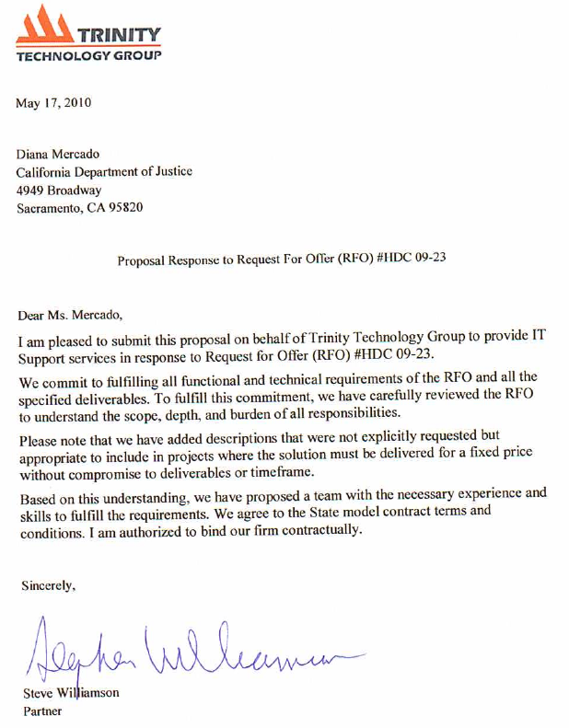

Stephen Williamson, Partner

916-213-4358

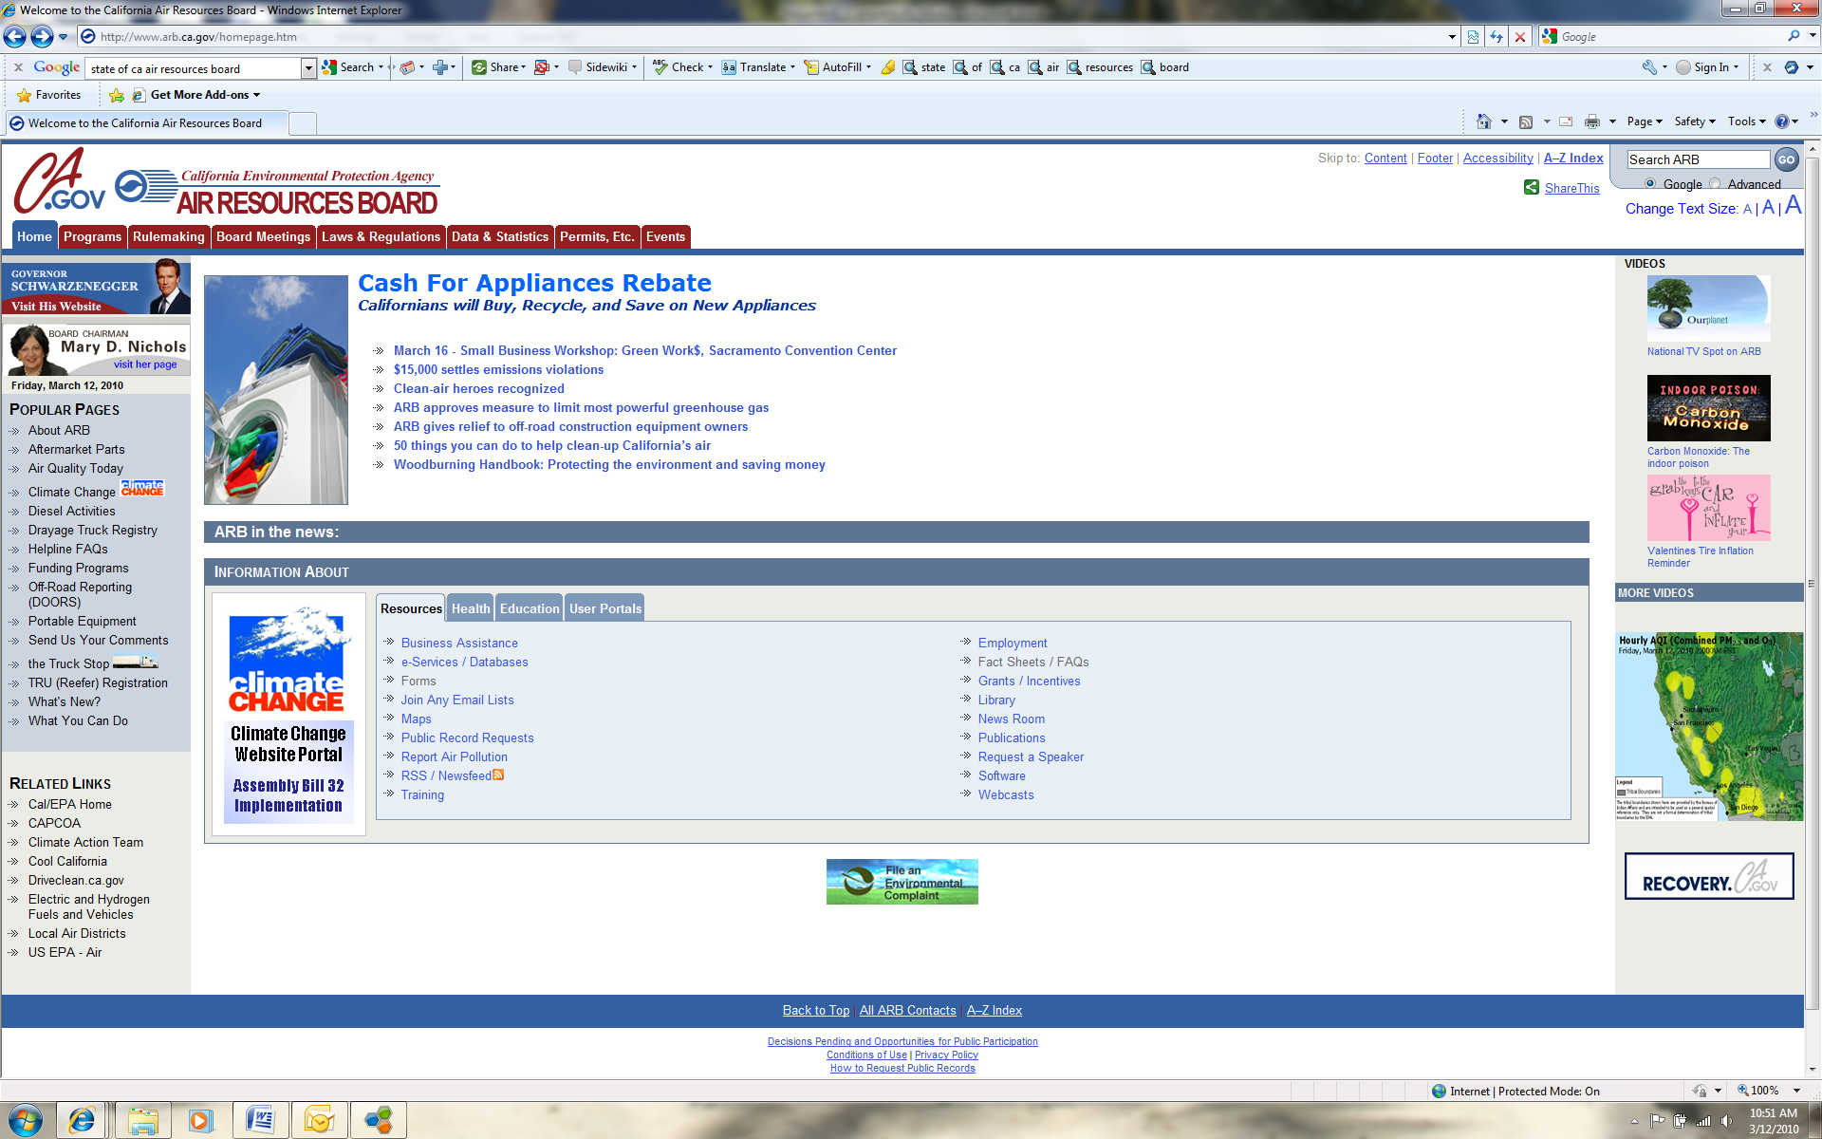  
  
**RESPONSE TO REQUEST FOR INFORMATION  
RFI #09-114**

**For:**

**The Cap & Trade Market Tracking System**

**Prepared and Submitted by**

.

June 10, 2010

**Contents**

Firm Overview and Capabilities 1

Our Approach 1

Our Projects 2

Functional Concept Feedback 4

Account Management 4

Accounting Platform 4

Data Interfaces 5

Business Rules Management 6

Reporting 6

System Design Considerations Feedback 8

Technical Architecture 8

Physical Architecture 9

Software Architecture 10

Usability 11

Cost and Timeframe Considerations 12

Other 14

Firm Overview and Capabilities

Trinity Technology Group provides enterprise technical architecture planning, business process analysis, custom software development, and end-to-end system integration services for departments such as the Office of the Chief Information Officer (OCIO), California Public Employees’ Retirement System, Department of Health Care Services, Department of Justice, Department of Water Resources, and the Bay Area Air Quality Management District (BAAQMD) among others. We leverage our technical expertise and wide industry experience to deliver successful solutions for all of our customers.

Experience means hands-on project management, business analysis, technical architecture, design and development, testing, change management, implementation and maintenance skills and lessons learned. Consulting skills means understanding our role, knowing how to communicate effectively with client and vendor staff, timely participation, clear writing, preparing and delivering presentations to management and stakeholders, technical staff, and subject matter experts. We hope you will see that our track record of successfully delivering solutions demonstrates we bring not just textbook knowledge but practical insights to making the defined approach work when unique challenges arise.

Our Approach

All our solutions follow a disciplined approach to business analysis and functional specification that emphasizes examination of business processes across organizational boundaries to properly understand the supply chain from customer request to service delivery. This formal analysis reveals opportunities to improve the process and verifies a shared understanding and commitment across the project’s business sponsor, subject matter experts, technologists and those involved in funding and implementation.

We started as specialists in breaking apart monolithic mainframe systems into components that could be readily re-used to enable self-service by external customers over the web or telephone to perform actions previously restricted to hardwired internal staff. This allows our customers to “build once and deploy multiple ways” to speed delivery to customers and avoid high ongoing costs to maintain multiple versions of the same functionality.

We now design and deliver “end to end” solution that combine new components for newly required functionality with a rich internet experience for customers and interaction with the existing systems of our clients and their external business partners. Our emphasis upon enabling future re-use based on open standards eliminates the risk of silos of functionality that are hard to penetrate or unable to reach across the diverse technologies found throughout the enterprise.

Our Projects

Solutions we design and implement in partnership with our clients integrate accounting systems, investment portfolios, live data feeds such as Bloomberg stock prices, criminal justice systems, health enrollment and health claims adjudication, grants management and a range of other case management needs, industry data standards such as SWIFT for stock trading and EDI X.12 for HIPAA compliance, content management systems and Google maps for reporting. In addition we turn geo-coded data into web services to enhance accessibility and work with ESRI to integrate them with GIS for geospatial data analysis and with SAP and other enterprise systems.

Success in the Field

“On November 11th (2005), the Legacy Enrollment Database and its associated "backbridge" process were decommissioned. For those of you who have lived the pain of reconciling data discrepancies between COMET and the legacy systems, the significance of this achievement is huge! The solution went into production seven weeks ahead of schedule and well under budget (**the budget was originally estimated at $4-5 million, but delivered for only $1.2 million**) **and** **the ongoing annual savings to CalPERS is estimated at $500,000 - $700,000.** However, the greatest benefit to this project is that we've eliminated a major source of our data integrity and redundancy problems.”

We provided both enterprise technical architecture guidance and the middleware “glue” that enabled CalPERS to make legacy functionality available to the award-winning myCalPERS website. This solution provides web customers a rich suite of pension and health benefits functionality that formerly was unavailable as it resides within legacy systems that were disconnected from one another and from the web. (We also designed and built the web services and "wrappered" the functionality in the legacy systems that enabled the middleware).

In 2009 we provided the Bay Area Air Quality Management District with a grants management system designed specifically for the Carl Moyer program, providing funding for replacement/retrofit of high emission devices. In early 2010 we developed a business object model and rules workflow to automate the permitting and licensing of emission generating organizations in the Bay Area.

The sex offender registration system for the Department of Justice combines a web-based solution for law enforcement agencies with interfaces to fourteen internal and external systems ranging from fingerprints to drivers licenses to tax records.

By mid-2010 over twenty percent (20%) of California’s $38 billion Medi-Cal program will use payment systems built by Trinity. These payment systems require integration with MEDS for beneficiary eligibility, over 30 million claims in the history file to identify duplicates, provider files, a business rules engine for hundreds of claim eligibility and payment decisions and business rules, accounting systems in other departments; and implement all HIPAA-required transactions to full SNP Level 7 for claim submittal, inquiries, explanation of benefits and capitated payment remittances.

But our previous experience is only part of our value proposition. Our clients also benefit from:

* Highly talented and creative technology professionals with a proven track record of delivering solutions
* Disciplined but collaborative project management that engages the client and controls scope
* Business process-driven approach to defining solutions that work across organizational boundaries
* Software development practices emphasizing component re-use, industry standards, and our own developer’s workbench for faster delivery, lower current and future cost of ownership , and greater future adaptability.

Functional Concept Feedback

To better analyze the market registry and data reporting functions of the proposed system, Trinity has defined a series of functional modules that group together the major activities. In general, ARB can expect such a system to include:

* Account Management – a module that allows organizations to securely register for system access and define account information while limiting access to system functions based on a set of defined security roles
* Accounting – the core module of the system, this would be responsible for managing and tracking an organization’s offsets and allowances, not only within an organization but across organizations based upon the unique serial number of the compliance instrument
* Data Interface – a layer that is responsible for managing the transfer of real time and/or batch data with clearinghouses or other financial institutaions
* Business Rules Management - a mechanism to control configurable business rules such as offset limits, fee schedules, etc.
* Reporting – a module that allows for the generation of business intelligence data, either through predefined reports or the ability to create ad-hoc reports

In the following sections we discuss additional insights about each of these modules, including suggestions and, where applicable, samples of other systems with similar functionality.

Account Management

An account management module focuses on participant registration, defining access based on roles, and storing participant information that is needed for the system’s functionality. Account management is a standard component of just about any custom built or Commercial Off the Shelf (COTS) product.

Environmental business transactions often involve a combination of organizations and agencies. These may include business partners, third party representatives, or sub-contractors with an ownership interest in a transaction or instrument. If these types of relationships may exist with organizations participating in cap and trade, then Trinity recommends including that fact as part of the system requirements or functional business process description. It will be important to define how ARB expects to manage these relationships as it will drive the design of the account management module. For example, the system could be designed to have organizations manage all the information of their business partners themselves. Conversely, ARB could decide that all entities must individually register, which changes the flow and functionality of the account management module.

Accounting Platform

The accounting platform will be the heart and soul of the MTS, responsible for registering compliance instruments, tracking transactions, and summating offsets and allowances. While Trinity’s current portfolio of systems does not include a tailored cap and trade market tracking system, we do understand what it takes to build such a module. Trinity believes that ARB would be better served by custom building a system that meets the unique needs of the cap and trade market management sought in California. This recommendation is based on several analysis points:

* An early study conducted in Oregon in 2006 identified several existing registries, including software in the public domain from EPA. Our experience in working with many state agencies in California is that the state’s business and technical requirements often require significant customization of any COTS or transfer system. For example, it is difficult to ascertain the scalability of such products, and often many COTS products are “choked” by the scale of California data. By contrast, a well managed custom development effort can actually be cheaper than trying to shoehorn an incompatible or insufficient product into a set of system requirements.
* The accounting platform will be heavily dependent on the data interface layer, from which all the market trading data is being brought in. This virtually guarantees that any transfer product would require major customization in order to support interoperability with a variety of trading and/or accounting systems.

Below Trinity has provided samples of a similar kind of accounting function that was custom-built for a grants program. In this example, a series of funding sources are defined in the system, which provides accounting for balances. This is similar in concept and presentation to the definition of compliance instruments, and how an account balance for an organization could be managed.

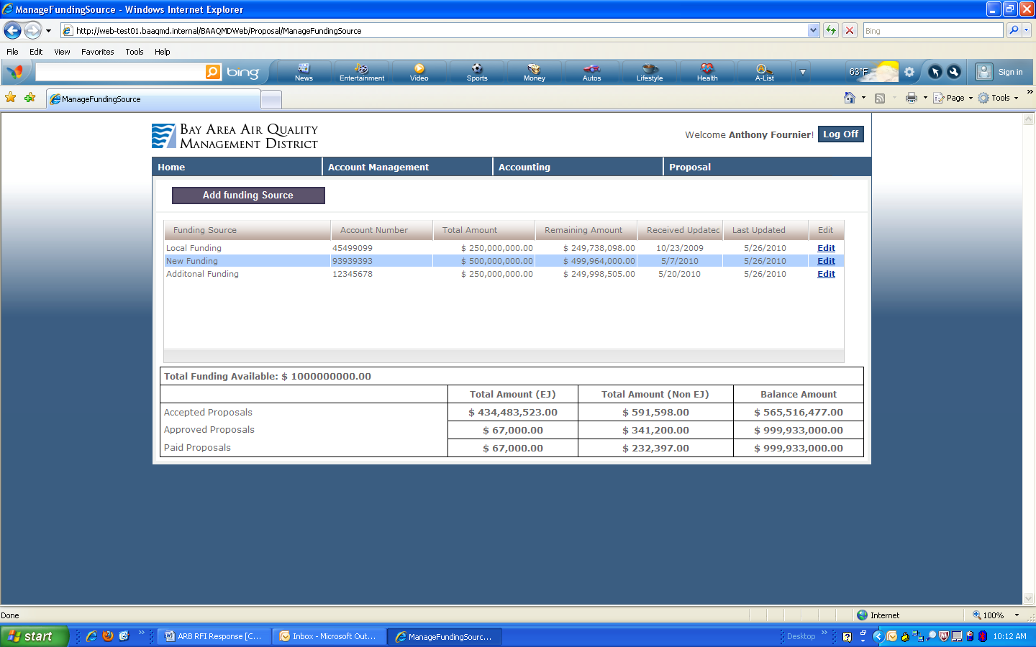

This sample also reflects a potentially important function, in that transactions will have several intermediate states, such as “pending”. The MTS would need to keep these separate from fully completed transactions, as pending transactions would impact allocated allowances, but should not count against them until the transaction is complete.

Data Interfaces

The RFI notes several potential data interface partners for the MTS. These data partners will be key in determining what kind of data is available and what the MTS can display and manage. Trinity recommends that ARB provide as much specificity as possible in terms of what data sources they are expecting to integrate with. The major areas of detail include:

* The identification of specific data interfaces and/or sources that ARB will require
* The availability of that data to ARB, particularly if there are any transaction fees involved
* The interface method(s) available for those data source (i.e. web services, extracts, XML, etc.)
* Data models or file layouts that demonstrate what data is being sent from the interface partner

The number and potential complexity of data interfaces will impact both cost and schedule of the project, making this area very important in terms of identifying the data requirements and potential data sources.

Business Rules Management

The functional concept included the need to manage regulatory rules, such as allowance limits. This implies a need for functionality that allows ARB staff to configure and manage a defined set of business rules. Below is a sample of this kind of functionality from a grant management system for an emissions program.

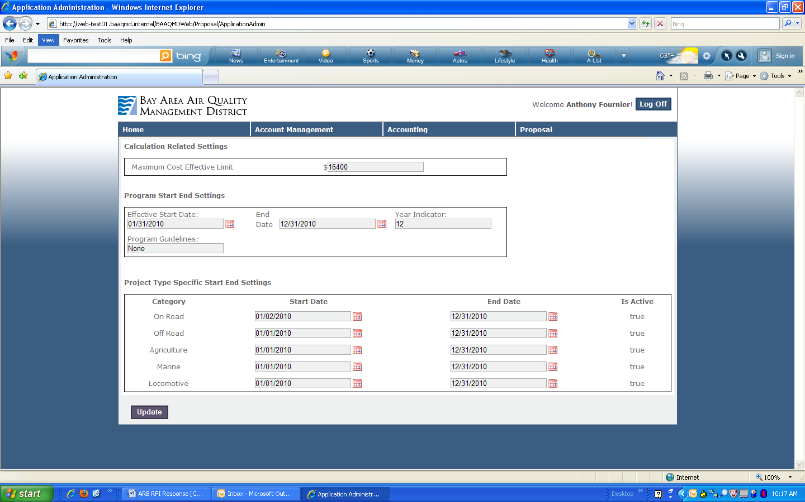

To provide ARB with the necessary configuration capability, the functional requirements will need to be specific in terms of what rules will need to be managed on an ongoing basis. This will drive the design and complexity of any administration consoles or similar functionality in the system.

Reporting

The functional concept mentions the ability to generate ad-hoc reports. There are two approaches to this kind of functionality. One approach is to provide a full-fledged business intelligence product that allows for constructing any manner of reports. While this functionality can be powerful, it requires significant knowledge and experience to operate. Specifically, a user seeking to create an ad-hoc report needs to understand the data model of the system, which is unavoidably technical in nature. So asking for this functionality very often leads to the construction of a robust reporting tool, but one that users cannot successfully navigate.

Alternatively, ARB should consider refining the reporting requirements to a series of pre-defined management reports that can be built by the vendor for your use. Not only will this be easier to use, but it will help to manage the scope and complexity of the reporting effort. Once the MTS is in production, ad-hoc reporting would be a good consideration for a future phase or enhancement, as users will be able to more accurately determine the extent of their ad-hoc needs.

System Design Considerations Feedback

In this section we provide feedback on the system design considerations, and how that potentially translates into a scalable technical architecture. We present feedback and insight on both the physical and software architectures for MTS, and also suggest an additional design consideration for ARB’s review.

Technical Architecture

Below is a conceptual depiction of a solution technical architecture. Descriptions of the various layers are on the next page.



The **Presentation Interfaces** layer conveys the idea that users should have a single point of access for related functions that they use. This might be implemented as one or more portals.

The **Presentation Integration** layerencapsulates all the presentation logic required to service the clients accessing the system. The presentation tier intercepts client request, controls flow, and controls access to business services.

The **Business Services** layer is responsible for exposing the business services in a consistent manner while enabling services to be implemented in a variety of technologies.  Ideally it should also define the standard contract for a service type, therefore allowing substitution of service implementation without affecting clients of the service.

The **Business** layer shows groupings of business functions that are built for specific purposes.  By leveraging services available in the architecture, applications should generally be quicker to develop and easier to maintain.

The **Services** layer represents the separation of re-usable services from application logic. The service layer will thus consist of services with clearly defined contracts that can be used by any application.  The services have initially been classified in to three major groupings:  Core Services for technical and basic services, administrative for services that provide access to administrative data or processes and Business Services for services specific to domains.

The **Service Integration** layer is responsible for exposing the services in the architecture in a consistent manner while enabling services to be implemented in a variety of technologies. Ideally it should also define the standard contract for a service type, therefore allowing substitution of service implementation without affecting clients of the service.

The **Security Services** layer, while conceptually similar to other types of services has been shown separately because it has significant impacts at all levels within the architecture.  It will be necessary to apply access and control security to data, to services, to applications and finally to user interfaces

Physical Architecture

Given the potential size of the user base and the volume of data being managed, the architecture of the MTS will play a role in the success of the system. Trinity recommends that ARB focuses on “ownership” of the architecture. By this we mean creating a system where ARB has the flexibility to decide how the system should be scaled initially, as well as how that scalability and extensibility should be adjusted over the lifetime of the system.

Implementing this recommendation means leaning more toward custom deployment rather than COTS product. This helps ARB avoid two major implementation risks:

* The product lacks sufficient functionality, requiring moderate to significant customizations to the product
* The product was not designed to handle large volumes of data that are typical with a large state like California, requiring a re-architecture of the product.

Trinity has had over a decade of experience in creating and implementing scalable architectures. Understanding how to segment data and application layers, integrate security, and identify load balancing are components of constructing a scalable architecture.

Following is a sample system architecture diagram from a proposed system that included requirements for integrating financial data from several outside sources:

Given ARB’s emphasis on scalability, you should expect a similar kind of architecture for the MTS. Note that this model includes load balancing of the web servers, as well as clustering of the SQL servers. Given the expected volume of data and number of users, we are assuming that the MTS architecture will need to include performance oriented designs. Of particular importance is a separate application tier to manage interoperability of the systems. Trinity has experience in creating interoperability frameworks that provide a common “language” for various data sources to use in order to properly send/receive transactions. A properly constructed interoperability tier can help to save long term maintenance costs for the system.

Software Architecture

Also key to long term viability of the MTS is how the software is architected. A well-designed system will have a business logic layer that sits between the presentation layer and database. Within the business layer, the software should be segmented into a series of re-usable components that are organized by business transactions. Examples that may be relevant to the MTS would include defining components like “compliance instrument management” or “offset accounting”, where the coded business logic is stored in a single place, but called from several different places in the application. The benefit to this approach is that any changes to the code only have to be made in one place, helping to reduce testing and deployment efforts. But the challenge is in defining the right set of components. Accomplishing this task requires staff that are technically savvy, but also have the business acumen to understand how the design or structure of an application impacts the business, such as understanding which transactions will be most frequent or being able to identify redundancies in business operations that could be streamlined in the system design. This approach to software design (and having the talent to do it) has allowed us to easily transfer components of other systems into new ones. Examples include account management modules, XML bulk upload, and business intelligence capabilities.

Usability

In addition to the technical architecture, Trinity also recommends that ARB invest some time in defining usability guidelines for the MTS. Considering the number of potential users, ARB simply will not have the time or resources to provide a full-time call center for help and assistance. Therefore, the system must be user-friendly to the point that users can navigate and interact with the system without the need for assistance. Below are some examples of design principles to consider:

* Logical, easy to navigate menus
* Screens should focus on no more than 1-2 activities
* Consistent look and feel across the system
* Filters and edits to prevent users from navigating incorrectly
* Plain English error messages

In terms of technical requirements, Trinity recommends that the ARB provide specificity on the need for ADA compliance. In our view, ADA compliance requirements have historically limited the ability to add very useful and intuitive features to the user interface. This is typically because the requirements are written for screen-reading software that is several years old and unable to handle some of the feature found in Web 2.0 presentations, such as certain AJAX controls. While we understand that ADA compliance is often an administrative requirement with state systems, we would encourage ARB to consider the clientele and determine if such a requirement will be necessary, to the extent ARB has the discretion to do so.

Cost and Timeframe Considerations

As mentioned in the functional feedback, there are several unknown factors that will play a large role in defining the cost and timeframe. In particular, the number and complexity of data interfaces will determine how robust of an interoperability layer is needed, as well as the scalability needs of the application. The scalability in turn determines the potential hardware and infrastructure costs.

Given the relative uncertainty in those areas, it would be difficult to provide a realistic estimate of time and scope, both of which drive cost. As an alternative, Trinity has provided ranges that estimate across two broad dimensions:

* Functionality – a measure of system complexity, where functional requirements and number of interfaces drive the measure of complexity
* Schedule – a measure of time, which would be driven by number of deliverables and/or possible business deadline constraints. The cost differences account for larger number of staff to complete work in a shorter duration.

Across these dimensions and within the constraints of several assumptions documented below, the following table provides preliminary estimates of the potential costs of the MTS.

|  |  |  |  |
| --- | --- | --- | --- |
| Functionality | Low | Medium | High |
| Schedule |  |  |  |
| Low (6-9 Mos) | $900,000 | $1,300,000 | $1,800,000 |
| Medium (9-11 Mos) | $1,100,000 | $1,700,000 | $2,000,000 |
| High (11-14 Mos) | $1,400,000 | $2,000,000 | $2,500,000 |

The above estimates are based on a staffing model that includes key staff such as a Project Manager, Technical Architect, and Senior Business Analyst. The staff mix also includes 3-5 developers, a Test lead and testing resource, and a Training Lead. The staffing mix is based upon staffing approaches used for similar projects, but can be scaled up/down as needed depending on the actual scope.

Assumptions include:

* The MTS can be fully developed using MS development tools, and does not require third party software products
* Estimates exclude any potential fees or transactions costs that ARB may incur with data interface partners
* A “typical” set of project deliverables are part of the project scope, with review cycles that do not exceed 5 business days. These include documents such as:
  + Status Reports
  + Project Management Plan and Schedule
  + Requirements
  + Functional Specifications
  + Design Specifications
  + Test Plan
  + Implementation Plan
  + Training Plan
* Data conversion is not required
* Estimates exclude hardware/infrastructure costs, which can vary depending on scale of the application and hosting options

In recent years we have seen many bid solicitations from State agencies that have listed between 25 and 40 deliverables each requiring its own deliverable expectation document and draft review process.  There is considerable cost associated with a work product into a deliverable that requires a formal review and approval process that must be included in the project duration and in the staffing for both the vendor and the Air Resources Board.   Our best practices based on lessons learned and industry investigation call for:

* Deliverable Expectation Documents that describes the scope, depth, and format for the deliverable and agreement upon who will perform the review and approval; at least one work in progress review that includes these reviewers; and timely review of the draft and turnaround of needed enhancements and clarifications.
* Use of a MS SharePoint-based repository for administration of project activities including project schedules and assignments, roles and responsibilities, issue tracking, risk management, action logs, status reports, change controls, project work products and versioned deliverables.

Other

Trinity Technology Group has no additional information to provide at this time.