July 30, 2026

Ms. Mary Nichols
Chair
California Air Resources Board
1001 I Street
Sacramento, CA 95814

Re: ETAAC Report

Dear Ms. Nichols:

The Association of California Water Agencies (ACWA) appreciates the opportunity to submit comments on the final report of the Economic and Technology Advancement Advisory Committee (ETAAC). ACWA consists of 450 public water agencies. Our members serve over 90% of the delivered water in California for domestic, agricultural and industrial uses.

ACWA is writing to express our concerns with Chapter 9 of the report dealing with the water sector. Our concerns stem both from the content of this section and more so with the process by which it was included. We strongly request that the Air Resources Board (ARB) defer adoption of this chapter until it can be properly analyzed and vetted.

Since the inception of the ETAAC, ACWA has been monitoring its progress on the report to provide advice and recommendations on the best technologies and policies for reducing greenhouse gas emissions in California. Just a few weeks ago we became aware of an entirely new and unexpected chapter addressing water-related energy use. We have grave concerns with how this section emerged suddenly and without any known consultation with experts in the water arena.

Despite our best attempts to review this section and submit comments within the very brief two-week timeframe provided, we were unable to do so due to the very controversial nature of certain elements; namely, the establishment of a water loading order and a public goods charge for water. These schemes are highly complex and, as presented, ill-conceived. More time and effort is needed to assess the appropriateness and accuracy of these concepts. We strongly urge the ARB to suspend action on Chapter 9 at this time.

We support ETAAC’s efforts to identify technologies and incentive opportunities to reduce greenhouse gas emissions, and we agree that water may play a role in this objective, especially through renewable energy generation. However, we cannot support a process that is done too hastily, without proper analysis or consultation, and most importantly, does not provide adequate opportunity for public involvement.

Thank you again for this opportunity to submit comments.

If you have any questions, please feel free to contact me at kristac@acwa.com or 916-441-4545.

Sincerely,
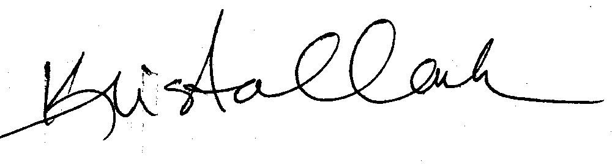
Krista Clark
Director of Regulatory Affairs

