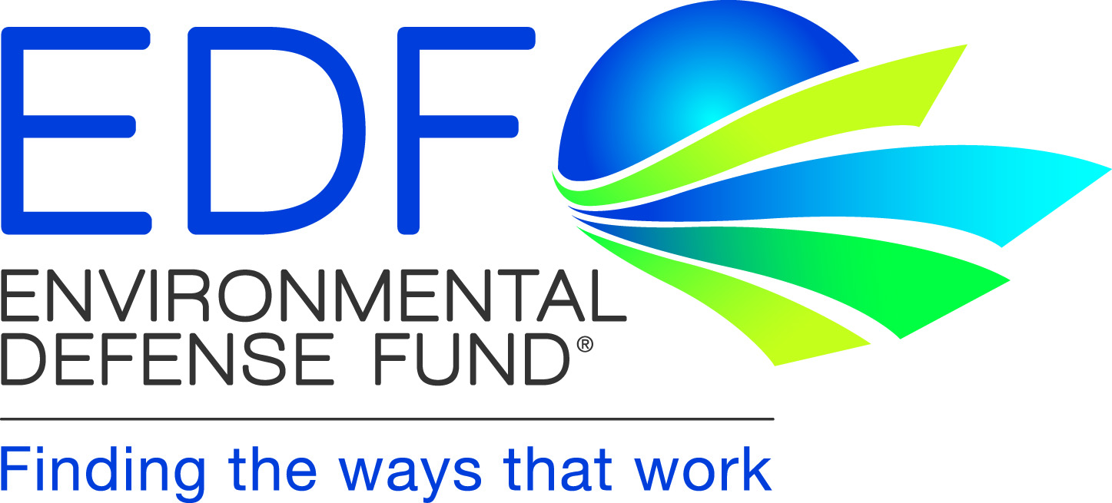 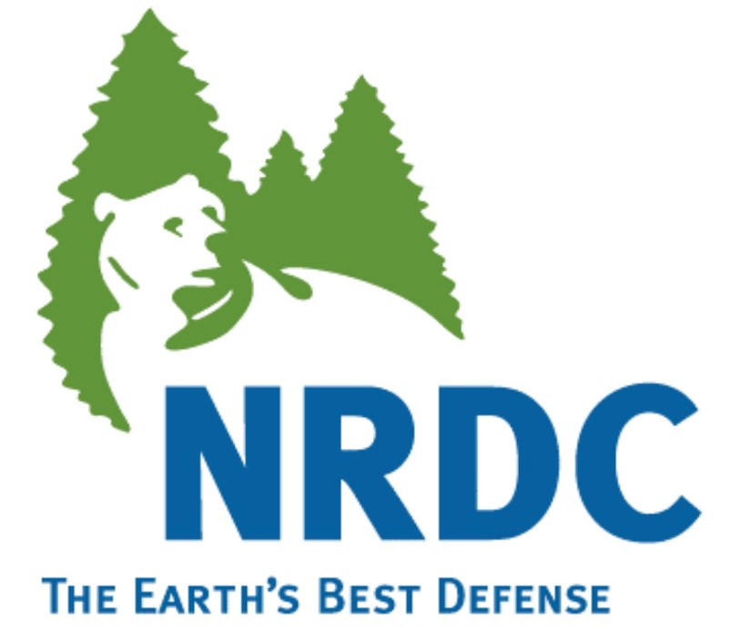

February 17, 2012

Steve Cliff, Branch Chief

Climate Change Program Evaluation Branch

Stationary Source Division

California Air Resources Board

1001 “I” Street, Sacramento, CA, 95812

Rajinder Sahota, Manager

Climate Change Program Operating Section

Stationary Source Division

California Air Resources Board

1001 “I” Street, Sacramento, CA, 95812

**Subject: Comments of Environmental Defense Fund and the Natural Resources Defense Council on February 3, 2012, Cap-and-Trade Workshop: Regulation for Linking California and Quebec’s Cap-and-Trade Programs**

Dear Mr. Cliff and Ms. Sahota:

Please accept these comments on the February 3, 2012, Cap-and-Trade workshop on linking California and Quebec’s cap-and-trade programs.

Environmental Defense Fund (EDF) and the Natural Resources Defense Council (NRDC) support CARB’s efforts to consider linking[1] California’s cap-and-trade program to Quebec’s through a formal rulemaking process that has the potential to lead to a mutual recognition of compliance instruments issued by either program, should CARB determine upon thorough evaluation, that Quebec's program meets California's rigorous standards for environmental integrity. EDF and NRDC’s paramount interest is to preserve the integrity of California’s cap-and-trade program. That said, linking, or mutual recognition between strong programs, can, in principle, provide additional flexibility and cost-saving opportunities for regulated entities in both California and Quebec. It was clear from the linkage workshop that CARB’s decision on whether to recognize the validity, for compliance purposes, of compliance instruments in the Quebec program will be based on CARB's thorough consideration, and continuing assessment, of what will provide the strongest and most effective means of reducing greenhouse gas (GHG) emissions and protecting California from the impacts of climate change. We strongly encourage CARB to maintain that perspective throughout the rulemaking process.

In the coming months, we also urge CARB to clearly identify the criteria it will use to evaluate the stringency of other programs whose compliance instruments it will consider recognizing. These criteria should include, at a minimum, core programmatic elements such as: the stringency of the cap, the reliability of mandatory reporting requirements, the stringency of offset protocols, limits on borrowing, and the adequacy of penalty and enforcement mechanisms. By developing these criteria through a public process, CARB can ensure that California stakeholders have confidence that linking, or mutual recognition of compliance instruments, will be in the best interests of California and further the goals of AB 32.

When the California Legislature passed and Governor Arnold Schwarzenegger signed the Global Warming Solutions Act of 2006 (AB 32), it tasked the Air Resources Board with developing a suite of actions that were and still are urgently needed to protect the health and welfare of California citizens in the face of impending global climate change. Since 2006, the science on climate change has only become clearer - GHG emissions threaten our way of life and increasing atmospheric concentrations of anthropogenic CO2 and other GHGs are already showing signs of having adverse impacts, including here in California.

Since EDF and NRDC originally co-sponsored AB 32 in 2006, we have worked diligently to assist with implementation of the bill and have provided detailed comments throughout the development of the cap-and-trade regulation. EDF and NRDC’s comments and participation in this process are rooted in the belief that reducing GHG emissions is of paramount importance to public health and welfare and can be achieved in a manner that will help our economy prosper.

Linking California’s program has the potential to be just one of many elements of the overall AB 32 program that allows California to achieve its GHG emissions reduction targets cost-effectively. We applaud CARB on its tremendous efforts to-date in developing a state-of-the-art blueprint to reduce GHG emissions under the AB 32 Scoping Plan that will benefit Californians for generations to come. In this same vein, if CARB determines that Quebec's program meets California's stringent standards, and if authorities in Quebec make the corresponding determination about California's program, linking via mutual recognition could provide additional flexibility and cost-saving opportunities for regulated entities in both California and Quebec, thus improving the overall effectiveness of each jurisdiction’s cap-and-trade program.

EDF and NRDC recognize that if after making such a determination, California is going to effectively offer the benefits of linking to its stakeholders, certain (though not all) elements of the California and Quebec programs will need to be harmonized. EDF and NRDC agree with CARB that joint auctions, a shared compliance instrument tracking system, and equivalent holding limits are among the programmatic elements that should be harmonized to allow California entities better access to the market of fungible compliance instruments and will enhance the integrity of both programs. WCI, Inc. – which was created as a not-for-profit organization in November, 2011 – will also allow WCI participants to avoid duplicative efforts and achieve cost-savings by carrying out logistical, administrative tasks for all participants that would have been completed by an independent contractor if WCI, Inc. did not exist. Of course, California will retain its full suite of enforcement tools, ensuring that it can exert full authority over regulated entities doing business in California.

EDF and NRDC also want to commend CARB for its participation in the WCI. By joining WCI, California recognized that climate change is a global challenge and that emissions must be reduced quickly and effectively worldwide in order to avoid the most devastating impacts of climate change. As a state, California can best work towards this goal by designing and implementing a strong program that demonstrates to other global actors that reductions are achievable. The WCI coalesced as a group of likeminded states and provinces, brought together by their shared sense of the urgent need to reduce GHG emissions. The WCI provided a platform for these states and provinces to share information and discuss best practices for reducing emissions. Because of WCI’s role as an information portal, California and Quebec ended up on parallel tracks with cap-and-trade programs that are similar enough that linking the programs is possible and could result in many benefits to each jurisdiction.

CARB has provided a key resource to California stakeholders by publishing relevant information about regulated entities under the California program such as name, location, historical emissions and economic sector; we recommend that the same is provided for sources within Quebec’s program. Overall, EDF and NRDC see tremendous benefits and potential in assessing the possibility of linking with Quebec and future jurisdictions that meet the stringency of California’s program.

Thank you for your consideration of these comments on the cap-and-trade linkage workshop. We look forward to working with CARB and providing further comments as this rulemaking proceeds.

If you have any questions or concerns regarding the comments made in this letter, please contact Erica Morehouse at [emorehouse@edf.org](mailto:emorehouse@edf.org); (916)492-4680.

Sincerely,

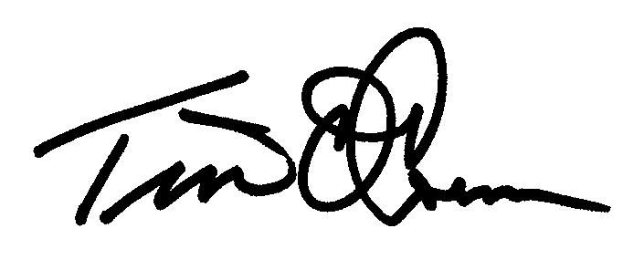

|  |  |  |  |
| --- | --- | --- | --- |
| Tim O’Connor  Director, California Climate and Energy Initiative  Environmental Defense Fund    Erica Morehouse  Policy and Legal Analyst  Environmental Defense Fund | C:\Users\emorehouse\AppData\Local\Microsoft\Windows\Temporary Internet Files\Content.Outlook\72PMOQI0\KE e-sig (2).jpg  Kristin G. Eberhard  Legal Director, Western Energy and Climate Projects  Natural Resources Defense Council   |  |  | | --- | --- | | **Cc:**  Mary Nichols  Ellen Peter  Virgil Welch | Edie Chang  Holly Stout  Jason Gray | |
|  |  |

1. In this letter we use the terms “linking” or “linkage” to mean that compliance instruments issued by California and another jurisdiction are fungible because the responsible governmental authorities in each jurisdiction have independently evaluated the stringency, quality, and overall design of the external program; concluded that the external program is of comparable environmental integrity to the home jurisdiction’s program; and determined that it is in the home jurisdiction’s best interest to recognize compliance instruments from the external program.