

November 19, 2007

Mr. Doug Thompson
Manager
Climate Change Reporting Section
California Air Resources Board
P.O. Box 2815
Sacramento, CA 95812

Dear Mr. Thompson:

Several food processors will be among the firms that will be required to begin reporting their facility greenhouse gas (GHG) emissions in 2009. The California League of Food Processors (CLFP) has previously submitted comments to the Air Resources Board (ARB) regarding proposed mandatory reporting requirements for GHG emissions, and CLFP appreciates that some of its suggestions have been incorporated into the final staff report and draft regulations. In preparation for the ARB Board hearing on this topic scheduled for December 6, 2007, CLFP would like to submit a summary its previous statements and add some additional points for consideration.

CLFP is a member of the AB 32 Implementation Group, and like other members of that organization, CLFP urges ARB to promulgate regulations that are as transparent, consistent, simple as possible, are based on sound science, and are implemented in a manner that will impose the least possible costs on the regulated entities. The specific key issues of concern to food processors regarding mandatory reporting are as follows:

Emissions Data Verification
CLFP believes that food processors and most other firms are quite capable of self-verifying their emissions data in a complete, timely, and accurate manner. This is especially true in cases where fossil fuel consumption accounts for the vast majority, or all, of a facility’s GHG emissions and the calculations are a relatively simple matter. Most companies are quite familiar with environmental data reporting requirements and have sufficient in-house expertise to conduct the reporting and verification tasks. The facilities all understand that they will have a legal obligation to report accurately and are aware of the potential consequences of ignoring that duty. If a firm did have concerns about specific technical issues and required outside expertise to help prepare their information then they could still choose to hire a consultant to assist with the verification. So, the proposed requirement for mandatory third party verification of emissions data is unnecessary and will increase industry compliance costs with little, or no, tangible benefit to ARB.

If third party verification is mandatory, then CLFP proposes that the requirements be waived by ARB if 90 percent or more of a facility’s GHG emissions are derived from fossil fuel combustion. Firms could use their source test data or simply convert their natural gas Btu consumption into CO2 equivalents. In most of these cases the data collection, analysis, verification, and reporting activities will be quite simple and not require and outside verifier to certify what most likely will consist of performing simple arithmetic. If source test data is used, it will already have been certified by the local Air District.

If ARB proceeds with a mandatory third party verification system, then CLFP supports ARB’s proposal that reporting entities be given the option of having their local Air District verify the emissions data. The Air Districts are obviously quite familiar with collecting, analyzing, and verifying air emissions data and reporting findings to ARB. Further, including the option of using the Air Districts to verify reports will inject competition into the marketplace that will help to ensure that private third party verifiers are offering the best technical advice at the lowest possible cost.

Phase-In Period for Reporting GHG Emissions
CLFP supports ARB’s decision to phase-in the reporting requirements and to allow the facilities some latitude with respect to the data that is reported in 2009. This rulemaking has occurred in a compressed time frame in order to begin implementation January 1, 2008. Firms will not have much time to learn and understand all of the rules and to begin collecting their 2008 emissions data. Most companies will be diligent in their efforts, but this is a new regulatory frontier for all of the entities involved so providing some initial flexibility would a fair and reasonable approach by ARB.

Reporting and Verification Schedules
CLFP requests that ARB change the reporting schedule for general stationary combustion sources. The current proposal would require that firms submit their reports to ARB by April 1, and that the verification be completed by October 1. To avoid confusion about deadlines and to provide the regulated entities with as much time as possible to collect and report data, CLFP suggests that all firms be on the same schedule; reporting facility emissions data by June 1, with completion of all verification activities by December 1.

Reporting Exemption for Backup Boilers
Some food processors rent or own backup boilers that are used in case of emergency on a short term seasonal basis. If the equipment is rented it may be removed from the site at the end of the season. ARB has already indicated that reporting will not be required for backup or emergency generators, CLFP requests that this same exemption be extended to backup boilers.

Alternative Emissions Factors
CLFP supports the ARB proposal to allow firms the option to use source-specific emissions factors. The reporting system will benefit from allowing participants to use the most accurate and reliable form of measuring or calculating emissions. CLFP requests that ARB ensure that its process to petition to use an alternative factor is simple and that the decision to approve or disapprove that factor is made as quickly as possible.

Electronic Data Submission
CLFP supports ARB’s proposal to allow electronic reporting of GHG emissions. A properly designed system would simplify reporting, data analysis, and storage of records. However, ARB should take special precautions to ensure the security of the data.

Public Disclosure of Information
CLFP believes that if ARB intends to publicly disclose information about the greenhouse gas emissions from individual companies that the only data that should disclosed is the total greenhouse gas emissions from each site. There is no obvious need for the public to have knowledge of energy consumption, process information, or any other details about individual facility’s operations. Some of this information may be commercially sensitive and should not be disclosed without written permission from the reporting facility.

De Minimis Provisions
CLFP supports ARB’s proposed de minimis provision that would cover up to three percent of a facility’s CO2 emissions. In many cases the cost of collecting, analyzing, and reporting the data from minor sources will be prohibitive, and provide little meaningful information to ARB.

Facility Reporting Threshold
CLFP strongly urges ARB to not reduce the facility fuel combustion reporting threshold below 25,000 metric tons of CO2. ARB has indicated that the facilities that will be obliged to report at the proposed 25,000 metric ton level account for about 94 percent of total industrial GHG emissions. As has been noted by ARB staff, increasing the coverage level by just a few percent will entail adding hundreds of additional facilities. This would add greatly to the oversight cost incurred by ARB and would not be a very cost effective effort.

Reporting Other Emissions
CLFP supports ARB’s decision to not require general stationary combustion sources to report their process emissions, fugitive emissions, and vehicle fleet emissions. For many firms it may be difficult to accurately calculate process and fugitive emissions and would likely take a number of years to develop suitable metrics. In many cases these emissions will be minimal and not warrant reporting to ARB. Regarding mobile emissions, it is CLFP’s view that if, at some point, ARB requires that fleet emissions be reported then the fleet owner should be responsible and not the customer of the trucking services or the sites that the vehicles may visit. This would be the most accurate and simple approach. Finally, emissions emanating from any mobile rental equipment should be attributed to the rental agency and not the stationary facility renting the equipment (similar to ARB’s forklift emissions rule).

Secondary Emissions Attributed to Electricity Consumption at Manufacturing Facilities
CLFP continues to oppose ARB requiring that food processors and other industrial facilities report their consumption of electricity purchased from off-site providers. If both the load serving entity and the end user provide this data it will just be double-counting the same electricity and same emissions. Most firms are already quite cognizant of their energy use and are taking measures to reduce their energy purchases. The new greenhouse gas regulations will accelerate that process. With respect to reporting electricity use CLFP strongly supports an upstream approach to reporting as that will yield the most accurate and complete results.

Oversight
CLFP suggests that ARB create a private sector advisory board to conduct an annual independent review of reporting and verification activities to ensure that data is being collected in the most cost effective manner and imposes the least amount of burden on the regulated community.

CLFP appreciates the opportunity to comment on the proposed reporting requirements, and urges ARB to ensure that the reporting requirements are fair and cost effective. Please contact me if you have any questions regarding CLFP’s recommendations.

Sincerely,

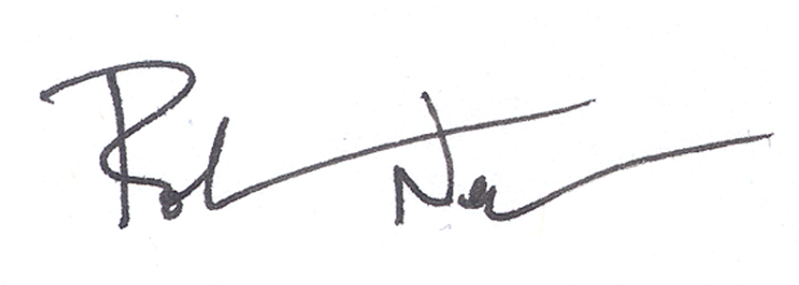

Rob Neenan
Director of Regulatory Affairs

