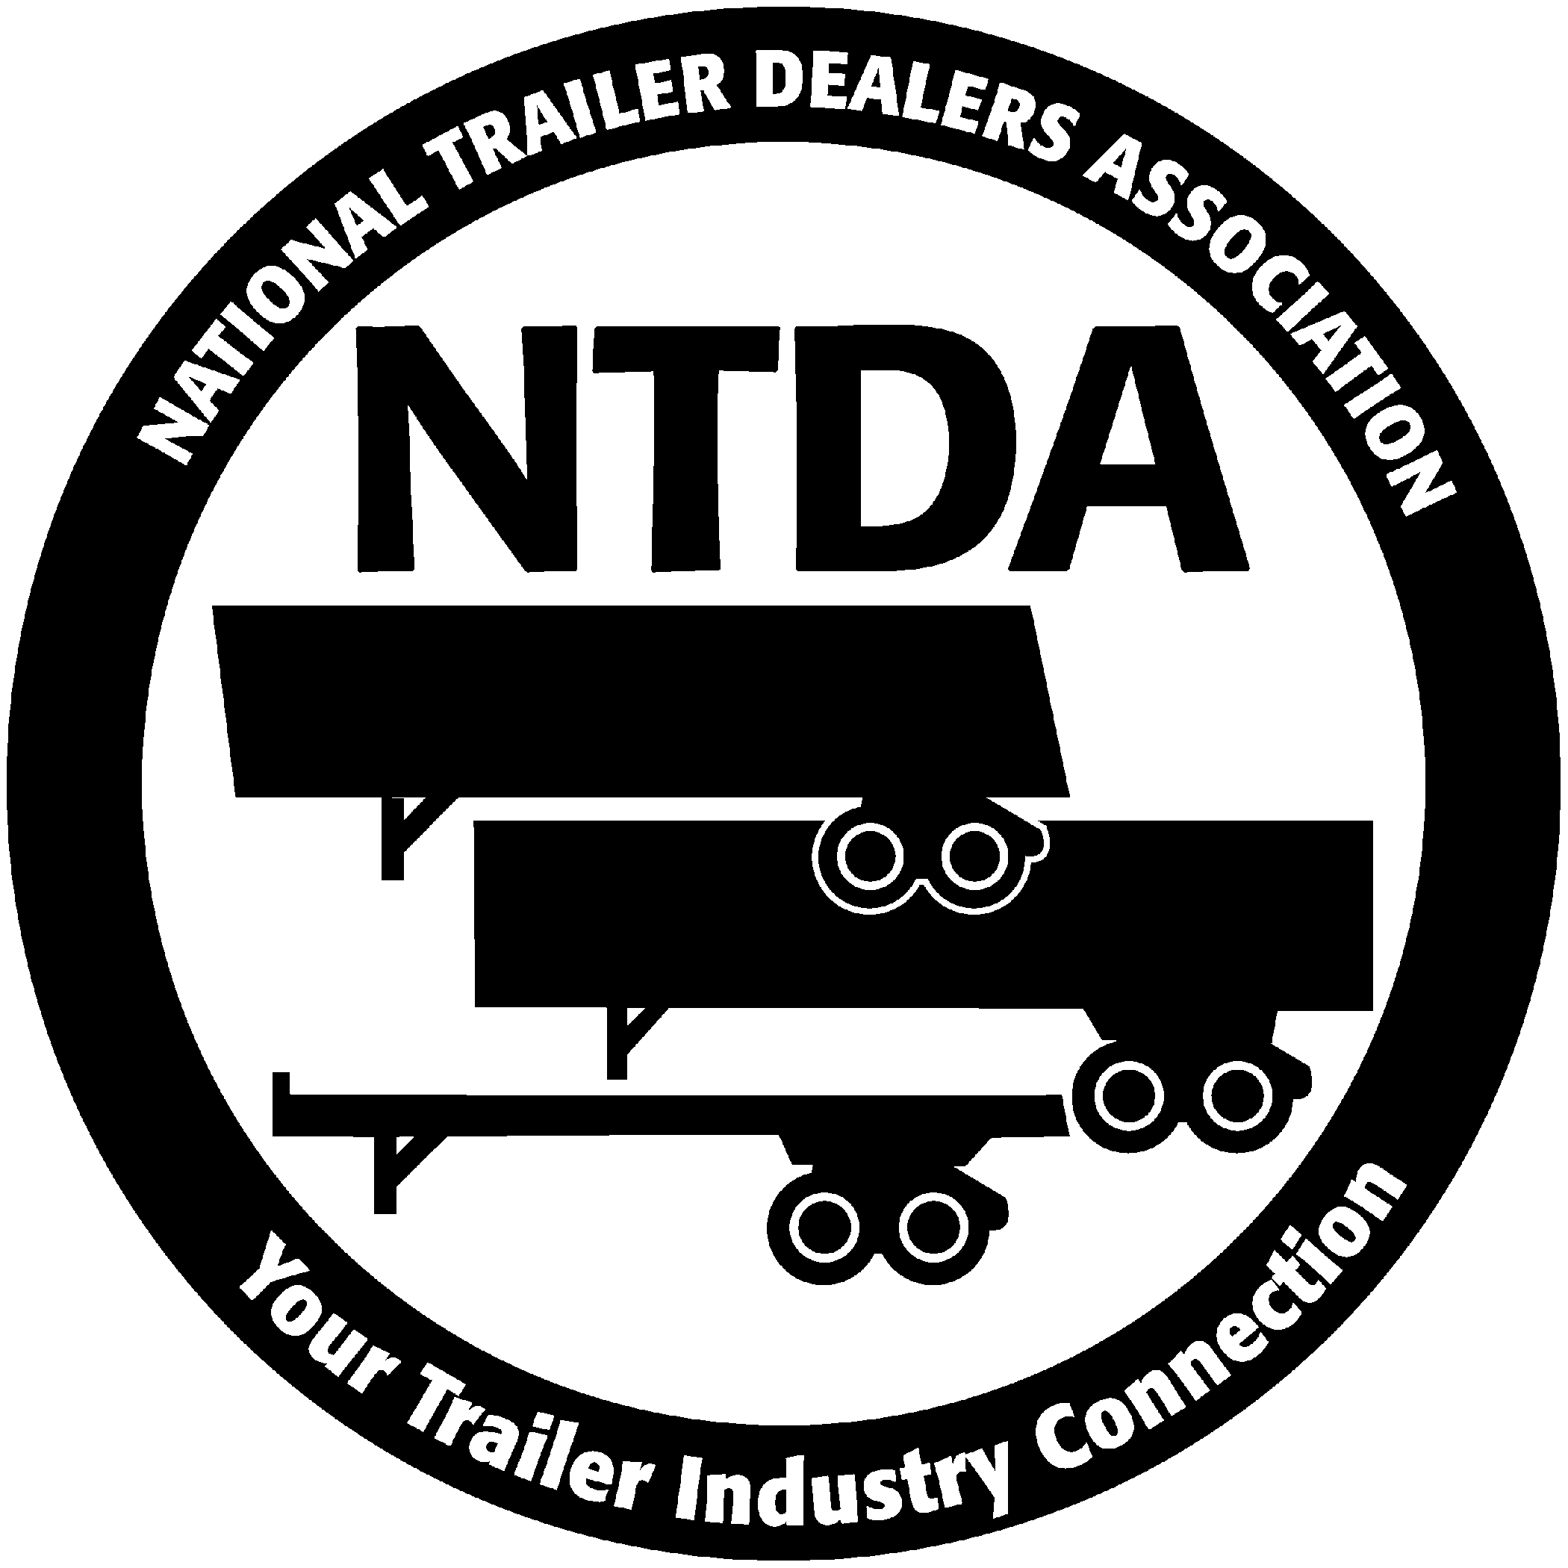
National Trailer Dealers Association
37400 Hills Tech Drive, Farmington Hills, MI 48331-3414
1-800-800-4552, Fax (248) 489-8590

info@ntda.org • www.ntda.org

November 24, 2008

Clerk of the Board
Air Resources Board
1001 I Street
Sacramento, California 95814

Re: December 11 and 12, 2008 Hearing:
RULEMAKING TO CONSIDER ADOPTION OF A REGULATION TO REDUCE GREENHOUSE GAS EMISSIONS FROM HEAVY-DUTY VEHICLES

The National Trailer Dealers Association (NTDA) requests that the California Air Resources Board (ARB or Board) not make mandatory the proposed requirements for trailers based on the U.S. Environmental Protection Agency (EPA) SmartWay Partnership Program.

Under the SmartWay program, the U.S. EPA certifies tractors and trailers that have been demonstrated to be more fuel efficient than their traditional counterparts. At this time, there are SmartWay specifications for tractors with sleeper cabs and for 53-foot or longer dry-van trailers, and therefore, only these products can be certified by original equipment manufacturers under the SmartWay program. The SmartWay program also approves individual aerodynamic equipment for trailers and efficient (low-rolling resistance) tires for tractors and trailers.

According to the EPA, “SmartWay is positioned as a personal choice that can make a difference for the environment.” The NTDA believes these actions should remain a choice, not a mandate.

Founded in 1990, the NTDA represents over 300 semi-trailer dealers and manufacturers throughout the United States, Mexico and Canada.

Background

In 2006, California enacted The Global Warming Solutions Act (AB 32) to address climate change issues within the state. The legislation requires the Board to develop programs to reduce greenhouse gas emissions to 1990 levels by 2020. To begin fulfilling the commitments made in AB 32, ARB has developed a list of discrete early action measures.

In 2007 the Board approved a list of nine discrete early action measures that are scheduled to be adopted by the Board and enforceable by January 1, 2010. The list included a measure entitled: “SmartWay Truck Efficiency.” The proposed regulation referenced above is designed to implement this measure. The proposed regulation would apply to both California-registered and out-of-state-registered tractors and trailers. It relies on the voluntary federal EPA SmartWay program to establish mandatory California tractor and trailer requirements.

Cost of the Proposal

According to the ARB STAFF REPORT: INITIAL STATEMENT OF REASONS FOR PROPOSED RULEMAKING, “While compliance with the proposed regulation would require an initial capital cost, it is expected that a cost savings would ultimately result due to the increase in HDV fuel efficiency and the resultant usage of less fuel.” The report estimates the average cost of trailer compliance for the initial purchase and installation of aerodynamic technologies and low-rolling resistance tires is approximately $2,900 per trailer. In addition, annual maintenance costs for inspection and repair of installed aerodynamic technologies, and replacement and retread costs for low-rolling resistance tires, is estimated to be about $120 for the trailer.

The NTDA questions the veracity of these figures. In the report itself staff notes that the fleets they chose to interview reported side skirts alone costing as much as $2,600. In addition to the side skirts the regulation would require SmartWay approved low-rolling resistance tires and either front or rear fairings.

The report flatly states that “In the real world it is difficult to isolate the benefits achieved using one particular aerodynamic technology from all other fuel-saving strategies and technologies that may be used.”

On the benefits side of the equation the staff report’s data is similarly incomplete. The analysis for vehicle usage takes estimated vehicle miles traveled (VMT) and assumes that a very high percentage of those miles are at highway speeds. In Table XII-3: Annual Operating Cost Savings of the report staff used the assumption that 84 percent of the vehicle miles traveled are at highway speed. The fuel efficiency improvements of currently certified aerodynamic devices are determined from track tests conducted at speeds of 60 to 62 miles per hour according to “SAE J1321 Type II” test procedures.

While the staff reports calculates the benefits of this proposal for vehicles traveling 60 to 62 miles per hour, the speed limit for trucks in California is 55 miles per hour, assuming traffic conditions allow for traveling at the speed limit. The NTDA questions whether the staff report data is reflective of the real world conditions typically experienced in the state of California. It appears that the report’s analysis clearly overstates the monetary benefit that would actually be experienced.

Additionally, the report indicates that the VMT data the staff were able to obtain cannot be directly applied to the fuel efficiency improvements they show as VMT is accrued at various speeds, while the fuel efficiency improvements are determined at speeds of approximately 60 miles per hour. The report then clearly states, “…the
speed-VMT distribution of the impacted tractors and fuel efficiency improvements at different speeds are needed in order to accurately quantify the GHG emission benefits. However, such data were not available and therefore staff estimated the GHG benefits using only the VMT accrued at highway speeds, without taking into account benefits that occur at lower speeds.”

Trucks traveling at higher rates of speed are likely to obtain much greater fuel savings from the proposed aerodynamic equipment than while traveling at lower speeds.

Further, the NTDA questions the estimates used in the analysis for the number of trailers likely to be affected by the proposed regulation. As the report indicates, “for trailers, no database exists that provides a complete inventory on the total number of box-type trailers that would be impacted by the proposed rule.” Staff then simply chose to estimate a ratio for the number of trailers to tractors and extrapolate a figure.

Conclusion

The report’s cost/benefits analysis relies on incomplete data. The number of trailers likely to be affected is conjecture. The cost estimates of compliance for each affected trailer are unreasonably low. The benefits are certainly inflated due to inaccurate estimates of the speed at which the vehicles typically travel.

In the discussion of costs and user concerns many conclusions seem to be based on a small sampling of anecdotal evidence. Also, there appear to be a great many statements that begin, “staff anticipates that…” It is clear that the staff is counting on numerous instances of future improvements and developments to be carried out by the private sector in order to make this regulation viable.

It is unreasonable to approve a regulation whose implementation and benefits are unknown and dependant on future occurrences which may or may not happen.

While the goal of greater fuel economy and reduced emissions is laudatory, more testing and analysis is required before placing such a significant financial burden on the businesses shipping and carrying goods to and from California. In the meantime, we suggest that California create additional financial incentives to help persuade companies in adopting the voluntary SmartWay program. If the NTDA can be of further assistance on this matter please feel free to contact our Executive Director Steve Carey at (248) 489-7090.

Sincerely,



Elvin Spellman
President
National Trailer Dealers Association

