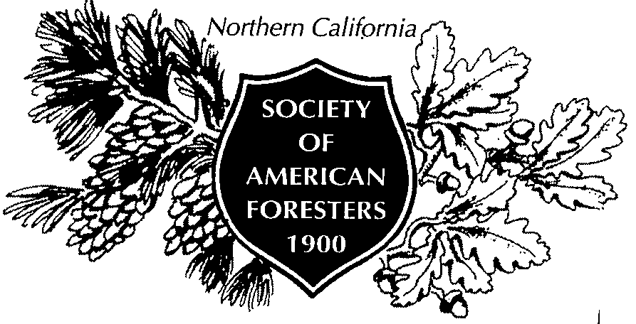

2829 Lakewood Ranch Road
Weed, CA 96094
February 18, 2010

Clerk of the Board
Air Resources Board
1001 I Street
Sacramento, CA 95814
(Submitted my email)

SUBJECT: Proposed Withdrawal of Board Adoption of Approved Forest Protocols

Dear Board Members:

The Northern California Society of American Foresters (NorCal SAF) represents roughly 700 foresters in northern California. Our primary mission is to advance the science, education, technology, and practice of forestry. NorCal SAF strenuously opposes withdrawal of Air Resources Board (Board) approval of forest protocols adopted by the Climate Action Reserve (CAR). Forests play an important role in carbon sequestration. Forest Carbon Project Protocol Version 3.0 is essential to allow forest owners to participate in carbon markets and to contribute in a verifiable way to meeting California’s ambitious goals for greenhouse gas reductions. The Board approved forest and urban forest project protocols less than five months ago. NorCal SAF is unaware of any new information that has come to light in the interim that could possibly justify this abrupt and disruptive reversal of state policy. Withdrawing approval would drastically undermine all progress to date to encourage forest owners to participate in carbon markets and would eliminate a key incentive for them to remove or reduce carbon from the atmosphere.

We agree that the forest protocols and the process for protocol development can and should be improved as California moves from voluntary- to compliance-based approaches to greenhouse gas reduction. However, the way to do that is by adaptive management, i.e., by having forest owners, carbon project developers, and third-party offset verifiers work with the protocols to learn their strengths and weaknesses and the best ways to respond thereto. Rather than withdrawing approval of the protocols at this early, high vulnerable stage, the Board should be signaling its sustained support for legitimate forest carbon projects and verifiable carbon offsets.

Withdrawing approval now would likely upset stakeholder confidence in CAR so thoroughly as to preclude its survival. It would invite lawsuits that portend large liabilities for state taxpayers from forest owners who have invested in CAR forest carbon projects mistakenly presuming that Board approval meant approval. Responding to the threat of litigation regarding the forest project protocols by making the proposed about-face in state policy would send the worst possible signal to AB32’s future regulated community about the ability of its regulator to operate in good faith.

Thank you for your consideration.

Sincerely,

Nicholas Dennis, Chairman
Northern California Society of American Foresters

