

February 24, 2010

By posting to:
www.arb.ca.gov/lispub/comm/bcsubform.php?listname=ghgprot&comm_period=N
Mary Nichols
Chair

James Goldstene
Executive Officer

Lynn Terry
Deputy Executive Officer

Kevin Kennedy
Office of Climate Change

California Air Resources Board
1001 I Street
Sacramento, CA 95814

Air Resources Board (ARB) February 25, 2010 Public Meeting Agenda Item 10-2-9 –
“Consider a Process for Adoption of Greenhouse Gas Accounting Protocols for
Compliance Purposes, Including Withdrawal of Board Adoption of Voluntary Protocols”

Dear Chair Nichols, Members of ARB and Staff,

Thank you for the opportunity to provide preliminary comments regarding the above-referenced agenda item. I am writing now to ask that as you take up this important matter you continue to provide clear guidance to and support for those projects and market participants who have responded to your call for early action by actively engaging in the market for greenhouse gas emission reductions developed under the Climate Action Reserve protocols previously adopted by ARB.

Since ARB’s adoption of the Climate Action Reserve’s (“CAR”) Forest Project Protocol Version 2.1 in October of 2007 (“Forest Protocol”), The Conservation Fund has registered two forest projects with CAR comprised of more than 40,000-acres of redwood/Douglas fir forestland in Mendocino County. CAR has issued more than 940,000 Climate Reserve Tons (“CRTs”) to these projects since our initial project verifications in 2008. Of these, more than 715,000 have been transferred to more than fifteen distinct purchasers. These purchasers include Pacific Gas
Comment letter of The Conservation Fund
ARB February 24, 2010 Meeting
Agenda Item 10-2-9
Page 2

and Electric Company, The Disney Company, United Parcel Service and other prominent entities, each of whom by their investments has indicated their support for the use of high quality forest-based offsets to contribute to the effort to combat climate change. Clearly, the early action stimulated by ARB’s adoption of these voluntary protocols has demonstrated that the availability of rigorous protocols for carbon offsets will stimulate high quality projects that advance California’s goal of reducing greenhouse gas emissions to 1990 levels by 2020.

Encouraging early action is fundamental to California’s response to climate change (see, e.g., Health and Safety Code 48210). This principle reflects an understanding that stimulating immediate changes in behavior and encouraging innovation is an essential precursor to the adoption of regulations. As indicated by the transactions highlighted above, these benefits clearly have been realized since ARB’s initial adoption of the CAR protocols. The early action principle, and the positive activities it has stimulated, would clearly be diminished if the earliest of actions in support of forest-based offsets were ultimately not recognized as compliance instruments in the final cap and trade program adopted by ARB.

Accordingly, as you begin to consider the adoption of protocols for compliance purposes, we ask that you continue to emphasize ARB’s commitment to the early action principle to which so many project developers and offset purchasers have favorably responded. Specifically, we ask that you give very serious consideration, after appropriate environmental review, to the eventual adoption for compliance purposes of each of the voluntary protocols previously adopted by ARB beginning in 2007. Such action is consistent with the draft cap and trade regulations issued late last year by ARB and is essential to ensuring that project developers and offset purchasers that are continuing to take, or are contemplating taking, early action will not curtail their pursuit of meaningful emission reduction projects.

Those who took early action in response to ARB’s leadership will of course be paying careful attention to ARB’s process for adopting protocols for compliance purposes. Your careful articulation of a policy and procedure that provides stability and predictability during this transition is very important to protecting the remarkable progress CAR and ARB have made in developing the nation’s most highly regarded emission reduction protocols.

Thank you very much for your continued hard work and leadership on behalf of the environment.

Chris Kelly

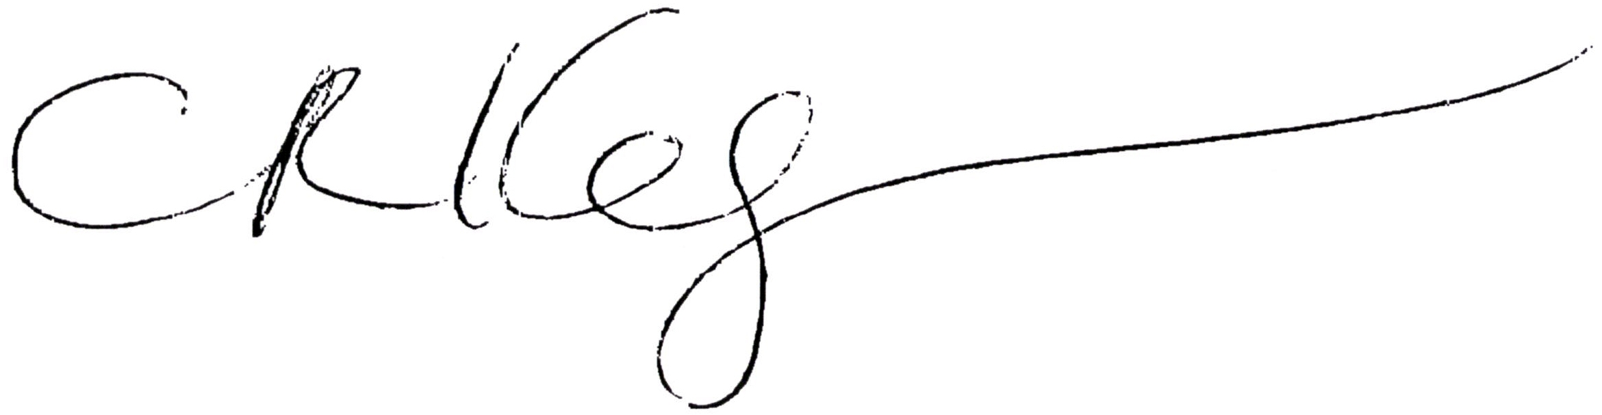
California Program Director

