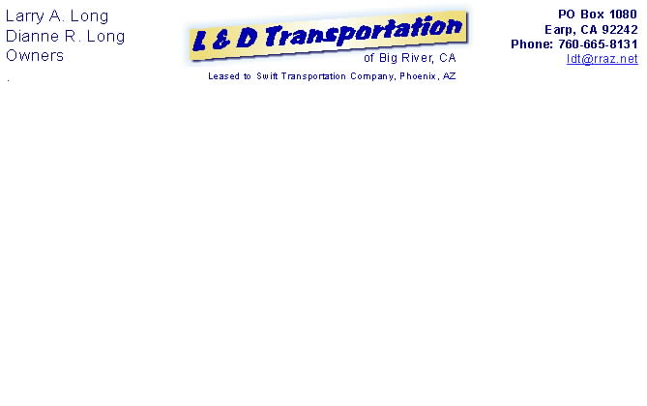

Email: ldt@npgcable.com

May 1, 2008

Air Resources Board
Sacramento, CA

To Whom It May Concern:

We own a single diesel tractor currently in compliance with USDOT and CA standards. With the establishment of anti-idling rules beginning January 1, 2008, we began using Idle-Aire when it is available within the state of CA and elsewhere. The average cost of using this service is $20 to $40 per stop, depending on how long the truck is parked. The current cost of diesel fuel is over $4 per gallon. While we receive a fuel surcharge to offset some of the cost, we have to pay for the fuel at the time that it is purchased using a carrier-provided company credit card and the cost is deducted from our weekly settlement.

The current USDOT Hours of Service regulations require the driver to have a 10-hour rest period each day; however, the truck might be stopped longer if the driver is between loads, waiting to deliver, or waiting to pick up the load. A well-rested driver is a much healthier and safer driver. If the interior temperature of the cab is not conducive to sleep, then the driver is fatigued (tired) and at greater risk for health problems and accidents. Your current requirements will kill us sooner than any perceived particulate matter possibly could.

So far as I can tell, there are no grants to single-truck operations in California. The grants are reserved for fleets. A fleet is typically a carrier and a carrier can afford to add APU equipment a whole lot easier than we can. Our truck is the primary source of income to our family. We are a sole proprietorship (DBA) registered in San Bernardino County, California

Fuel already costs over $4 per gallon and costs more in California because of the higher taxes placed on it at the pump. Idle-Aire, the only non-APU alternative to engine idling, recently reported being on the verge of bankruptcy and may be closed down. If this resource is no longer available, what effect does that have on small operations like ours? At that point we will be forced to add additional equipment to our truck that will cost upwards of $10,000 (including installation) and be financed at 12 percent interest (or more), even using a SmartWay resource.

I am looking for ideas and solid referrals. Currently, we have a loan payment against the truck, so our funds for repaying any additional loans are limited. We are currently leased to a large carrier, but that carrier is not going to equip our truck with aerodynamic devices or an APU system. We will have to do that, but at 12 percent, or more, there will be almost no profit left in our operation.

Do any of the people at CARB read the papers? Do any of the staff members bother to look at the kinds of things that we have to pay for before we ever start the truck? We are currently getting up to 7.5 mpg, which is quite good for any heavy truck. Newer trucks use more fuel, get fewer miles per gallon, run hotter, their engines require more maintenance, and engine failure occurs sooner. Replacement engines cost over $30,000, we know, because we replaced our engine in 2006. When possible, even rebuilding the engine costs about $20,000, usually more.

I am looking for answers. While we can agree that the environment is a matter for concern, we do not believe that increasing the operating costs of a single industry so quickly and extremely is the answer.

So what is the answer? We do have some choice in where we run our truck, and we can refuse loads going into California. The problem is that we live here!

When does CARB begin to enforce our rights instead of driving us out of business?

Dianne & Larry Long
L & D Transportation

