

59 Greif Parkway, Suite 101 • Delaware, Ohio 43015 • (740) 201 - 8088

April 15, 2009

The Honorable Arnold Schwarzenegger
Office of the Governor
State Capital
Sacramento, California 95814

RE: Concerns Regarding Proposed LCFS Regulation

Dear Governor Schwarzenegger,

On behalf of the Ohio Corn Growers Association, representing 26,000 farmers we are writing to express concerns with regard to the Low Carbon Fuel Standard (LCFS) proposed by the California Air Resources Board (CARB). For more than 20 years, the National Corn Growers Association and the Ohio Corn Growers Association have worked side by side with farmers, industry and government to build the ethanol industry from the ground up. Through our efforts, corn growers across the country and the ethanol industry have helped America move closer to energy independence.

Ohio applauds your leadership in promoting alternative fuels. Increasing America’s energy resources and protecting national security by reducing our dependence on foreign oil, in addition to, continuing to grow our domestic renewable fuels industry are among the most important challenges facing our country. As corn growers we play an important role in reducing our dependence on foreign oil. However, we are deeply concerned, about the trajectory of the current LCFS proposal in your state.

It is our understanding; the LCFS was originally intended to allow all eligible fuels to compete on a level, carbon-based playing field. There is widespread agreement in the scientific and research communities that biofuels produced from U.S. farms have significant benefits over petroleum and other fossil fuels like natural gas based on the “cradle to grave” carbon emissions associated with producing and using the fuel. For example, corn-based ethanol receives a 67 g/MJ. Advanced biofuels like cellulosic ethanol and renewable diesel have even better carbon scores. These numbers are considerably lower than California gasoline, which CA-GREET scores at 96 g/MJ.

To be clear, the CA-GREET model accounts for the carbon emissions directly attributable to the full lifecycle of the respective fuel. For biofuels the Air Resources Board’s (ARB) analysis includes the application of fertilizer, and the land converted to produce biofuel feedstocks. For petroleum CA-GREET includes major upstream refinery emissions. In both cases transportation and combustion of the fuel is included.

Unfortunately, the Air Resources Board (ARB) is proposing to enforce an additional carbon penalty against biofuels only, increasing the carbon score of these fuels by 40 percent or more. ARB staff calls the penalty “indirect land use change,” but in actuality the effect is a “market-mediated” or “economic carbon effect” derived by running estimated future biofuel demand through an econometric model. The problem with this proposal is two-fold: (1) the science of predicting indirect, economically-derived carbon effects is extremely new and uncertain; and, (2) no level of certainty justifies enforcing economically-derived carbon effects against only one type of fuel.

As to the issue of uncertainty, we feel it is imperative to note that 111 scientists submitted a letter providing details surrounding the state of the science and offering recommendations against premature enforcement of indirect effects. We would also note that AIR, Inc. released a study, in which the findings indicated that today’s biofuels result in zero indirect land use change based on updated treatment of biorefinery co-products and yield. Furthermore, it is particularly troubling to us that the current model runs for indirect land use change do not include inputs for the use of marginal and idle land. The omission of these land types is problematic because any grower who is looking to produce biofuel feedstock will look to idle and marginal land in order not to disrupt current cash flows. A land use assessment without this factor is quite simply not credible or based on real world decision-making.

With regard to the issue of selectivity, it is clear that all fuels have market-mediated carbon effects. However, only biofuel is penalized for indirect effects. As stated in the letter submitted by the aforementioned 111 scientists, “[e]nforcing different compliance metrics against different fuels is the equivalent of picking winners and losers, which is in direct conflict with the ambition of the LCFS.”

It is vitally important to note that corn production is becoming increasingly more efficient. Today, through technological advances America’s corn growers have the ability to apply fewer inputs to produce larger crops on the same land. Currently it takes about 40 percent less land to grow a bushel of corn than in 1987, and energy used to produce a bushel of corn has fallen by an average of 50 percent. According to Keystone Center’s “Field to Market” Report released in January 2009, the production of corn in the U.S. has made significant measurable improvements in reducing energy, water, land use and carbon emissions. U.S. farming practices are advancing and will continue to advance in terms of sustainability and productivity. For example, according to the United States Department of Agriculture (USDA), in 2008 American corn growers produced the second largest corn crop on record and attained the second highest yield per acre in history with fewer energy and fertilizer inputs. In addition, the dried distillers grains that are a co-product of ethanol production are playing a major role in providing livestock—in the U.S. and abroad—with high-protein, nutrient rich feed.

America’s corn growers are eager to play a central role in the decarbonization of transportation fuel. However, if adopted as currently proposed, the LCFS will uniformly dissuade the production and use of all forms of biofuels that utilize land and undercut what is a tremendous opportunity to spur economic growth in agricultural communities and reduce carbon emissions with American farming.

In closing, several different stakeholder groups, including the 111 scientists who submitted a letter to your office on March 2nd, recommended that ARB adopt an LCFS regulation based on direct carbon effects, or those emissions directly attributable to the production and use of the particular fuel, while taking the lead on the further assessment of the indirect carbon effects of all fuels. It is our strong feeling that a regulation based on direct effects will be balanced and represents the “level playing field” your office envisioned at conception of the program.

Thank you for your time and consideration in this matter of mutual interest. Ohio appreciates this opportunity to comment on this vitally important program.

Sincerely,
John Davis 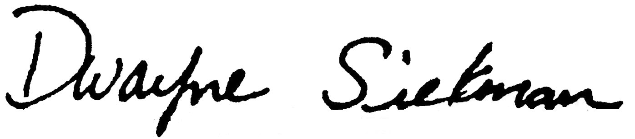

John Davis Dwayne Siekman
President Executive Director

