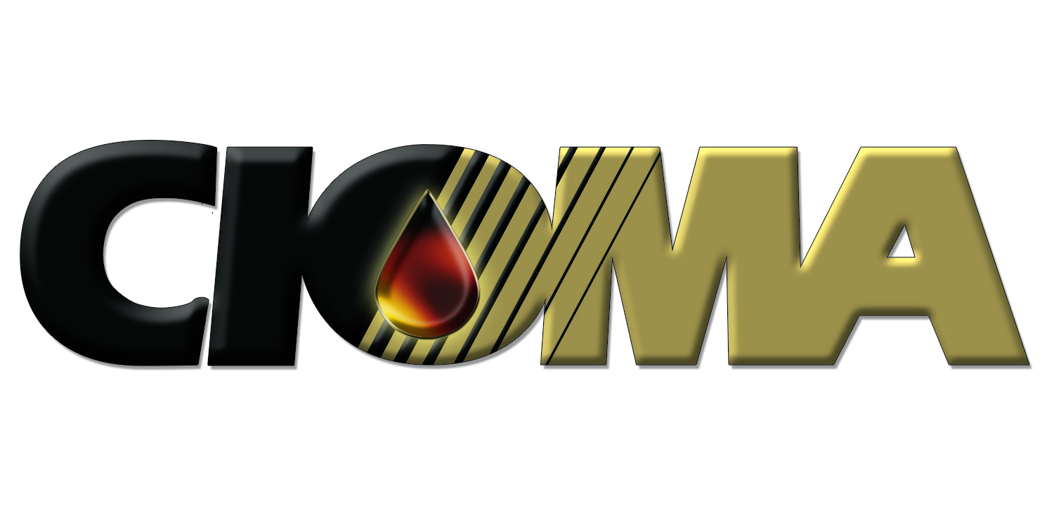
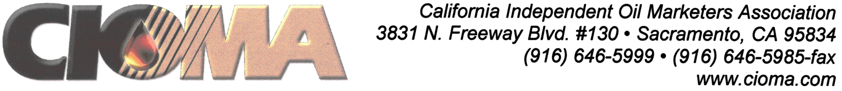

April 20, 2009

Clerk of the Board
Air Resources Board
1001 I Street
Sacramento, California 95814

Regarding: CIOMA opposition to Board Item 09-4-4; Low Carbon Fuel Standard

Board Members and Clerk of the Board:

The California Independent Oil Marketers Association (CIOMA) whishes to go on record opposing the proposed Low Carbon Fuel Standard (LCFS). This very complex and incomplete regulation needs much more time and attention before it is addressed by the Board. CIOMA is part of a coalition which has presented numerous failings of the regulation, and insufficient disclosure by staff of relevant and important documents for our review. These failings must be addressed or the regulation will have fatal procedural flaws. Beyond the procedural errors, the broader issue of providing the regulated community with adequate information to evaluate potential impacts needs to be confronted by the Board.

Beyond the comments contained in the coalition letter, CIOMA has a specific issue related to the LCFS. This regulation proposes to prioritize fuel types and specific fuels for distribution on the stream of commerce. As such there need to be fail-safe procedures in the regulation to assure that these fuel type and fuels are certified for use, not just their carbon intensity. Without this key regulatory provision fuels may appear as favorably incented due to their carbon intensity, but may not be available to fuel consumers. This is just another regulatory train wreck in the making.

This is not hypothesis. The state currently has a problem with biodiesel. While many in state leadership positions have promoted the use of biodiesel, a flaw in the state’s legal and regulatory structure is prohibiting its storage in underground storage tanks, above B-5 levels. This has taken a significant portion of biodiesel out of the stream of commerce. As new fuel types and fuels line up to enter into the fuel mix, others such problems are likely, if not predictably, to occur.

A very simple adjustment to the regulation is needed. The regulation needs to contain a provision that assures that all important checkpoints have been addressed before a low carbon fuel is certified. This would include:

- Appropriate certifications and allowances have been finalized which address blending, pipeline transportation, storage (above ground, under ground and in trucks) and dispensing of the fuel.
- Appropriate public notice and signage requirements have been addressed.
- Insurance companies are willing and able to insure marketer and fuel handling liability.
- The fuel will not cause harm into any vehicle or device the fuel might legally be used to power.

Without such a simple checklist your regulation is fatally flawed and will create another enforcement fiasco similar to, if not worse than, the recent enhanced vapor recovery requirements.

Sincerely,
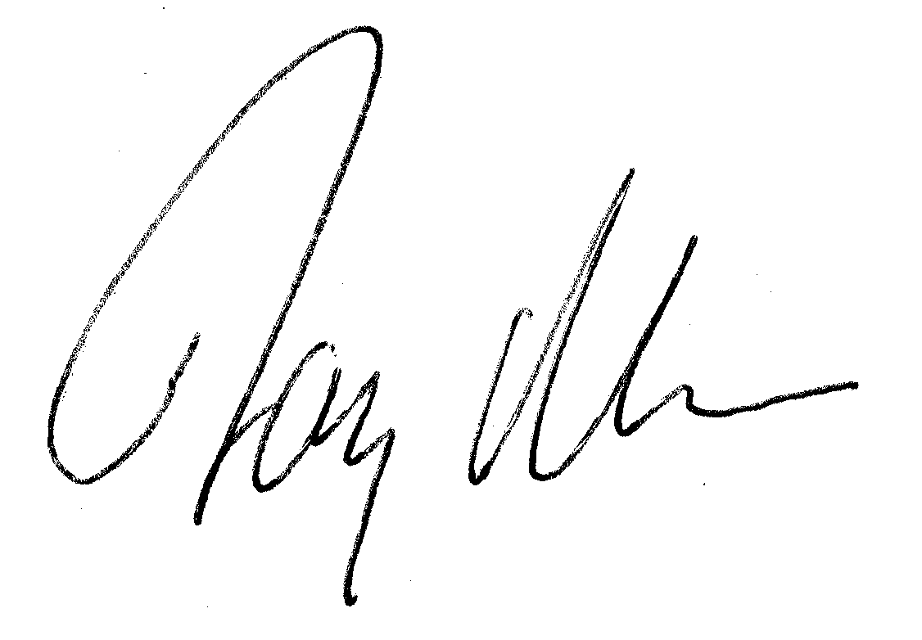
Jay McKeeman, Vice President of Government Relations & Communications

cc: Board Members, CARB
Linda Adams, Cal/EPA
Cindy Tuck, Cal/EPA
John Moffatt, Governor’s Office

