California Air Resources Board
P.O. Box 2815
Sacramento, CA 95812

RE: California Low Carbon Fuel Standard

Dear Chairman Nichols and Board Members:

Sierra Club California believes reducing the carbon intensity of transportation fuels should play an important part in cutting overall greenhouse gas emissions. We compliment the Air Resources Board for recognizing that we need to simultaneously green the fuels used in our cars and trucks, improve vehicle technologies, and reduce vehicle miles travelled.

Adoption of the Low Carbon Fuel Standard will protect California from the dirtiest fuels. Production of high-carbon intensity fuels, including those derived from Canadian and U.S. tar sands, oil shale, and liquid coal, will emit as much as three to six times GHG emissions as conventional oil, threatening to undermine California’s many efforts to reduce transportation emissions. The development of these ever-dirtier fossil-fuel sources to produce transportation fuels has enormous consequences not only for our climate, but the air we breathe, the water we drink, and our wildlands and wildlife in North America. We applaud CARB’s intent to provide additional pathways that distinguish between both lower carbon intensity fuels and higher carbon intensity fuels. Doing so will help ensure accurate accounting of emissions and establish a level playing field for all fuels.

We urge the Board to approve an LCFS that reduces greenhouse gas emissions from transportation fuels without damaging California’s public lands, sensitive ecosystems, water or air quality. Therefore, we ask the Board to:

- Include the impacts of using land to produce biofuels. For California to be a global leader in reducing pollution from fuels, the LCFS must account for all major sources of emissions. For some biofuels, emissions from indirect land use change (iLUC) are a major source of pollution; California must include these emissions for the LCFS to be credible. We therefore appreciate that ARB has accounted for iLUC in the proposed regulation.
- Include the water impacts of producing biofuels.
The standard should factor in the costs of polluting groundwater and the stress on our water supply from biofuels production. California must avoid repeating the mistake of MTBE, which was added to gasoline to reduce air pollution but caused a tremendous groundwater pollution problem. ARB could determine appropriate costs for water impacts by using a probabilistic (insurance) approach, or allow the insurance industry to make the calculations and provide actual insurance to cover future groundwater cleanups.

- Ensure the LCFS provides real pollution reductions and ushers in a new generation of ultra-low carbon fuels. The LCFS must be a platform for bringing ultra-low carbon fuels into the state’s energy system, not just a mechanism to increase deployment of modestly lower-carbon fuels. Therefore, we request that ARB include ultra-low carbon fuel requirements. California must ensure that the LCFS generates true reductions in global warming pollution beyond current state and federal laws, and puts the state on a trajectory towards meeting our long-term emission reduction goals. If fuel providers meet federal fuel requirements by merely shuffling low carbon biofuels into California, no real carbon reductions will result from the LCFS, and fuel providers may have little incentive to develop ultra-low carbon alternatives.
- Remove Incentives for Landfilling Organic Wastes. The landfill gas to Compressed Natural Gas pathway fails to account for fugitive landfill emissions and should be re-evaluated before being adopted as a fuel pathway within the LCFS. We ask that additional technical review and modifications to the landfill to fuels pathway be made before final adoption of the pathway.

In addition, the approach to fuels developed from waste lacks balance because it does not provide a pathway to produce fuel from processes involving alternatives to landfilling organic materials. To level the playing field, we ask that the Board give staff direction to develop a fuel pathway for fuels from dedicated anaerobic digesters. Development of the additional pathway will provide an alternative path for waste to be used, in a manner that reduces landfilling and that further supports the multiple environmental objectives of ARB and AB 32.

- Ensure minimum land safeguards. The LCFS should include a definition of renewable biomass to help prevent unintended incentives for fuel production that result in ecological harm to our federal lands, forests, and other sensitive native ecosystems.

- Provide incentives for sustainable fuels. The final regulation should direct ARB staff to develop metrics to ensure the LCFS provides incentives for the development of broadly sustainable alternative fuels, while avoiding unintended support for fuels with negative impacts on our forests, agricultural lands, water, and other important natural resources.
- Protect air quality and public health. To avoid an unintended worsening of air quality and threats to public health from new fuel production or fueling infrastructure, the LCFS should include requirements for state and local review to ensure that the appropriate mitigation measures are taken. In addition, the LCFS should require a comprehensive public health analysis, using updated tools and data, of the fuels and infrastructure used to comply with the regulation.

Thank you for your work to make California a leader in reducing the pollution that causes global warming, and for your consideration of these comments and suggestions.

Sincerely,
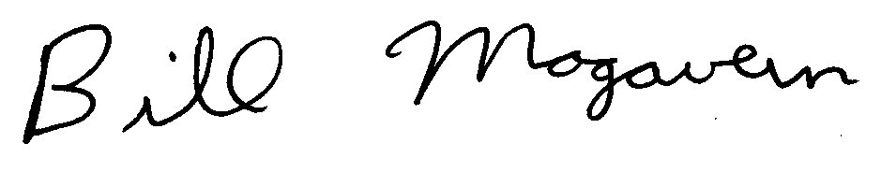

Bill Magavern
Director

