

August 18, 2009

Mary Nichols, Chairwoman
California Air Resources Board
1001 “I” Street
Sacramento, CA 95814

Dear Chairwoman Nichols and members of the board:

On behalf of 26,000 corn producers in the state of Nebraska, we thank the California Air Resources Board (CARB) for the opportunity to comment on the amendments to the low carbon fuel standard. We believe that with the increased usage and production of biofuels that states such as California and our nation can reduce our carbon footprint. Although we have serious concerns about the passed regulations that CARB adopted at their March hearing, we will keep these submitted comments in reference to the amendments released on July 20, 2009.

First, we applaud the formation of the expert workgroup and the opportunity to have an unbiased and scientifically robust discussion on the list of topics that the staff has presented for discussion. We believe that there are many very well qualified individuals in both private and academia ranks that we will submit names for recommendation of inclusion on the expert work group. In addition, although we do not agree with indirect land use change, we believe that there should be a coordination of efforts amongst those that want to apply this penalty to biofuels. Those mainly should include here in the US, the Environmental Protection Agency, and if you look at the current figures, they do not match up.

Secondly, CARB released their preliminary draft for public comment on method 2 in which a regulated party has the opportunity to present a new pathway or a sub-pathway of an already approved pathway. We again applaud this opportunity, but take serious concern to the possibility of a fee schedule being attached to method 2 submissions. The reason for this concern is that we don’t believe you have taken into account all types of ethanol production practices. For instance, here in Nebraska, some of the plants produce a modified wet distillers grains (MWDG). This product has a dry matter in the range of 45 – 50%. Currently you do not have a pathway for the production of MWDG and in order to quantify this pathway that you do not have, a regulated party will need to pay a fee for an approved pathway. This again, raises serious concerns as it seems a pay to play mentality.

Lastly, in a presentation by a staff member titled “Draft Guidance to Regulated Parties On Establishing New Fuel Pathways and Sub-Pathways” it states on slide 20 that fuel with no indirect effects are those that do not displace food, feed or fiber crops. We again disagree with this analogy. Corn based ethanol is not displacing food, feed or fiber crops. The basis behind that statement is as you look back over time, producers across this nation have produced a corn crop that has continually met the demands of all uses. In fact the supply of corn (less the usage for ethanol) has consistently been above 10 billion bushels; exports have stayed on trendline of around 1.9 billion bushels, in fact the US had record exports in 2007-2008; all the while seeing a carryout that has increased the last 3 years. In addition, through corn based ethanol, you have a feed co-production in the distillers grains product that is displacing corn in the various livestock rations. All of this again is some of the basis of why we don’t believe that corn based ethanol should be penalized for significant indirect effects such as land use change.

In closing, we appreciate the opportunity to comment again and ask that you consider the concerns that we outlined above, while at the same time moving forward with aspects of the formation of the expert work group.

Sincerely,
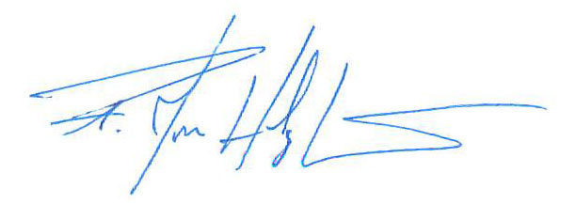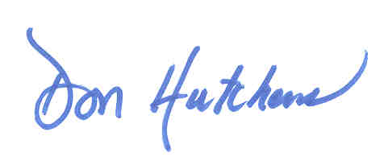
F. Jon Holzfaster Don Hutchens
Chairman Executive Director
Nebraska Corn Board Nebraska Corn Board

