

Western States Petroleum Association
Credible Solutions • Responsive Service • Since 1907

Catherine H. Reheis-Boyd
President

February 22, 2011

Clerk of the Board
CalEPA
California Air Resources Board
1001 I Street
Sacramento, CA 95814 [via electronic submittal]

Re.: Western States Petroleum Association’s Comments on Notice of Public Hearing to Consider Amendments to the Carbon Intensity Lookup Tables in the Low Carbon Fuel Standard Regulation

Dear Clerk of the Board:

The Western States Petroleum Association (WSPA) is providing comments in the attached paper on the above-referenced Executive Officer hearing that will take place February 24.

WSPA is a non-profit trade association representing twenty-six companies that explore for, produce, refine, transport and market petroleum, petroleum products, natural gas and other energy supplies in California, and five other western states.

In summary, our comments focus on the following issues:
- Circumvention of the “substantiality” requirement by allowing sub-pathways to qualify for separate carbon intensity (CI) values,
- Lack of verification for modifications that do not yet exist, such as separate CI values for an optimized plant energy mode that would result in additional heat recovery and energy savings in the future,
- Changes to CA-GREET inputs that result in lower CI values where other inputs may not have been included,
- Selective inputs to CA-GREET, and,
- Use of same feed value for de-oiled and non-de-oiled DGS.

If you have any questions, please contact me or my staff, Gina Grey, at 480-595-7121.

Sincerely,
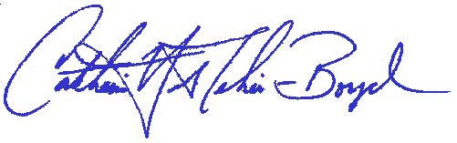
c.c. M. Waugh

WSPA Comments on
CARB Notice of Public Hearing
Staff Report: Initial Statement of Reasons for Proposed Rulemaking
Amendments to the Low Carbon Fuel Standard Regulation Carbon Intensity Lookup Tables
Hearing Date: February 24, 2011

This staff report is proposing to add carbon intensity (CI) values for 28 new fuel pathways to the LCFS Lookup Table. Of these, 22 are for corn ethanol (via Method 2A/2B applications), three are for sugarcane ethanol (via Method 2B applications), two are for biodiesel from used cooking oil (staff-developed), and one is for biodiesel from corn oil (staff-developed). In addition to these pathways that are open for a 45-day public comment period, the staff report notes that staff is currently evaluating Method 2A/2B applications representing 16 additional corn ethanol pathways as well as ethanol pathways utilizing corn, sorghum, wheat, sugarcane, beverage waste, and molasses. Staff is also developing three internal priority pathways. Note that the comments below only pertain to the 28 new pathways that are part of the official 45-day comment period.

Comments on the pathways are summarized below:

- Staff appears to have circumvented the substantiality requirement by allowing “sub-pathways” to qualify for separate carbon intensity values as long as the initial 5 gCO2e/MJ hurdle was achieved. These “sub-pathways” are additional modifications built off of the same primary modification. This results in, for example, CI values that differ by much less than 5 gCO2e/MJ, as illustrated below. 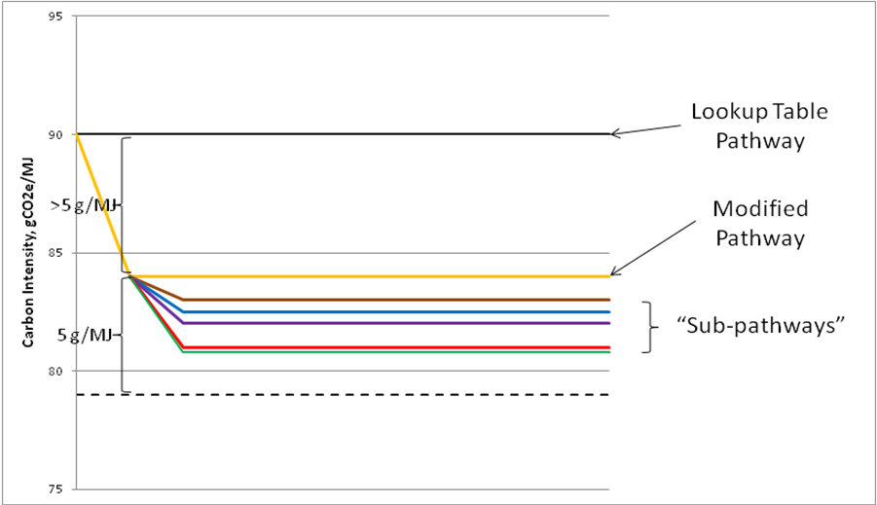

WSPA’s position is that the regulations require a pathway modification to meet the substantiality requirement. This requirement should apply equally to modifications of an existing Lookup Table pathway and modifications of modified pathways that ARB intends to approve (i.e., sub-pathways).

For example, pathways in a submittal were approved for sub-pathways containing various percentages of biomass (0%, 5%, 10%, or 15%) that do not achieve the minimum 5 gCO2e/MJ CI reduction threshold between each of the sub-pathways. This reduction threshold should be consistently applied across the sub-pathways. For example, the 15% biomass sub-pathway achieves a greater than 5 gCO2e/MJ savings relative to 0% biomass, but the 5% and 10% biomass sub-pathways do not.

- Staff has proposed separate CI values (~ 1 gCO2e/MJ delta) for an “optimized plant energy mode” that would result in “additional heat recovery and energy savings… in the future” (Emphasis added). How has staff verified modifications that do not yet exist? Approval for CI values for the optimized mode should be withheld until it has been implemented and data are available with which to confirm the energy savings.

- Another comment relates to other changes to the CA-GREET inputs that result in lower CI values for pathways - including the use of biomass to displace coal, and the use of coal with a lower carbon content than the default CA-GREET pathway. Both of these changes imply a difference in transportation emissions because of the lower energy content of biomass and lower carbon coal relative to the baseline. Was this accounted for in the CA-GREET analysis? Is there any special pre-preprocessing of biomass for this application (e.g., drying or chipping/grinding), and if so, were those emissions accounted for?

- WSPA also believes some pathways reflect selective inputs. Under some pathways, credit is given for a lower transportation distance from the corn field to the corn stacks and from the corn stacks to the ethanol plant relative to the baseline CA-GREET estimates. Although valid, it appears to us that this borders on “cherry-picking” inputs. Has ARB confirmed that other inputs to CA-GREET properly reflect the local conditions of this plant, e.g., electricity mix? For cases in which local inputs that result in a relatively small decrease in the CI estimates are proposed, ARB should also require a thorough investigation of local inputs that could potentially increase the CI estimates.

5. Under the biodiesel pathway, ARB has assumed the same feed value for de-oiled distiller’s grains and solubles (DGS) as for non-de-oiled DGS. This assumption is not consistent with the view of the animal feed experts who participated in the LCFS Expert Work Group/Co-Products Subgroup meetings and should be re-evaluated. For example, Appendix A of the Co-Products Subgroup final report notes that the “heating values of DGS will change as the fat content changes,” and Appendix C notes that the “Nutritional Value of DGS varies as a function of extent of fermentation, amount of solubles added to DGS, oil removal, sulfur use.” The report also says:

“There are cases in which the real-world in which DGS displacement ratios can be less than 1:1. For example, DGS with corn oil removed will have a lower caloric value than rolled or flaked corn, and if DGS displaces SBM in poultry rations without adding additional fat or amino acids to the diet, animal performance could suffer (but may be acceptable because of economics).” (Emphasis in original.)

