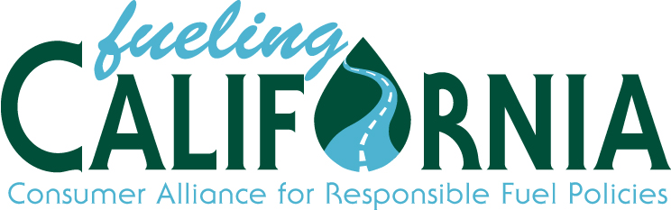

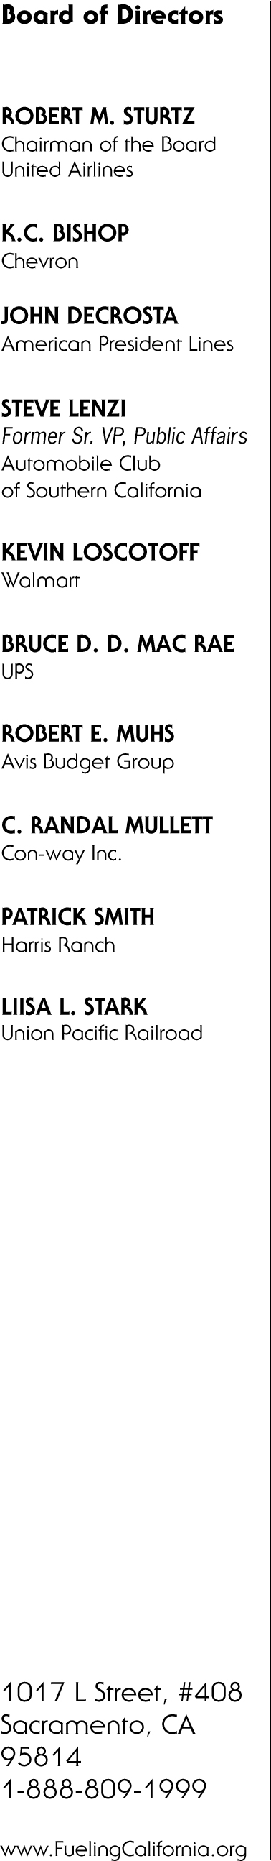
December 14, 2011

Mary Nichols, Chair
California Air Resources Board
1001 "I" Street
Sacramento, CA 95814

Re: Low Carbon Fuel Standard

Dear Chairwoman Nichols:

On behalf of a number of members of Fueling California, an alliance which represents a broad range of major transportation fuel using industries; employs more than 500,000 California residents; and contributes over $3 billion annually in tax revenues to the state, we would like to share our viewpoints regarding the California Air Resources Board’s (ARB) implementation of the Low Carbon Fuel Standard (LCFS) regulation.

The success of the LCFS hinges on the cost and feasibility of implementing the program.
One year into the implementation of this first-of-its-kind fuels policy, the ARB’s rule design, coupled with the realities of the projected alternative fuels market, have led us to conclude that this policy will likely become infeasible and unworkable well before the 2020 compliance date. We have arrived at this conclusion based on outstanding issues related to an overly complex design, questions about adequate volumes of low carbon biofuels and potential high costs of designated low carbon intensity fuels or credits, well researched and analyzed in recent work by the California Energy Commission (CEC). The CEC shared these concerns and their analysis of possible LCFS compliance scenarios recently in the context of developing the Commission’s Integrated Energy Policy Report (IEPR).

Foremost among our concerns are:

Significantly Higher Fuel Costs Projected by new California Energy Commission Report
A November 14, 2011 independent cost analysis by the CEC concluded that under CARB’s “high petroleum price” scenario the LCFS would make California fuel more expensive by nearly $3 billion in 2018, nearly $4 billion in 2019 and approximately $4.5 billion in 2020. The CEC’s analysis also indicates that LCFS program costs may reach as much as $9 billion by 2024/2025. Further, the CEC also concluded that costs are likely to rise even further should other states adopt LCFS regulations (22 states are currently considering such programs). The billions of dollars in projected LCFS costs will not fall on fuel providers, but will dramatically increase costs for businesses in all sectors that rely either directly or indirectly on energy, and consumers in the form of higher fuel costs and increased costs for fuel-dependent goods and services.

Job Losses Economy-wide
Higher fuel costs directly translate to job loss. As energy costs increase, economic activity slows, creating job losses during a time when California suffers from the second-highest unemployment rate in the nation at 11.2 percent. Additionally, as prices of fuel-related goods and services will rise, consumers will spend less, further weakening and delaying California’s economic recovery.

LCFS will create Supply Constraints and CEC Questions Feasibility
California already has the most differentiated fuel blend mix in the nation, and adding one more layer onto an already complex mix will likely lead to ever greater additional cost and, most troubling, increased risk of supply disruptions/outages and threat of prolonged periods of price spikes. The CEC’s LCFS report analysis raised concerns about the availability of biodiesel, the feasibility of corn-oil biodiesel in 2017 and beyond, the supply or renewable diesel and the feasibility of using half the U.S. supply of cellulosic fuels in 2018 and beyond.

LCFS is Adds Another Costly Layer on Top of a Myriad of Expensive Regulations
California already has numerous laws and regulations aimed at reducing greenhouse gas emissions, such as AB 32, CARB’s Clean Car Standards and the state’s Renewable Portfolio Standard (RPS) that are expensive to implement, hampering job creation, and pressuring economic recovery. The cost of the LCFS alone will impose severe financial burdens on California’s economy, but combined with other recently adopted regulations will have additional, additive negative economic impact. Energy costs are already escalating dramatically under AB 32 and the state’s RPS. Implementing another expensive layer -- the LCFS -- on top of these further complicates the interplay among all the various regulatory programs, likely leading to conflicts among the different policy frameworks and increasing the likelihood of negative unintended consequences.

Given these concerns about fuel cost, supply, and feasibility of implementation, we believe that it is necessary and timely for your Administration to consider whether this policy and its implementation schedule is the correct fuels policy now for California considering the current economic climate. As you review this policy and the ARB moves forward with its planned implementation, we encourage you to consider the following:

- First, the ARB needs to give serious consideration to the CEC’s analysis and adjust its own projections and rule elements accordingly.
- Further, engage the CEC to independently analyze the economic impacts of the LCFS (both in isolation and in combination with the other regulations previously cited) on the cost and reliability of fuels, in view of its unparalleled expertise in fuel supply issues, conducting independent analysis of economic impacts and true fully burdened Cost-Benefit analysis during a time of economic crisis.
- Develop and analyze alternative approaches to reducing GHG emissions from transportation fuels that may be a better approach than the current policy.

Fueling California stands ready to support and partner on any and all of these issues, as they are critical to the state’s economy. We look forward to working with you to develop a realistic implementation approach on the LCFS without threatening our fuel supply and increasing costs.

Sincerely,

ROBERT M. STURTZ
Chairman of the Board

