www.ceres.org/BICEP

January 24, 2011

Mary Nichols
Chairman

California Air Resources Board
1001 "I" Street
P.O. Box 2815
Sacramento, CA 95812

Re. Advanced Clean Cars Rules

Dear Chairman Nichols,

As major U.S. businesses, we are writing to voice our strong support for California’s proposed Advanced Clean Cars Rules. By addressing greenhouse gas (GHG) and criteria pollutant emissions, supporting adoption of zero emission vehicles (ZEVs), and promoting alternative vehicle outlets, the rules will promote economic growth, reduce dependence on oil, improve public health and mitigate climate risk.

The new rules will bring tangible benefits to the economy by saving consumers money, creating jobs, and promoting California’s leadership position in manufacturing advanced vehicles. The new GHG standards alone will bring new jobs to California; Ceres partnered with Management Information Services, Inc. last year to look at the impacts of the proposed GHG/fuel economy standards on job creation, and found that strong standards will lead to job growth by creating jobs both in the auto industry, and more broadly by diverting consumer spending away from fuel. The July 2011 report “More Jobs Per Gallon: How Strong Fuel Economy/GHG Standards Will Fuel American Jobs;” found that the proposed standards (equivalent to approximately a 54.5 mpg) would create approximately 484,000 economy-wide new U.S. jobs and more than 57,300 new jobs in California.
In addition to job creation, the proposed standards would boost California’s GDP by about $3.67 billion. Since the stronger the standards, the greater the economic benefits, it is critical that the standards be as strong as possible. Of course, by promoting innovation in advanced technologies, the ZEV program and the criteria emissions standards will bring additional jobs to the state, and drive California’s leadership position in the advanced vehicle industry. The proposed rules will provide the requisite regulatory certainty to ensure investment in technologies that will drive California’s economy forward.
Further, the proposed standards will allow us to reduce our dependency on oil, which is becoming increasingly expensive and carbon intensive. Thus, the standards will protect consumers and businesses from the inevitable rise in oil prices as global demand surges, as well as helping avoid climate risk associated with fossil fuel consumption.
This rulemaking presents a unique opportunity to strengthen our economy, save consumers money, create jobs, spur innovation, and reduce our dependence on oil. As successful American businesses, we know the importance of seizing such opportunities, thus, we urge the adoption of the proposed rules.

Sincerely,
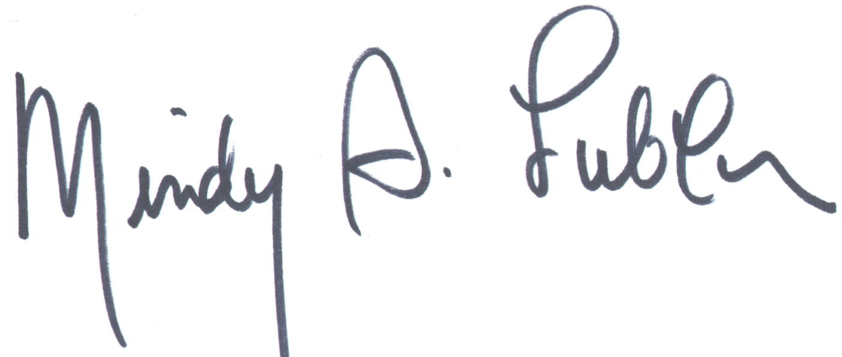
Mindy S. Lubber
On behalf of Business for Innovative Climate and Energy Policy [BICEP] *
President, Ceres

cc: David L. Strickland, Administrator, National Highway Traffic Safety Administration
Gary Guzy, Deputy Director and General Counsel, White House Council on
Environmental Quality

*BICEP members include Anvil Knitwear, Aspen Skiing Company, Avon, Inc, Ben & Jerry’s, Clif Bar, eBay, Eileen Fisher, Gap Inc, Jones Lang LaSalle, Levi Strauss & Co, New Belgium Brewing, Nike, The North Face, the Outdoor Industry Association, Seventh Generation, Starbucks, Stonyfield Farm, Symantec, Timberland and the Portland Trail Blazers.

ARB’s analysis concludes that consumers will see net savings from great vehicle efficiency associated with the GHG standards; approximately $4,000 over the lifetime of a MY 2025 vehicle. “Advanced Clean Cars Summary,” p. 10, Table 5, December 14, 2011. In turn, these savings will be invested in the broader economy.
http://www.ceres.org/resources/reports/more-jobs-per-gallon/view
Approximately equivalent to the 4% scenario presented in EPA and NHTSA’s Joint Notice of Intent, “2017 and Later Model Year Light Duty Vehicle GHG Emissions and CAFE Standards;” EPA 40 CFR Parts 85, 86, and 600; http://edocket.access.gpo.gov/2010/2010-25444.htm

