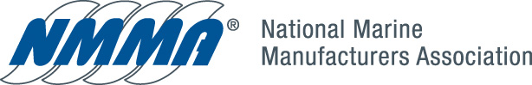

May 25, 2009

Mr. Michael Carter
California Air Resources Board
9528 Telstar
El Monte, California 91731

Dear Mike:

The National Marine Manufacturers Association (NMMA) has completed its review of the amendments to the 15-day notice of Staff’s Modifications to the Proposed Regulation Order for Marine Engines and Vessels. We appreciate the efforts of CARB staff to work with us on these modifications and to have the opportunity to review the rule in the second 15-day notice period. NMMA has one comment regarding the harmonizing of the emission test requirements and timing with EPA. Once this modification is made, NMMA members have agreed that we support this rule.

The comment is that EPA has reassigned the location for its test procedures for marine engines from 40 CFR Part 91 to 40 CFR Part 1065. In the CARB rule there will be new design engines that will be certified to the the new test procedures in Part 1065, but there will also be carry over engines that meet the CARB requirements and were certified under Part 91. The rule needs to have language that recognizes Part 91 for those engines where the certification will be carried over until 2013.

One suggested remedy would be to add language in the Final Statement of Reason (FSOR) that clarifies that carry over engines previously certified under 40 CFR Part 91 continue to be certified under this part until 2013

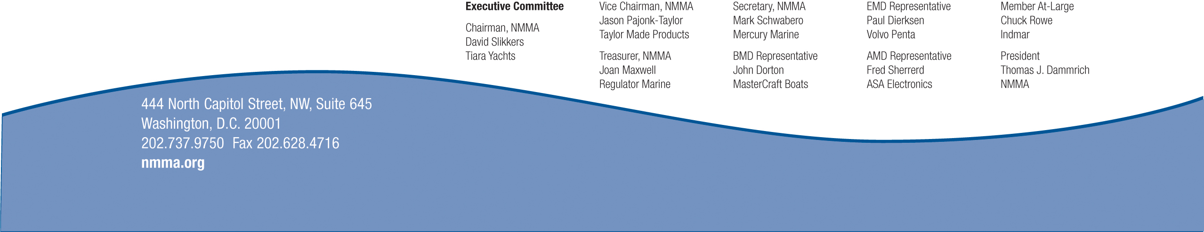

Mr. Michael Carter
Page 2

Thank you for the opportunity to provide comments on the 15- day notice.
If you have any questions, please do not hesitate to call me at 202-737-9757 or
jmcknight@nmma.org.

Sincerely,

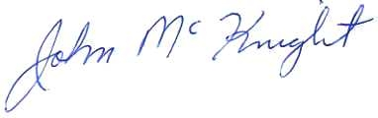
John McKnight, Director
Environmental & Safety Compliance

Cc: Scott Rowland
Jeff Lowry

