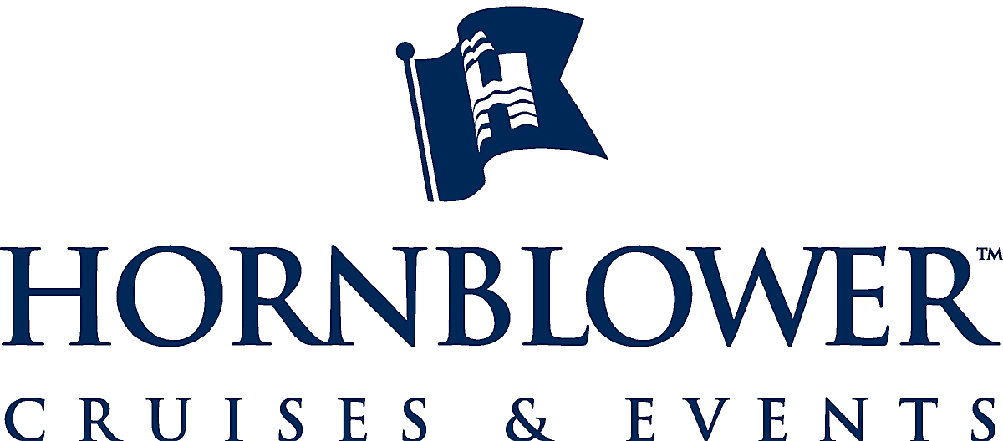

March 26, 2008

Ms. Mary D. Nichols, Chair
And Members California Air Resources Board
1001 “I” Street
PO Box 2815
Sacramento, CA 95812

RE: Amendments to Carl Moyer Program

Honorable Chair Nichols and Members of the Air Resources Board:

As a small vessel owner in California for the last 25 years I would like to thank you for your leadership in the creation and administration of the Carl Moyer program.

In review of the proposed changes and up-date to the Moyer program, we note many of the same thoughts offered by the Construction Industry Air Quality Coalition. We believe it is time to modify the program to allow its resources for projects that may not currently be funded due to the expansion of regulatory efforts.

In particular, the pending adoption of the Harbor Craft repower regulations, and the accelerated engine replacement schedules, will affectively eliminate any chance for Moyer funding of a large portion of eligible equipment, placing the entire economic burden of complying on the vessel owners throughout the State. In a thorough review of other funding opportunities offered by the State or Federal government, there are little to no resources available to the industry to comply with the Harbor Craft repower regulations.

As the industry tries to grapple with the significant economic burden (up to $500 – 750,000 per vessel) of the proposed repower legislation, it seems that a logical modification to the Moyer program is to offer assistance to comply with the regulations, such as providing matching money or strategic grants for certain improvements that would allow owners to comply with the goals of the legislation (for example, particulate filters or after burn treatment technologies). One other way to approach the issue may be to specifically target older engines and equipment. Rather than trying to legislate compliance, why not use Moyer funds to target specifically known, older engines and equipment as established by the vessel surveys done in support of the Harbor Craft repower legislation.

In support of modifying the Moyer program to comply with the Harbor Craft repower regulations; we also suggest the following modifications to:

Chapter IX, Section IV (a), item 14:

The following criteria apply to engines subject to ARB’s Harbor Craft Regulation:
“(A) Harbor craft engines receiving a rule compliance extension are ineligible
for Carl Moyer Program funding.” Modify language to say, “if a compliance extension is granted by the Executive Officer then all vessels within 3 years of a compliance date remain eligible for Moyer Program funding”.
(B) Harbor craft engines demonstrating compliance with the regulation through an Alternative Control of Emissions (ACE) are ineligible for Carl Moyer Program funding. .” Modify language to say, “if an Alternative Control of Emissions (ACE) plan is approved by the Executive Director and compliance extensions are granted then all vessels within 3 years of a compliance date remain eligible for Moyer Program funding.”

(C) Engines that demonstrate rule compliance through a mechanism other than engine replacement or installation of an ARB- or U.S. EPA-verified retrofit device are not eligible for Carl Moyer Program funding. Modify language: “Moyer Program funds may be expended for rule compliance through a mechanism other than engine replacement or installation of an ARB or US EPA verified retrofit device.”

Chapter IX, Section IV (f) New Purchase:

New marine vessels with propulsion and auxiliary engines certified to be at least 30 percent cleaner than the applicable NOx emission standard are eligible for Carl Moyer Program funding on a case-by-case basis. While no marine vessel propulsion engines currently are certified as such, engines meeting these emission limits may become commercially available as engine technologies continue to advance.
(1) The eligible costs for a marine vessel new add language: construction and purchase projects shall reflect the difference between the cost of the cleaner-than-required vessel and the cost of a similar vessel that meets existing standards.

(2) New purchase of a ferry is not eligible for add language: complete Carl Moyer Program funding due to the ARB Harbor Craft Regulation requirement that new ferries utilize the Best Available Control Technology, add language: but may be eligible for partial funding of the vessel not related to BACT.

3) Add language to say, Moyer Program funds may be expended for demonstration of either new and/or altered propulsion systems that are at least 30% cleaner than the applicable NOx emission standards, or that would implement new, experimental or demonstration propulsion systems for vessels that might eventually be implemented in other vessels within the state notwithstanding any other specified limitations on funding.

We think this last proposed change is significant and important, since it would provide a source of funding for systems such as solar and wind propulsion that might eventually be implemented throughout California, and which could very significantly reduce global warming-related emissions. Such a source of funding would demonstrate yet again California’s commitment to remain in the forefront of addressing air quality and global emissions in the most innovative ways.

We agree with CIAQC’s recommendations that the Moyer program needs “statutory reconstruction” and that legislation be prepared to create additional categories of funding that would not contain all the limitations now present in the incentive side of the program. As suggested above, the program could create categories that would target specific elements of the harbor craft industry such as older engines, or funding for particulate filters for all vessels with certain types of age of equipment.

We are available to discuss these matters with you and staff at your earliest convenience.

Respectfully submitted,

Joe R. Wyman
Director
Planning and Development
Hornblower / Alcatraz Cruises and Events

Cc: Ed Welch, Director of Legislative Affairs, Passenger Vessel Association

