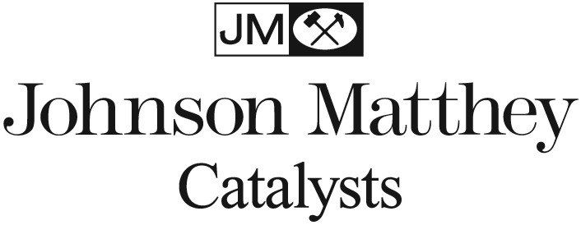
JOHNSON MATTHEY, INC.
380 LAPP ROAD, MALVERN, PA 19355 – 1210 USA
T + 484 RX FOR AIR F + 484.320.2306

27 April 2011

Statement of Johnson Matthey, Inc.
On The
California Air Resources Board Hearing Agenda Item 11-2-3
Public Meeting to Consider Revisions to the Carl Moyer Memorial Air Quality Standards Attainment Program Guidelines

Johnson Matthey is a technology company that has been providing advanced catalytic solutions to reduce emissions for over thirty years. We have worked with both the ARB and EPA to develop and provide ever increasingly advanced technology solutions to reduce emissions from both mobile and stationary sources. Johnson Matthey fully supports the goal of the ARB’s Diesel Risk Reduction Program to significantly reduce particulate matter from California’s inventory of existing diesel engines.

Johnson Matthey has existing business relationships with a number of North American diesel engine manufacturers. We are a major supplier of emission control technology for the EPA’s 2007 and 2010 on-road rule and we will be a major supplier to the engine OE’s for a number of non-road diesel engine and machine manufacturers for application of emission control technology for the EPA’s Non-Road rule for Tier 4 engines.

With regard to retrofit, Johnson Matthey technology has been verified by both ARB and EPA for retrofit of on-road legacy vehicles. Additionally, Johnson Matthey retrofit technology has approval from governmental bodies in both Europe and the Far East. In fact, Johnson Matthey has retrofit over 180,000 vehicles over the past 13 years.

As you may know, Johnson Matthey has existing verified Level 3 PM technology available for the broad range of vehicles covered by the on-road rule. Additionally, we are in the verification process for a combined PM+NOx system for on-road vehicles that would reduce PM on a Level 3 basis, and based on data from verification testing done for both ARB and EPA, we fully expect the SCRT® (1998 – 2003 MY engines) and SCCRT® (2004 – 2006 MY engines) system to be verified by ARB at a Mark 4, or 70% NOx reduction. To support this point further, the EPA has already verified Johnson Matthey’s SCRT® system at 70% NOx reduction for 1998 – 2003 MY engines.

Within the in-use private Fleet Rule, there is a provision for vehicles that are retrofit and meet the 2007 emission standard for both NOx and PM to stay in service up until 2003. In order to accomplish this, engines for model years 1998 to 2003 must reduce NOx by Mark 4 or 70%. Engines for model years 1998 to 2003 must reduce NOx by Mark 2 or 40%.

With an ARB verification for either the SCRT or SCCRT system at a Mark 4 or 70% NOx reduction, the systems would allow 1998 – 2006 model year engines that are retrofit with these systems to meet the 2007 emission standard and they should be eligible for Carl Moyer funding. However, for 2004 to 2006 MY engines retrofit with the SCCRT system, the NOx reduction would be 30% in excess of the required reduction to meet the 2007 standard.

Johnson Matthey would like to propose that ARB consider allowing funding of the SCCRT system for 2003 to 2004 MY engines through Carl Moyer at a higher value than is standard. We would suggest that for the NOx reduction that is two Marks or 30% higher than required be funded at a 30% higher level than is standard. This clearly would create incentives for the retrofit of 2004 – 2006 MY engines with the SCCRT system and provide California with additional NOx reductions from the on-road fleet.

Thank you.

Marty Lassen
Johnson Matthey, Inc.

