December 14, 2010
Clerk of the Board
Air Resources Board
California Air Resources Board
1001 “I” Street
Sacramento, CA 95814

SUBJECT: Proposed Amendments to the In-Use Off-Road Diesel-Fueled Regulation and the Truck and Bus Rule

On behalf of our thirty member counties, the Regional Council of Rural Counties would like to express our appreciation to the Air Resources Board (ARB) and the ARB staff for their efforts to address the concerns related to the financial impact of these regulations during the current economic recession. We wish to thank staff for their diligent work to revise the emissions estimates to be reflective of the reduced equipment population and emissions inventory. And finally, we very much appreciate the proposed amendments that will provide economic relief to fleets.

RCRC previously submitted comments on the In-Use Off-Road Diesel-Fueled Regulation(Off-Road Rule) requesting a delay in implementation and increasing the “low-use” vehicle exemption hours. The proposed amendments do delay implementation and increase the low-use vehicle exemption hours, and also simplify the regulations and requirements, allow fleets to keep vehicles longer, and provide rewards for early action. The amendments will reduce costs to industry in the early years and cut the total cost of the regulation overall.

One issue that has not been addressed that RCRC has brought up since the development of the Off-Road Rule, is the extension of the Captive Attainment Area provision to counties that are classified as nonattainment strictly due to transport. These are the Mountain Counties Air Basin and include the counties of Western Nevada, Amador, Calaveras, Tuolumne, and Mariposa. Compliance with the requirements of the proposed regulations in those counties will not significantly reduce the emissions and will never bring those counties into attainment. However, emission reductions from the contributing upwind districts will lead to the downwind area attainment. Those counties should be afforded the same consideration as their similar rural counterparts.

Again, RCRC would like to express our gratitude to you and all the ARB staff for your continued efforts to understand the rural county constraints. We will continue to work with you and your staff in outreach efforts and implementation of the rule. Thank you for your consideration.

Sincerely,
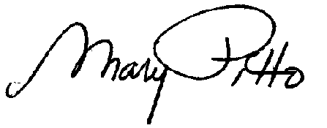
Mary Pitto
Regulatory Affairs Advocate

cc: Erik White, Chief, Heavy-Duty Diesel In-Use Strategies Branch
Kim Heroy-Rogalski, Manager Off-road Implementation Section
RCRC Board Members

