December 15, 2010

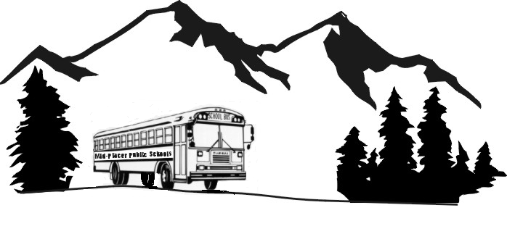
13121 BILL FRANCIS DRIVE, AUBURN, CA 95603-9022
OFFICE (530) 823-4820 OR (916) 652-0794
FAX (530) 823-7264
MID-PLACER PUBLIC SCHOOLS

TRANSPORTATION AGENCY
Mary D. Nichols, Chair
California Air Resources Board
1001 “I” Street
Sacramento, Ca 95812

Dear Chair Mary D. Nichols:

We are opposed to your regulations. Our Agency and its member districts have made devastating cuts. It looks like it is going to get worse in 2011-12 with additional cuts of at least 4% below this year’s level. Your regulations will cost us another $2.9 million. We simply do not have any money to pay that.

Our Agency and our community urge you to either postpone your hearings until after the Governor Elect has presented his budget proposal, or to postpone your regulations until K-12 education and the state gets back on its feet, or to make all your regulations contingent on available funds. If the funds are not available then we do not want to have to fire teachers or eliminate transportation in order to pay for your regulations.

We are extremely concerned about safety of our school children. We are concerned that your regulations would force us to curtail or to eliminate school transportation for most of our disadvantaged children. School transportation is 172 times safer than riding in the family automobile. It will harm our most disadvantaged children because they will have to walk longer distances to school or simply not go.

Your mandates would have the unintended consequence of increasing congestion and thereby increasing air pollution. Parents and children from affluent areas will be able to drive their children to school. It will be the less affluent that will be hurt the most.

We agree with you that we need to update our school bus fleet with new modern buses. Our parents want their children to ride in school buses that have seat belts. However, this is the worst time to impose new mandates on school districts without additional funds.

We were very appreciative of the Proposition 1B funds, but those funds are no longer available to us. Carl Moyer and Federal DERA funds are also not available because of your regulation. We urge you to wait. We know of no other state program that has been cut as much as education. Our member districts cannot afford to take additional funds out of the classroom or to eliminate or reduce school transportation any more. Please work with us to get additional funds for school transportation. Thank you.

Sincerely,

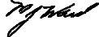
Martin Ward, CEO

