Law of unintended consequences
In 1687, Sir Isaac Newton published his laws of motion, his vision of how the world works. The third of these laws is the one that concerns us today…most simply stated it says for every action there is an equal and opposite reaction.
In the world of human interaction, Newton’s law is known as the “Law of Unintended Consequences.”
The great American sociologist Robert K. Merton clearly defined this concept in his 1936 article titled "The Unanticipated Consequences of Purposive Social Action," Merton identified several sources of unanticipated consequences. The first two—and the most pervasive—were ignorance and error.
Merton labeled the third source the "imperious immediacy of interest." By that, he was referring to instances in which an individual or group wants the intended consequence of an action so much, that they purposefully choose to ignore any unintended effects.
In the case of the proposed off-road diesel regulation, our industry has worked for the past three years to help your staff with a fundamental lack of knowledge about how construction really works and to call attention to outright errors in their calculations of the benefits and financial impacts in the rule. In some cases, we have been successful, in others, not so much.
We have made no progress at all in remediation of the “imperious immediacy of interest,” where this rule is concerned. Despite acknowledging that the industry’s emissions would reach their goals through the natural process of equipment replacement, staff persisted in using a command-and-control approach, annual targets and brutal punishment for failure to comply.
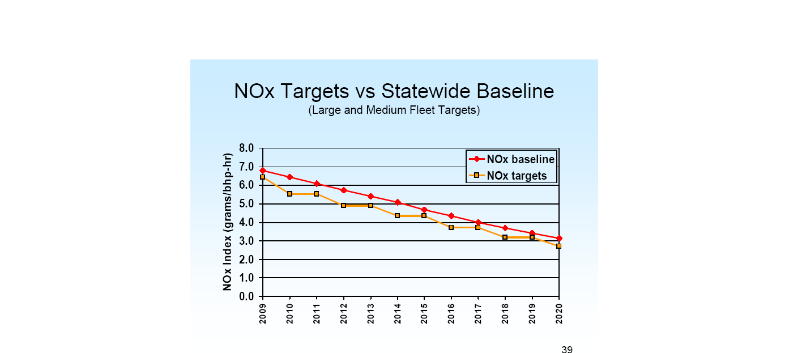
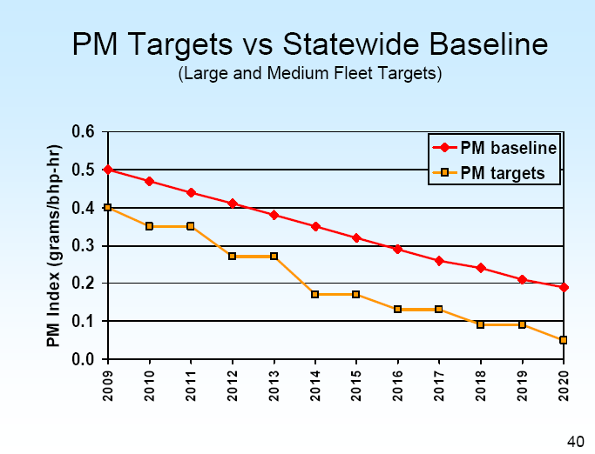
Your staff, the environmental community and the industry all agree that new generation construction equipment, added to our fleets during the normal course of equipment replacement will achieve virtually the same emission reductions, particularly in terms of NOx. This is clearly illustrated in staff generated presentation slides from workshops held earlier this year (see below).

Normal replacement cycles will achieve a 75 percent reduction in particulate matter—the reason why we started on this adventure in the first place. Moderate use of filter systems will get industry to the 85 percent reduction in PM required by the Diesel Risk Reduction Plan adopted by the board seven years ago.
It is clear from the slides that we will meet the NOx requirements without any regulation at all…yet this portion of the rule will cause the greatest damage to our industry. This damage will come from the commandment to replace, repower or retire eight percent of the fleet each year until 2015 and ten percent per year thereafter. This is a 400 to 500 percent acceleration in our normal replacement cycle.
With its rigid annual requirements, this section of the rule ignores the economic environment and unnecessarily limits the options of owners to deal with their fleets. The first compliance date is March 1, 2010, for the newly expanded large fleet category, so most owners will have to start making these decisions very soon…2009 at the latest and every year thereafter until they can meet the ever-declining annual emission targets.
This command-and-control approach will cause several unintended consequences.
Confusion over the final version of the rule is already having an impact on new equipment sales. Fleet owners are waiting to see what the requirements are before investing in units that they will have to replace again within the next few years. This is slowing the pace of industry emission reductions.
Since the final goal of the regulation is a near match for Tier 4 engine standards most fleet operators plan to do as little as possible to their existing equipment until the new, cleaner engines are available. Some equipment dealers are reporting sales declines upwards of 40 percent—and are making staffing adjustments accordingly.
Most equipment owners who are at the edge of one of the rigid horsepower definitions—small (<1,500 h. p.) and medium (>1,500 hp but <5,000 h. p.) specifically—will shrink their fleers through the retirement option to benefit from the compliance timing provisions of the rule.
One reason for this is that small fleets (about one-fourth of all machines according to the CARB staff) are exempt from these NOx provisions and medium fleets have until 2013 to start compliance, which means large fleets (redefined in April of this year as >5,000 h. p.) carry the entire NOx burden for the first years of the rule.
Because of this rule, we will see an absolute decline in the fleet numbers. This decline will cost the state dearly in lost competition for the bond projects and all other critical work.
The “retirement” option is the simplest and least expensive way (in the short term) for contractors to achieve the annual percentage requirements. This option will be in play for all Tier 0 and Tier 1 equipment—80 percent of the medium and large fleets according to the staff report, or some 124,000 pieces of equipment over the 10-year compliance period.
Staff estimates 1,000 job losses because of this option, a ridiculously low number—suggesting that less than a tenth of one percent of equipment will be “retired.” Industry’s most conservative estimate is between 30,000 and 40,000 jobs lost.
Why such a difference? Because most contractors increase fleet capacity through the purchase of older used equipment—it performs the same function at a fraction of the cost of new equipment. Many buy equipment to accomplish a specific project and then sell it at auction when the project is finished.
Virtually no compliant equipment will enter the used market in the future as fleet owners chase the emission reduction curve. This will destroy the hundreds of used equipment companies and auction companies throughout the state, putting their workers on the bench.
The highest-level job losses will come through the retirement option exercised by contractors where machines are not replaced due to the high cost of new equipment. Contractors will hunker down, shrink their fleets and fight to survive. For each piece of equipment retired there is a one to one ratio of operators fired with other company and vendor support personnel losing their jobs as well.
Our homegrown equipment rental firms who patiently built their inventories with reconditioned used equipment will be forced to drastically reduce their fleets at just the time when contractors are going to need access to rentals the most. Even the national and dealer-based rental houses are going to be impacted. They normally have the newest equipment, but depend on their ability to sell older machines out the back door for much of their operating capital. That door will be closed because no one will buy a non-compliant machine and everybody is waiting for Tier 4 technology, which is ultimately required to meet the target.
Several equipment manufacturers have told us they are worried that a large percentage of the contractors in California will take this retirement option to its logical conclusion and leave the industry altogether. We are already seeing a demographic trend in this direction. We are hearing of 20 to 40 percent declines in the California contractor base, which makes demographic sense—nearly 50 percent of owners are members of the Baby Boom generation and heading into their retirement years anyway. Because of this rule, these retirees will simply sell their equipment out of state, rather than pass it along to family members or their employees.
When, at some future date, a major earthquake or other disaster strikes and communities want their bridges, buildings and homes rebuilt, they will have wait, wait, wait because of this consequence.
William E. Davis is the Executive Vice President of the Southern California Contractors Association and actively works with the following organizations: The American Concrete Pumping Association, Construction Industry Air Quality Coalition, Engineering and Utility Contractors Association and the Mobile Crane Operators Group. In addition, he works with 43 other associations in informing their members and construction industry media. For more information contact him at williamedavis@cox.net or call 323-726-3511.

