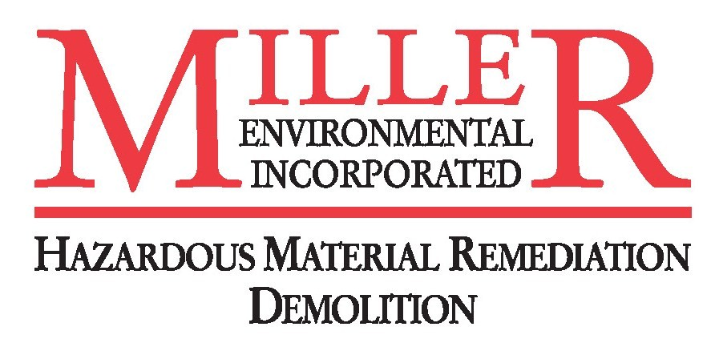

May 22, 2007

California Air Resources Board
P.O. Box 2815
Sacramento, CA 95812

Dear Members of the California Air Resources Board:

The California Air Resources Board (CARB) is currently considering the adoption of off-road diesel regulations that, if implemented as presently drafted, would have a profound, negative impact on California’s infrastructure rebuilding efforts, the health of the state’s construction industry and its overall economy.

We want to be clear: MILLER ENVIRONMENTAL, INC. is very supportive of reducing particulate matter (PM) and NOx emissions from diesel engines. In fact, using the Carl Moyer program over the past five years in Southern California alone, the construction industry has replaced more than 1,000 high polluting engines, resulting in a reduction of more than 3,787 tons of pollution every year.

There is no disagreement that we need to work collectively to improve the state’s air quality and all of us want to provide as healthy an environment as possible for our employees on our job sites. However, in their current form, the Board’s proposed regulations are not viable from an economic or technological perspective.

When CARB first announced its intention to promulgate these regulations in 2000, their plan called for an 18-year timeline to meet the state’s goals of reducing particulate matter emissions only. Due to delays in developing these rules, that timeline has been reduced to 13 years. In addition, the regulation of NOx emissions has been added to the rule – which significantly alters the kind of technology needed for companies to be in compliance.

There currently is no diesel engine that is capable of addressing both PM and NOx emissions. This lack of equipment technology and availability are serious barriers to meeting the targets under these rules. In some cases the engines and equipment necessary to meet the stringent standards in these regulations will not come to market until 2014. In addition, an estimated 165,000 pieces of machinery will have to be retrofitted, re-powered or replaced over the next 13 years to meet yearly reduction targets.

Under the annual emission reduction targets required under this proposal, many contractors will be required to first re-power or retrofit an engine, only to have to turn around a few years later and replace the entire piece of equipment when the technology to do the job right finally hits the marketplace.

While many of California’s larger construction companies have already begun the process of repowering or retrofitting its fleet in anticipation of these regulations, the smaller companies with less than five employees, which make up more than 55 percent of the industry, will be severely hampered by the costs of repowering or retrofitting equipment that, in some cases, are the sole assets of their family-owned businesses. Additionally, many of these companies simply do not have the resources or access to capital to repower or retrofit their engines and may be forced to park the equipment, ultimately costing jobs and revenue to the state’s economy.

We estimate the total industry-wide cost of implementing these proposed rules to be upward of $13 billion. For my company’s fleet alone, the cost will be approx. $500,000. Since the construction is a low-margin business, many contractors will be forced to reduce their fleets and in some cases go completely out of business in order to be in compliance with these regulations.

These rules will also significantly reduce the buying power of the historic $43 billion infrastructure bonds the people of California approved in November. Due to the enormous expense of replacing this equipment – in some cases more than $1 million for each machine – we will be forced to increase the cost of construction projects. This means fewer roads, schools, housing and levees will be built and the pace at which these projects can be completed will be significantly slowed.

However, restoring just five years to the implementation timeframe will give equipment manufacturers time to catch-up and produce engines that will allow the industry to meet California’s progressive air quality standards and distribute the massive expense of purchasing new equipment out over a longer period.

We look forward to working with you, CARB, environmental organizations, the Legislature and other stakeholders to find a feasible solution that achieves the state’s air quality goals while keeping California’s economy moving forward.

Sincerely,
Gregg Miller
Gregg Miller
President
Miller Environmental, Inc.

