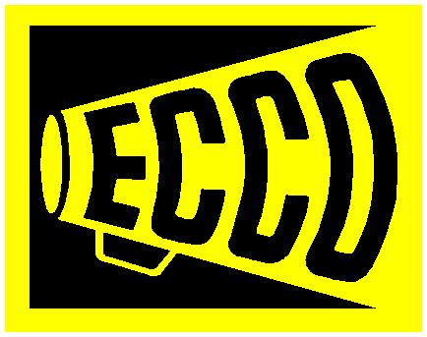
ECCO Equipment Corporation

1417 N Susan St
Santa Ana, CA 92703
714-554-4851
714-554-4071 FAX

May 22, 2007

Clerk of the Board
California Air Resources Board
1001 “I” Street
Sacramento, CA 95814

RE: Comments Regarding the April 2007 Proposed In-Use Off-Road Diesel Vehicle Regulation

Dear Members of the California Air Resources Board and Members of the Staff:

Clean air is a tremendous challenge facing California, the nation, and the entire world. I am thankful for the environmentalists who preceded us and were able to achieve air quality today which, despite the increased number of cars and people, is better than it was 30 years ago. We must continue to demand emission reductions of all kinds.

But the proposed regulation is not the answer. It is unfair, unaffordable, and ineffective.

It is unfair because it forces a fleet to use emissions figures from the worst polluting vehicles in each class when calculating its fleet average. Our fleet’s Tier 1 engines have the PM emissions of Tier 3 engines (as verified by the State of California), yet we only get credit at the Tier 1 level. It is also unfair because we run some Tier 1, 2, and 3 engines which, due to the fact that they were introduced AHEAD of the required deadline, get penalized one Tier level in the CARB fleet average formula. It is also unfair because it assumes a worst-case scenario where all fleet owners allow their engines to get out of tune over time and create more emissions. Our fleet should not be penalized because other fleets run dirty. Finally, agriculture runs some of the very same models of equipment as contractors, with the same engines and emissions, yet only the construction industry is subject to the regulation. Again: unfair.

It is unaffordable because it puts the entire burden of compliance on the consumer. Historically, whenever the government determines that a product is not safe, it holds the manufacturer responsible. However, under this regulation, the State of California is determining that off-road diesel engines are unsafe (for health reasons), but instead of ordering a manufacturer recall, California is going to make the end-user, the consumer, pay for the correction. This would be similar to making every vehicle owner repower their auto or truck engine. Clearly that is a ridiculous demand.

It is also unaffordable because the estimates of resale value of Tier 0 equipment given by CARB are too high. CARB staff claims that because California is just one state, the old machines that drag down a fleet’s average can be sold to operators in other states with no reduction in value! And even if removing 10-15% of the demand for a product while simultaneously increasing the supply 10-15% didn’t affect the price (a violation of one of the most fundamental laws of economics), certainly the imminent adoption of California’s regulation by other states (such as New York) would. Our company estimates a loss of value of Tier 0 equipment of 20-40% immediately, with Tier 1 values falling similarly (beyond normal depreciation) within 5 years. Applying the same laws of economics over the same period of time, the price of desirable Tier 2 and Tier 3 equipment will be affected in the opposite way, rising 20-40%. The cost of the regulation is much higher than CARB estimates. The regulation is NOT cost effective.

It is ineffective for five main reasons: 1) It’s pure paperwork. It has nothing to do with actual emissions. 2) Project owners have already begun setting entirely different (and sometimes contradictory) emissions requirements than the regulation calls for. 3) It’s unenforceable. 4) California will achieve the same result, in a slower time frame, by doing nothing. 5) The necessary emission products don’t exist. I am posting letters from four major engine manufacturers independently indicating their inability to provide sufficient quantities of low-emission engine solutions. The verified retrofit products also leave us convinced of the need for more time for CARB to conduct further investigation: please see the attached photo of the installation of the HUSS product on one of ECCO’s wheel loaders. Does anyone expect this equipment to survive the rigors of construction applications?

I suggest the following approach:
1) Register all off-road diesel equipment.
2) Check “tailpipe” emissions of registered equipment on a random basis. Shut down all machines above a reasonable threshold for its age and horsepower.
2) Use grant money to purchase the oldest and dirtiest machines at market value to remove them from circulation.
3) Allow no new equipment into the state below Tier 2 or Tier 1 with factory installed Level 3 VDECS.
4) Do not exempt agriculture.
The appeal of the above process is that it does not deprive anyone the use of the assets they already own, yet it makes them responsible for actual emissions. It will yield immediate, real results. It’s fair, affordable, and effective. I implore the State of California to consider it, or something like it. Thank you for your commitment to the citizens of California.

David Schmid

President, ECCO Equipment Corporation
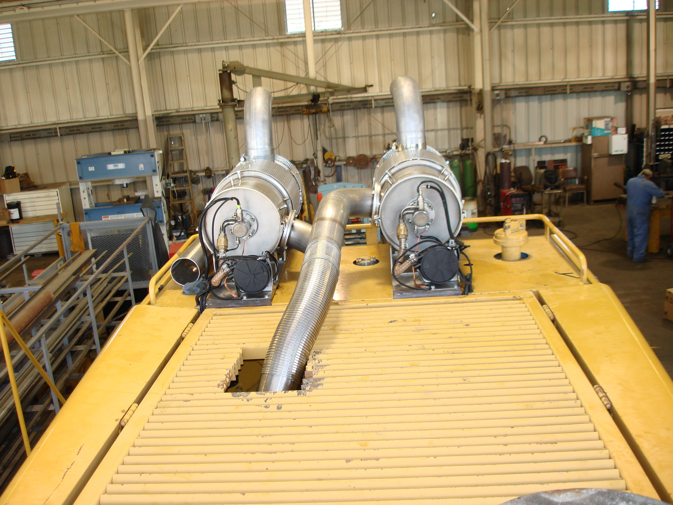
Cat 988F HUSS installation by HUSS personnel

Case New Holland (CNH) statement regarding California Air Resources Board
Proposed Regulation for In-use Off-road Diesel Vehicles
Title 13, CCR, New Section 2449 –

May 2007

Case New Holland (CNH), a major manufacturer of agricultural and construction equipment, markets its products in the State of California through a network of independent dealers contracted to represent one or more brands of CNH products. These include the construction equipment brands of Case, New Holland Construction and Kobelco, and the agricultural equipment brands of CaseIH and New Holland. Products sold in the State of California under the Case, New Holland Construction and Kobelco brands will be affected by the proposed regulations.

CNH supports the efforts of the California Air Resources Board and other regulatory agencies to reduce emissions. We believe our dealers and customers also support technically feasible, economically reasonable methods of advancing improvements in the environment, including air quality. However, we do recognize significant issues exist regarding the proposed regulations and the practicality of the proposed timetable for their implementation.

Fleet Owner Issues

This document was generated primarily in response to input and concerns of our dealers and customers regarding the proposed ARB In-use Off-road Diesel Vehicle regulations. Fleet owners of CNH manufactured equipment have expressed concerns about their ability to meet the fleet average requirements imposed by the regulations. Specific to the role of manufacturers or other solution providers, fleet owners have voiced concerns about availability of sufficient quantities of new equipment, repower engines and certified after-treatment, as well as dealer installation resources for retrofit solutions, to meet the emissions targets and timetables of the proposed regulations.

CNH Response

In order to address the issue of availability of solutions fleet owners will require to meet the proposed regulations, it is necessary to consider this issue within its proper context.

First, forecasting the demand for the various types of solutions that will enable fleet owners to meet the requirements of the proposed regulations requires economic modeling that considers at least the following: global, national, and state economic forecasts and business cyclicality projections, a like set of data for specific businesses in which fleet owners are engaged, the impact of other regulatory actions either within California or elsewhere, and customer intentions regarding the proportion and quantities of each solution type that will be used to meet the regulations (replace, repower, install after-treatment, etc.). This assumes adequate technical solutions will have been developed well in advance of forecasted demand, to allow reasonable lead times for production and installation of the solutions, and absence of issues related to suppliers upon whom CNH will depend for development and/or production of emission solutions.

Second, the resources required to develop, obtain certification of, and launch the required emissions solutions (e.g. technical knowledge, development and innovative skills, experience, testing facilities, etc.), are finite and in high demand throughout the off-road equipment industry. Ongoing dedication of research and development resources toward meeting the federally mandated Tier 3 and Tier 4 non-road engine emissions standards by necessity have consumed our limited resources and will continue to do so through the implementation of Tier 4B. Unfortunately, the specialized physical resources and personnel required to develop solutions that will enable fleet owners to meet the proposed regulations cannot be instantaneously multiplied simply by increasing the monetary investment applied to the issue.

Third, the fact that the currently proposed regulations are based on macro requirements at the fleet average level means manufacturers will be expected to simultaneously supply solutions across a broad range of product types, models and horsepower classes. Emissions reduction requirements tied to introduction of new products enable CNH and other manufacturers to effectively apply the limited resources required to develop and produce lower emission engines over a timeline of a series of new product introductions. This is not the situation proposed by the CARB regulations, since fleet owners will individually determine not only which products, models and specific units they will address in order to attain required fleet averages, but also the type of solution they will apply to each unit or groups of units, and the sequence in which they will do so. Federally mandated standards have generally provided four years product development lead time and implementation spread over three or more years. If the ARB approves this proposal in May 2007, lead time will be thirty-three months and the implementation effective 01 March 2010. This incremental set of variables further complicates the situation and increases the difficulty of responding adequately to the needs our customers will face if the proposed regulations are implemented.

CNH is dedicated to meeting customer needs, including those created through regulation or legislation. As a manufacturer, we fully intend to make every effort to develop the solutions fleet owners of our brand of equipment may need to meet requirements imposed on them by the State of California. However, the combined effect of the nature of the proposed regulations, uncertainty regarding the final form of the regulation, and the extreme difficulty of forecasting individual customer needs for the many CNH legacy products mean that despite the desire and commitment of CNH to fully support the owners of our brands of equipment, we cannot commit to the future availability of the retrofit products required to meet the proposed regulations.
16 May 2007

Re: ARB In-Use Off-Road Diesel Vehicle Regulation

Volvo Position

Background:
The California Air Resource Board (ARB) is poised to enact the “In-Use Off-Road Diesel Vehicle Regulation” aimed at helping to achieve overall California air quality standards. In this legislation, existing off-road equipment is the identified target. Due to the long life of construction equipment, the ARB has determined that waiting for the natural life cycle of these machines to conclude is too long to wait to obtain the air quality impact needed. The regulation addresses this issue by forcing the repower, replacement or retrofit of machines with technological solutions that improve emissions. The cost of this regulation will be fully burdened by the equipment owner.

Assumptions:
- ARB is under the assumption that by providing ARB, “Verified Diesel Emissions Control Strategy (VDECS)” or retrofit equipment, that the solution for equipment owners is complete.
- There is also an indication that the ARB is under the assumption that equipment manufacturers are ready to approve the installation and use of these devices or have solutions of their own waiting to be deployed.

From customer interviews we have determined that an OEM complete solution is the desired solution to the retrofit challenge. This is for a number of reasons:
- Installation left to the will-fit industry often violates machine and VDECS criteria. Installation problems have already been identified in the field resulting in failed VDECS, invalidation of Roll Over Protective Structure (ROPS) certifications due to mounting and excessive engine exhaust backpressures.
- Excessive failure rates were documented with early installations in Switzerland. This will happen under the ARB ruling also. Failures erase emissions gains, impact production and profitability, resulting in additional costs to the equipment owner.
- When customers begin dealing with three or more suppliers (VDECS supplier, machine manufacturer, will fitter, etc.) all supplying highly interactive products under warranty, the responsibility for resulting failures can become a highly debated issue. As it is or is not sorted out, the customer is left to pay.
- Technical lab performance and durability testing of the VDECS by ARB in itself is not adequate testing to approve its use on actual operating equipment.

To address these issues, an OEM verified package is understandably the desired solution by our customers.

From this customer market demand, Volvo CE is investigating the feasibility to supply a retrofit solution. This task is great, however, as each VDECS installation must be verified to meet all machine criteria including reliability and safety. The manpower, investment and time required to address the number of different legacy models is daunting.

As in any large business, product plans are set years in advance. This includes Tier 4a and 4b development requiring significant capital expenditures, resources and time. As the path is set, it is not feasible to reconfigure the product plans to meet the ARB implementation date.

Quality, safety and environmental care are Volvo’s core values and we will fulfil these to the greatest extent possible. Improving air quality is of great importance to Volvo. However, implementation of a VDECS device without proper installation and operating verification threatens what Volvo inherently designs into all its equipment. Volvo CE is working diligently to address all the issues facing its customers today and in the future but regrets that it is not able to commit to the legislation currently proposed by ARB.

