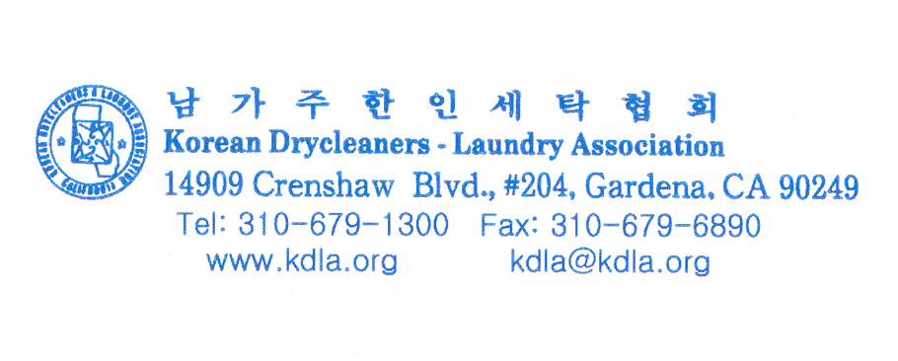

May 22, 2006

Dear Clerk of the Board / Air Resources Board:

I am writing this letter on behalf of the members of the Korean Drycleaners-Laundry Association (KDLA) to express our general support for the proposed amendments to the Airborne Toxic Control Measure for Perchloroethylene Dry Cleaning (ATCM) subject to several comments and recommendations which are explained later in this letter.

As is commonly known, KDLA member businesses have been, and continue to be, tightly regulated by the South Coast Air Quality Management District’s (SCAQMD) Rule 1421 – Control of Perchloroethylene Emissions from Dry Cleaning Systems, ever since it was first adopted in 1994.

The latest amendment to Rule 1421, which occurred in late 2002, requires an agreed upon and orderly transition from the use of perchloroethylene (perc) at dry cleaning facilities to alternative non-perc technologies. The rule also contains requirements for additional recordkeeping and reporting by business owner/operators. Finally, the adoption and subsequent implementation of the amendments to Rule 1421 put our entire industry on the pathway to reduce perc emissions in the South Coast Air Basin by approximately 850 tons per year at full implementation and thus, reduce risk to the maximum extent feasible.

Over a period of time, which spanned more than one year, the provisions of Rule 1421 were reviewed, discussed, and negotiated by representatives of KDLA, the California Cleaners Association, local government officials, community environmental organizations, various vendors, and SCAQMD management and staff.

Few rules have ever been subjected to closer scrutiny by such a broad spectrum of stakeholders.

At the end of the process, no single viewpoint emerged victorious. Rather, there was consensus among the stakeholders that gave confidence to the SCAQMD’s Governing Board in adopting a rule that succeeded in striking a balance between the needs of the environment, public health and safety, small business, and the overall economy of the region.

Our members are accustomed to being regulated by, and complying with, the SCAQMD’s rules, which are usually recognized and accepted as being the most stringent in the state. The KDLA believes, however, that the proposed amendment to the ATCM is also a responsible approach to protecting public health and reducing air pollutants. And we hope that it, too, will recognize and consider the impact on small, minority-owned, businesses and the economy of the state.

We have noticed a few distinctions between CARB’s proposed ATCM and the SCAQMD’s rules for dry cleaners, and our comments are as follows:

Treatment of New and Existing Facilities
The proposed amendment to the ATCM would treat relocated perc facilities the same as new facilities. SCAQMD’s rules treat relocated perc facilities as existing facilities. Since our members recognize the SCAQMD as the lead agency for stationary sources in the greater Southern California region, and because the owners of these “mom and pop” businesses often have limited English comprehension skills, we believe that compliance with SCAQMD’s rules would be equally protective of public health and reduce the potential for our members falling victim to being cited for inadvertently violating a control measure by an agency that is foreign to them. We, therefore, hope that any dissimilarities or conflicts would be resolved in favor of the SCAQMD rules that apply to our industry.

AB 998: Non-Toxic Dry Cleaning Incentive Program (Advantages/Disadvantages)
The California State Legislature enacted Assembly Bill (AB) 998, which establishes this program. The objective of the program is to provide financial assistance to California dry cleaners who replace their existing perc dry cleaning systems with non-toxic and non-smog forming systems such as water-based and carbon dioxide (CO2) cleaning systems.

AB 998 requires CARB to assess a three-dollar ($3) per gallon fee on the importers of perc for dry cleaning operations beginning January 1, 2004. This fee will increase one dollar ($1) per gallon per year from 2005 through 2013. As required by the legislation, the majority of these funds were used to establish a grant program to provide $10,000 grants to assist dry cleaners in switching to non-toxic and non-smog forming cleaning technologies. The balance of funds are used to establish a demonstration program to showcase these technologies statewide. CARB is to ensure that at least 50 percent of the grant funds provided are awarded to qualifying dry cleaners in environmental justice communities of minority populations or low-income populations.

AB 998 does not mandate that the grant funds be used only for water-based cleaning systems or C02 technology, yet our members have come to believe that other non-perc technologies, such as hydrocarbon solvent cleaning are excluded from this grant program. Clearly, when viewing CARB’s printed promotional materials, as well as the information on its website, there is a noticeable bias towards water based and C02 technologies. Further, it is our belief that the AB 998 program has had less than enthusiastic support from dry cleaners.

By contrast, the grant program that is administered by the SCAQMD has had remarkable results in spite of the industry’s undeniable preference for using perc. The $2 million dollars, which was originally used to fund the program, has long since been apportioned out to qualified dry cleaners. In April 2006, the KDLA, on behalf of all dry cleaners, applied for and was granted another $1 million by the SCAQMD’s Governing Board to continue the program to meet the demands of a receptive industry. Under this program, perc dry cleaners who find it advantageous to move to a non-perc technology may apply for a grant of $20,000 for a qualifying C02 system; $10,000 for a qualifying water-base system, and $5,000 for a qualifying hydrocarbon machine.

In spite of a handful of claims by individuals outside our association and the majority of the dry cleaning industry, many in our industry continue to have legitimate concerns about water based cleaning systems in that they are more labor intensive and require the purchase and installation of additional tensioning equipment to minimize shrinkage. Ours is an industry where the customer must have confidence that their soiled garments will be returned completely cleaned, and will be the same size as they were when they were entrusted to their neighborhood dry cleaner. If this confidence is lacking, the small business is sure to fail.

C02 cleaning technology is much more capital intensive than any other technology, yet it has many of the same disadvantages as water based systems. In addition, there are still persistent obstacles in finding detergents that are sufficiently aggressive and acceptable to our industry as a whole.

From a purely regulatory perspective, our industry, SCAQMD, and other stakeholders in the region recognized and accepted sometime ago that there would be a tradeoff of modestly higher volatile organic compounds in exchange for an accelerated reduction in perc usage when hydrocarbon machines are used. Nevertheless, this technology has proven to be widely accepted by our members, and by other dry cleaners.

Our recommendation is that CARB consider promoting hydrocarbon technology as an acceptable alternative to perc, and start offering a financial incentive similar to that offered by SCAQMD.

Finally, we have received reports of people having considerable difficulty in finding any reference to the AB 998 program on CARB’s website. In light of the number and significance of the claims and counter claims associated with perc usage, it might be beneficial to everyone for CARB to consider modifying its website to make it easier to locate information about the AB 998 program.

Sincerely,

Mun S. Kim, President
Paul Choe, Vice President

