BEFORE THE CALIFORNIA AIR RESOURCES BOARD

PROPOSED AMENDMENTS TO THE AIRBORNE TOXIC CONTROL MEASURE FOR EMISSIONS OF PERCHLOROETHYLENE FROM DRY CLEANING OPERATIONS

Comments of the
International Fabricare Institute
14700 Sweitzer Lane
Laurel, MD 20707

Jon Meijer
Vice President of Membership

July 29, 2026

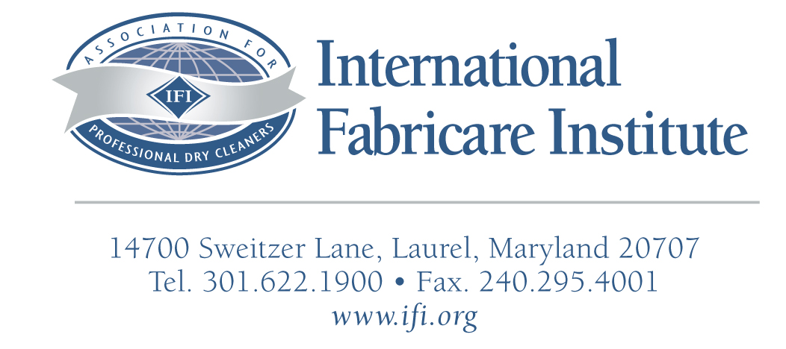

July 29, 2026

Clerk of the Board
Air Resources Board
1001 I Street, 23rd Floor
Sacramento, CA 95814

Dear Sirs:

The International Fabricare Institute (“IFI”) is a national and international trade association representing over 5,000 retail dry cleaners, launderers, and wetcleaners in the United States alone. On behalf of its members in California and the industry, IFI submits the following comments on the proposed amendments to section 93109, title 17, California Code of Regulations (CCR). As part of the California Air Toxics Control Measure, the proposed amendments would further reduce perchloroethylene (perc) emissions from perc dry cleaning plants.

A. Introduction
IFI appreciates the opportunity to provide written comments on the Air Toxics Control Measure (ATCM). Section 93109, title 17, California Code of Regulations. In 2003, the Air Resources Board (ARB) began its technical review of the existing dry cleaning regulation and found that additional regulation was needed to further control emissions from perc dry cleaning plants. While the proposed amendments include additional conditions and restrictions on perc use, equipment, and locations, IFI applauds ARB’s decisions to allow for the continued use of perc by dry cleaners in California.

B. Emissions From Dry Cleaners
Since the 1993 regulation to reduce perc emissions was adopted, California dry cleaners have done an incredible job in reducing perc vapor emissions. A combination of better equipment, efficiency, maintenance, and controls are largely responsible for the decline in perc use in California. Overall, perc use in the United States has dropped significantly. Between the years 1993 and 2004, perc solvent consumption dropped by nearly 75% according to an annual survey of perc production conducted by the Textile Care Allied Trades Association. In fact, ARB’s own estimates based on data collected from the “Perc Solvent Distributors Survey” “suggests that the California Dry cleaning industry uses less perc than the national average.” Additionally, a comparison of ARB’s 1991 and 2003 survey shows that cleaning efficiency of dry cleaners (clothes cleaned per pound of solvent used) has more than doubled, going from approximately 11,600 lbs. per drum to nearly 30,000 lbs. per drum. Most of this increase is based on the availability of tighter equipment and controls.

C. Co-residential Facilities

IFI understands that most co-residential facilities already utilize an enhanced ventilation system as required by the Bay Area Air Quality Management District. For the few remaining co-residential dry cleaners yet to be regulated, IFI believes that ARB should continue to explore options utilizing equipment, technology, and maintenance that will allow for their continued use beyond 2010. IFI believes that emissions can be further reduced by utilizing a combination of equipment and controls including the use of enhanced ventilation systems (vapor barriers). This type of technology is already required and successfully used in the state of New York, New York State Department of Environmental Conservation, Regulations Part 232, for Perchloethylene Dry Cleaning Facilities. The use of this type of enhanced ventilation system, while expensive, will allow a co-residential facility to continue operating for the foreseeable future. Adopting this technology will further reduce emissions from co-residential facilities, while still allowing the dry cleaner to remain in business. Unfortunately, without this option, many of these cleaners would be forced out of business by 2010.

- Requirements For Co-residential Facilities versus Existing Facilities
It is IFI’s understanding that ARB does not intend to regulate co-residential facilities under both the requirement for “co-residential” facilities as well as the requirement for “existing facilities.” However, under a strict reading of the regulatory language, it appears that a co-residential facility would also be regulated under the requirements-for “existing facilities”. Such facilities would include an additional 2008 or 2009 compliance deadline. Obviously, cleaners in co-residential facilities should not have to comply with a 2008 or 2009 “existing facility” deadline, if ARB plans to ban perc co-residential facilities by 2010. This of course would be unrealistically burdensome, unless these requirements were modified to allow for the continued use of perc dry cleaning in co-residential facilities utilizing an enhanced emission control option as recommended by IFI and the state of New York.

E. Leak Detection
IFI supports the use of a non-quantitative leak detector that can be used by dry cleaners for leak detection purposes. However, we are opposed to the dry cleaners having to purchase an expensive “quantitative” perc detector for measuring the perc concentration in the drum of the dry cleaning machine. While these perc detectors provide the user with quantitative results, they are expensive. Additionally, there is little or no information provided by ARB regarding maintenance, calibration, life expectancy, and other critical information regarding these types of perc detectors, which tend to be extremely sensitive. IFI believes that it might be more appropriate for each of California’s 35 Air Control Districts could purchase this type of equipment. Most of California’s dry cleaners are represented by just a few of the districts, such as SCAQMD and are already scheduled for or are currently inspected annually. Why penalize the cleaners from those districts who have yet to establish their own annual inspections? Why not simply put the burden on the local district? IFI also believes that it is difficult and unfair to expect that the local cleaners associations purchase this type of equipment. Has anyone considered the cost of getting these perc detectors to the local cleaner? What about packaging or shipping? As ARB knows, perc leak detectors are extremely fragile and extremely sensitive.

F. Enhanced Ventilation Systems

IFI appreciates the fact that ARB will allow dry cleaners to choose the type of enhanced ventilation system that works best for the facility, after considering space, cost, construction, and other relevant obstacles. However, IFI’s own research indicates that a full Vapor Barrier Rooms costs around $10,000 to install versus the upper end cost of $8,500 as reported by ARB

G. Alternative Technology
IFI continues to support development of an alternative process for drycleaning, including those processes that have been described over the years by EPA’s “Design for the Environment Garment and Textile Care Program, the Bay Area Air Quality Management District (BAAQMD), the Air Resources Board, and others. IFI’s own support for alternative solvents included our 2002 Research Fellowship, which showed GreenEarth® is a “viable alternative for the dry cleaning industry…” IFI’s chief concern with the use of some of the current alternative technologies is that regulatory agencies may be jumping the gun. The fact that these alternatives have some small penetration in the market should not imply that these alternatives are viable.

IFI is greatly concerned that ARB may assume that these process do actually work, meaning that the alternatives perform well in cleaning, handling garments currently cleaned, have realistic/affordable labor and operating costs, have realistic capitol costs, and have no known or expected health issues.
While IFI supports the development of new alternative solvents, recent work with the various agencies including the South Coast Air Quality Management District, BAAQMD, EPA, and others has shown us that opinions vary greatly about alternative solvents’ use, especially with regard to human health and the environment–some of which is described in the California Dry Cleaning Industry Technical Assessment Report. At best, information on many of the new technologies is still in the early stages. However, information on alternatives developed by ARB and other regulatory agencies is used by dry cleaners to make informed decisions. Unfortunately, the conflicting data that has already been generated by other districts may have a detrimental impact on businesses in California that may have already purchased new alternatives just to be told that there may be a problem with their use in the future.

Another issue that is very critical to IFI has little to do with the alternatives at all, but rather support for the equipment. IFI continues to receive reports from its members in California who are not getting the support from the equipment manufacturers with the use of some of these alternatives. As you are well aware, the science behind these alternatives and developing adequate equipment for their use is still very new and not completely understood.

Over the years, IFI has seen its share of so-called potential alternatives. Many cleaners have been burned from their use. 1,1,1 Tricloroethane, and Freon 113 are two such examples of alternatives that were ultimately banned on the basis of their potential to deplete stratospheric ozone, despite the fact that they were actively promoted as “safer” alternatives by regulatory agencies in California for many years. Again, while IFI is very excited about some of the newer alternatives, which alternative will withstand the test of time is still unknown. In five years, which alternative will be left standing? What will a dry cleaner do if it chooses the wrong alternative? This type of shake--out will happen– it is just a matter of when.

H. Wetcleaning
“IFI knows a great deal about wetcleaning and strongly supports its increased use as an adjunct to dry cleaning. IFI believes that most fabric care plants can process 30-40% wet cleaning with minimal difficulty, and 60-80% with training, skilled labor, and specialized equipment and chemicals. This position mirrors that of The Center for Neighborhood Technology and is validated by IFI studies and other independent, well run studies.
The percentage of wetcleaning a plant can achieve is increased by the commitment of an individual to maximize their plants wetcleaning capabilities. With a very high commitment, a plant may achieve higher that 80% wetcleaning.”

Since the original release of EPA’s “Cleaner Technology Substitute Assessment for Professional Fabricare Processes,” released in June 1998, there are no more 100% wetcleaners today than there were at the time of its release. To the best of our knowledge there are only a handful of 100% wetcleaners today and their ability to do 100% of the cleaning is suspect at best. In fact, several well-known 100% wetcleaning facilities have now moved primarily to solvent--based cleaning and use wetcleaning as an adjunct process. IFI is very happy to see that wetcleaning equipment has come a long way and in fact does a better job of cleaning some types of garments than dry cleaning. However, many types of fabrics cannot be wetcleaned, even with state-of-the-art equipment and chemicals.

The primary reason that dry cleaners have not embraced wetcleaning as a complete replacement for perc is simple––wetcleaning is not a 100% replacement. In fact, cleaners who have embraced wetcleaning admit that 40-60% of the garments that come over the counter can actually be wetcleaned.

I. FTC Care Label Rule
The Federal Trade Commission (FTC) Care Label Rule does not recognize alternative cleaning methods. Who pays for a damaged garment if it is processed by an alternative solvent? Although, the FTC does not require cleaners to follow the care instruction on the label, it certainty suggests that they do. The question of liability is a very serious one and it is quite clear that the liability will be borne by the cleaner.

Summary
IFI commends Air Resources Board for its efforts to reduce perc emissions. IFI will continue its effort to work with dry cleaners to reduce perc emissions. Over the last 10 years, California cleaners have reduced emissions by 80%, and already use some of the best cleaning technologies available. We believe that the goal to reduce emissions can be done without unduly burdening the industry. IFI urges ARB to promulgate a fair and reasonable standard, and stands ready to continue to work with the ARB as it reviews the proposed changes.
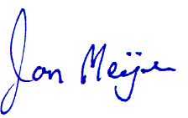
Sincerely,

Jon Meijer
IFI Vice President of Membership

California Dry Cleaning Industry Technical Assessment Report, Perc Solvent Distributors Survey Results, page IV-18 February 2006
California Dry Cleaning Industry Technical Assessment Report, Perc Solvent Distributors Survey Results, page I-2, Table I-1, Statewide Estimates of Dry Cleaning Operations, February 2006
California Dry Cleaning Industry Technical Assessment Report, page VII-8, February 2006
IFI Research Fellowship, No. F-47, Copyright International Fabricare Institute, September 2002
Wetcleaning, Focus on the new wetcleaning systems, IFI 2005

