BEFORE THE CALIFORNIA AIR RESOURCES BOARD

PROPOSED AMENDMENTS TO THE AIRBORNE TOXIC CONTROL MEASURE FOR EMISSIONS OF PERCHLOROETHYLENE FROM DRY CLEANING OPERATIONS

Comments of the
International Fabricare Institute
14700 Sweitzer Lane
Laurel, MD 20707

Jon Meijer
Vice President of Membership

July 31, 2026

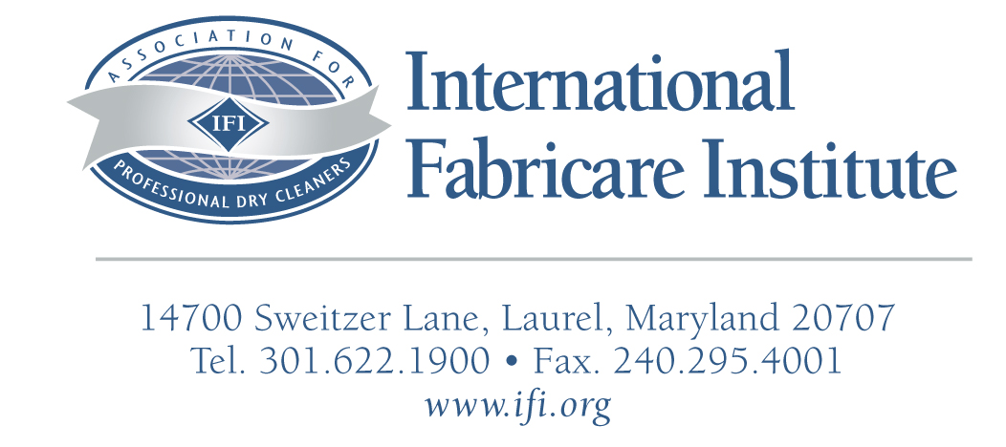

July 31, 2026

Clerk of the Board
Air Resources Board
1001 I Street, 23rd Floor
Sacramento, CA 95814

Dear Sirs:

The International Fabricare Institute (“IFI”) is a national and international trade association representing retail dry cleaners, launderers, and wet cleaners in the United States. On behalf of its members in California and the industry, IFI submits the following comments on the proposed amendments to section 93109, title 17, California Code of Regulations (CCR). As part of the California Air Toxics Control Measure, the proposed amendments would phase out Perc dry cleaning by January 1, 2023.

A. Introduction
IFI appreciates the opportunity to provide written comments on the Air Toxics Control Measure (ATCM). Section 93109, title 17, California Code of Regulations. In 2003, the Air Resources Board (ARB) began its technical review of the existing dry cleaning regulation and found that additional regulation was needed to further control emissions from perc dry cleaning plants. These recommendations were brought before the ARB on May 25, 2006.

The proposed amendments included additional conditions and restrictions on perc use, equipment, and locations, but also allowed for the continued use of perc by dry cleaners in California. It was unfortunate that the Board decided to reject their own staff’s recommendations on a proposal that included one of the strictest standards for perc dry cleaners in the U.S. On behalf of our members in California, we urge the Board to reconsider their position on phasing out perc use in dry cleaning.

B. Emissions From Dry Cleaners
Since the 1993 regulation to reduce perc emissions was adopted, California dry cleaners have done an incredible job in reducing perc vapor emissions. A combination of better equipment, efficiency, maintenance, and controls are largely responsible for the decline in perc use in California. Overall, perc use in the United States has dropped significantly. Between the years 1993 and 2004, perc solvent consumption dropped by nearly 75% according to an annual survey of perc production conducted by the Textile Care Allied Trades Association. In fact, ARB’s own estimates based on data collected from the “Perc Solvent Distributors Survey” “suggests that the California dry cleaning industry uses less perc than the national average.” Additionally, a comparison of ARB’s 1991 and 2003 survey shows that cleaning efficiency of dry cleaners (clothes cleaned per pound of solvent used) has more than doubled, going from approximately 11,600 lbs. per drum to nearly 30,000 lbs. per drum. Most of this increase is based on the availability of tighter equipment and controls.

C. Local Air Districts
Although the South Coast Air Quality Management District implemented their phase-out of perc in 2002, no other air districts in California have followed suit. On July 27, 2006 U.S. EPA promulgated the revised National Perchloroethylene Air Emission Standards for Dry Cleaning Facilities (NESHAPS).

While the revised NESHAP does include a perc phase out for facilities located in co-residential facilities, as did the proposed amended Air Toxics Control Measure (ATCM), it did not impose a ban for any other type of facility. The revised NESHAP sought to further decrease emissions from dry cleaners, and did so utilizing “new developments in production practices, processes, and control technologies.”3 The April ’06 proposed amendments to the ATCM also sought to further reduce emissions using a technology-based approach. And while states have the authority to develop their own standard, which could include a ban on perc use, none have done so. IFI believes that decisions to increase regulations or further restrict perc use, including a phase-out are better handled at the local level given the state’s diverse topography.

D. Alternative Technology
IFI continues to support the development of “viable” processes for drycleaning, including those processes that have been described over the years by EPA’s “Design for the Environment, Garment and Textile Care Program,” the Bay Area Air Quality Management District (BAAQMD), South Coast Air Quality Management District (SCAQMD), the California Air Resources Board (CARB), and others. In fact, IFI’s own support for alternative solvents includes our 2002 Research Fellowship, which showed GreenEarth® to be a “viable alternative for the dry cleaning industry…”4 IFI is also well versed in the use of hydrocarbon solvents, which have been successfully used by dry cleaners for many years.

IFI’s primary concern with the alternative technology discussion is that regulatory agencies may be jumping the gun. The fact that some of the current alternatives have some small penetration in the market should not imply that they are viable options. IFI is greatly concerned that ARB may assume that these processes do actually work, meaning that the alternatives can handle garments currently being cleaned, have realistic/affordable labor and operating costs, have realistic capitol costs, and have no known or expected health issues.
While IFI supports the development of new alternative processes, recent work with various agencies including the ARB, South Coast Air Quality Management District, EPA, and others has shown us that opinions vary greatly, especially with regard to human health and the environment–some of which are described in the California Dry Cleaning Industry Technical Assessment Report. At best, there are many unresolved questions about the alternative processes that exist today. Even with alternatives that have been around for some time, like hydrocarbon, serious questions have been raised by agencies over their viability as an alternative beyond the near future. By all accounts, the most popular choice thus far for dry cleaners has been a hydrocarbon process. However, at what point will CARB make it absolutely clear that this and other solvents will be acceptable beyond the near future or will the dry cleaners have to worry every time the state looks to reduce VOC’s? And while, IFI’s research found that Green Earth® solvent was a viable replacement for perc, industry still awaits word from the Office of Environmental Health Hazard Assessment for their assessment of the solvent.

The problem is that, information on alternatives developed by ARB and other regulatory agencies is used by dry cleaners to make informed decisions and dry cleaners in the state of California need clear guidance on the acceptability of alternatives by ARB before being forced into choosing an alternative that may or may not be acceptable in the future.
The financial burden of switching technologies twice (once from perc and then from another process later found unacceptable) is too great for small business to absorb and remain in business.

Over the years, IFI has seen its share of so-called potential alternatives and many cleaners were burned from their early movement to them. 1,1,1 Tricloroethane, and Freon 113, two examples of alternatives that were ultimately banned on the basis of their potential to deplete stratospheric ozone, despite the fact that they were actively promoted as “safer” alternatives by regulatory agencies for many years. Again, while IFI is very excited about some of the alternative processes, which process will withstand the test of time is still unknown. In five years, which process will be left standing?
What will a dry cleaner do if they choose the wrong alternative? This type of shakeout will happen and it is just a question of when.

E. Wet cleaning
IFI has over 80 years of experience with wet cleaning and strongly recommended and supported its increased use as an adjunct to dry cleaning. Based on IFI’s experience, most fabric care plants can process 30-40% wet cleaning with minimal difficulty, and can process up to 60-80% with training, skilled labor, and specialized equipment and chemicals, but with significantly increased expenses. The percentage of wet cleaning a plant can achieve is increased by the commitment of an individual to maximize their plants wet cleaning capabilities. With a very high commitment, a plant may achieve higher than 80% wet cleaning, but not without an increase in expense.5 This position was supported by EPA’s wet cleaning partnership, comprised of Green Peace, The Center for Neighborhood Technology, and IFI and is validated by various studies done or reviewed by each partner.

Since the original release of EPA’s “Cleaner Technology Substitute Assessment for Professional Fabricare Processes,” released in June 1998, there are no more 100% wet cleaning facilities today than there were at the time of its release. To the best of our knowledge there are only a handful of 100% wet cleaning facilities today out side of California and their ability to do 100% of the cleaning is suspect at best. IFI’s experience with the few wet cleaners that operated on the east coast was that these facilities were not wet cleaning 100% of the garments and that many garments were sent to a traditional dry cleaner. In fact, several well-known 100% wet cleaning facilities have now moved primarily to solvent--based cleaning and use wet cleaning as an adjunct process. IFI is very happy to see that wet cleaning equipment has come a long way and in fact does a better job of cleaning some types of garments than dry cleaning. However, many types of fabrics cannot be wetcleaned, even with state-of-the-art equipment and chemicals.

The primary reason that dry cleaners have not embraced wet cleaning as a complete replacement for perc is simple––wet cleaning is not a 100% replacement. In fact, cleaners who have embraced wet cleaning admit that only 40-60% of the garments that come over the counter can actually be wet cleaned.

The resistance of dry cleaners to fully embrace wet cleaning as a 100% replacement is well founded and this issue goes well beyond whether or not a garment can be satisfactory cleaned with this process. The issue goes to increase liability as a result of going against the recommended care label instructions.

F. FTC Care Label Rule
The Federal Trade Commission (FTC) Care Label Rule does not recognize alternative cleaning methods, such as wet cleaning. IFI is very active in both national and international care labeling efforts. IFI gave testimony and took an active role in working with the FTC in the two major revisions to the care labeling rule that took place in 1984 and in 1997 and in the latest revisions that went through in 2000 where the issue of wet cleaning was addressed. The FTC position at that time and the position that is outlined on the FTC website is that the Commission concluded “that some level of standardization is necessary before a ‘Professionally Wet Clean’ instruction can be placed on garments that are to be sold throughout the entire country.” The Commission’s position was based on the fact that there is no appropriate test method for wet cleaning which would give garment manufacturers clear guidance for establishing a reasonable basis for a wet clean instruction. The American Association of Textile Chemists and Colorists (AATCC) develops those test methods in the United States. IFI is a member of that organization and has served as chairman of the committee that oversees the development of Professional Cleaning test methods. And while the issue of developing a method for wet cleaning has been discussed, currently there is no work being done on development of a test method.

Additionally, the FTC only requires manufacturers to provide instructions for a single cleaning process. Which type of process do you think the manufacturers will choose? Manufacturers will recommend the process they feel is easiest with regard to processing the garment and result in the least damage and headache for them, while taking into consideration their customer base and their preferences in terms of care of their garments. You can rest assured that a company like Dolce & Gabanna is not going to modify their care label because they have been educated to do so.

Who pays for a damaged garment if it is processed by an alternative process? Although, the FTC does not require cleaners to follow the care instruction on the label, it certainty suggests that they do. The question of liability is a very serious one and it is quite clear that the liability will be borne by the cleaner.

G. Is there financial assistance for dry cleaners that would like to replace their Perc dry cleaning systems?

So far, (AB) 998, which established the Non-Toxic Dry Cleaning Incentive Program only provides grants to cleaners who replace their current perc dry cleaning systems with non-toxic and non-smog forming systems. Financial assistance ($10,000) is being provided to cleaners who opt for professional wet cleaning systems or carbon dioxide (CO2) cleaning systems. As previously discussed, resistance by dry cleaners to embrace a 100% wet cleaning is well founded. Additionally, the use of CO2 has its own obstacles, including, but not limited to large equipment capitol costs. At least SCAQMD permits dry cleaners to use these monies for the purchase of other alternative technologies, like hydrocarbon. SCAQMD’s grants for converting to other process have totaled more than $2,000,000, far more than what has been offered by CARB at this time. Dry cleaners have limited resources for which to borrow monies from financial institutions. According to the “The Dry-Cleaning Facility Survey,” 40% of the dry cleaners are grossing less than $100,000,6 which is significantly less than the national and state average gross sales for dry cleaners. Without a serious commitment from CARB, many of these cleaners do not have the resources to move to an alternative process and will go out of business.

Summary
Over the last 10 years, California cleaners have reduced emissions by 80%, and already use some of the best cleaning technologies available. We believe that the goal to reduce emissions can be done without unduly burdening the industry. IFI urges ARB to promulgate a fair and reasonable standard.

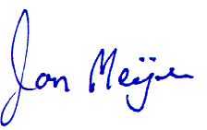
Sincerely,

Jon Meijer
IFI Vice President of Membership

California Dry Cleaning Industry Technical Assessment Report, Perc Solvent Distributors Survey Results, page IV-18 February 2006
California Dry Cleaning Industry Technical Assessment Report, Perc Solvent Distributors Survey Results, page I-2, Table I-1, Statewide Estimates of Dry Cleaning Operations, February 2006
3 71 Federal Register 42723, July 27, 2006
4 IFI Research Fellowship, No. F-47, Copyright International Fabricare Institute, September 2002
5 Wet cleaning, Focus on the new wet cleaning systems, IFI 2005
6 California Dry Cleaning Industry Technical Assessment Report, Business Information Table IV-1, Page IV-2 February 2006

