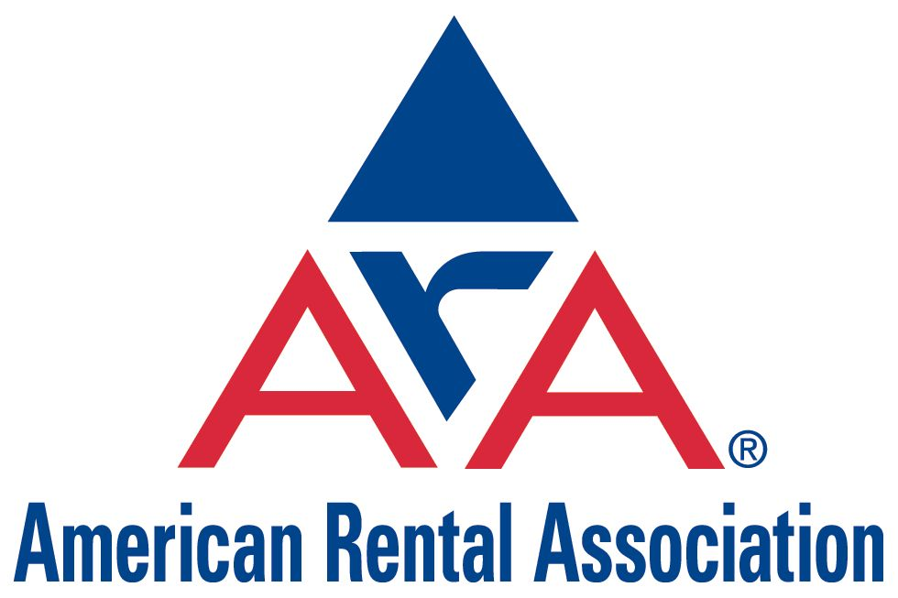
1900 – 19th Street Moline, Illinois 61265 (309) 764-2475 (800) 334-2177 Fax (309) 764-1533
http://www.ararental.org

American Rental Association
Comment on Finalization of Amendments to
Portable Equipment Registration Program and Air Toxic Control Measure

Air Resources Board

March 22, 2007

By

John W. McClelland Ph.D.
ARA Vice President Government Affairs

Michael S. Graboski Ph.D.

1101 Vermont Ave. N.W., Suite 400
Washington, D.C. 20005

- Compliance Flexibility When Most Current Tier Engines Are Not Available: The final rule allows for non-current Tier engines to be sold in California if it is verified that there is an insufficient supply of the most current Tier. This is most likely to occur upon introduction of Tier 4 equipment.

There is no coincidental relief in the averaging requirements for fleets. Thus, especially in 2013, fleets that rely on new Tier 4 engines to meet averaging requirements but are forced to buy lower Tier engines will have a problem complying with the ATCM.

The averaging requirements of the ATCM should be modified to consider unavailability of most current Tier equipment.

- In Service Date: ARA has commented to Staff and the Board throughout this process that section 24549(c) is a burden and imposes significant financial hardship on businesses that must pay financing costs on equipment while waiting to receive a registration document.

The Board should instruct staff to modify the PERP regulation and the ATCM to alleviate the hardship.

The PERP regulation states that:

“After obtaining registration in accordance with this article, an owner or operator of the registered engines or equipment units:
(2) may operate within the boundaries of the State of California so long as such registered engines or equipment units comply with all applicable requirements of this article and any other applicable federal or State law.

PERP allows staff 90 days to issue a registration after receipt of an application. ARB staff has indicated to ARA that their current screening process of incoming applications allows them to determine if an application has a high probability of being meritorious nearly immediately.

Assuming that purchased engines meet the most current Tier provision and the various allowances provided, there is no environmental harm in allowing engines to be put in service immediately upon delivery and submittal of a meritorious registration application.

- Record Keeping and Notification: Section 2458 (b) states

“The owner shall provide each person who rents a registered engine or equipment unit with a written copy of applicable requirements of this article, including recordkeeping and notification requirements, as a part of the agreement.”

March 22, 2007

When asked about what constitutes a “written copy of applicable requirements”, ARB staff has responded that it is their belief that attaching a copy of the registration satisfies this requirement.

ARB should instruct staff to codify applicable requirements so rental companies fully understand how to comply with this section of the regulation.

- Collection of back Fees: The ISOR provides these conflicting statements regarding back fees.

- The primary purpose of the proposed amendments to the Statewide PERP Regulation is to more readily bring diesel engines into a regulatory structure so that they may meet current and future emission requirements.
- The biggest benefit for air quality is expected to come from the thousands of engines operating without permits or registrations that will be brought into compliance and eventually replaced with cleaner engines in the future.
- There are over 24,500 engines registered, which represent nearly half of the estimated statewide inventory of portable engines.
- If engines were let into PERP without the collection of back fees, it may be deemed unfair to those who had been in compliance since the startup of their portable equipment.
- The alternative to paying these back fees is to replace the engine with a new engine that meets the current emission standards.

We have objected and continue to object to back fees. ARB has done no analysis to show that adding fees will actually improve air quality.

As stated, the purpose of PERP and the ATCM is to turn engines over. According to ARB staff, less than half of the engines in the portable fleet have been registered. Business representatives have indicated that the State has undercounted off-road engines by a significant amount. In order to improve air quality, the State has indicated that the biggest benefit will come from registering engines into the program. Back fees are considered to be a fairness issue. However, imposing such fees may reduce the number of engines registered as violators may decide to continue business as usual with their older engines instead of paying thousands of additional dollars to enter the program. They certainly will not voluntarily buy new cleaner equipment. Fees do not improve air quality or improve the competitiveness of the construction business and may actually harm complying businesses more.

March 22, 2007

