Comment on Modified Regulation Order for the PERP Regulation
American Rental Association
November 24, 2010
The American Rental Association generally supports the proposed modifications to the PERP regulation.
We specifically would request clarification in the regulation in several sections.
- 2458(b)(1)(A): This section seems to require that each person be physically given their own written copy of the registration as a part of the rental contract at the time they rent the unit. Would it not be acceptable to merely inform the customer that the registration is provided and attached to the unit that they are renting?
- 2458(b)(3): We do not understand how this item is related to Rental Company recordkeeping requirements. The Rental Company has no control over whether the customer keeps a copy of the contract with the equipment. Furthermore, there is no requirement to inform the customer of this requirement.
- 2458(b)(4): Many long term rental transactions are monthly contracts that are renewed or rewritten. We assume that this and the notification requirement 2459(h) would apply, for example, upon an 8th renewal?
- 2458(b)(4): If the customer ultimately keeps the portable equipment for one year at one location, we understand that it becomes reclassified as stationary equipment. Assuming the Rental Company informs the District in compliance with the regulation, does the 9 month requirement protect the Rental Company from any enforcement action related to the reclassification? If the Rental Company is not held harmless, what is the purpose of this reporting requirement?
- 2458(b)(5): This is a requirement of the renter. If the renter does not fill out the log, the rental company must be held harmless in any enforcement action related to the reporting requirement.
- 2458(e)(3): We understand that the objective of this section is to use Rental Companies to be reporter of all activity related to equipment units. Rental Companies can obviously only report what the renter has logged; we cannot be held responsible for its authenticity. As long as our members provide the required reports based upon the log, our members have fulfilled their obligation under this requirement. If the renter is not responsive, the Rental Company can only report that the data are not available in the log.

Very Truly Yours,
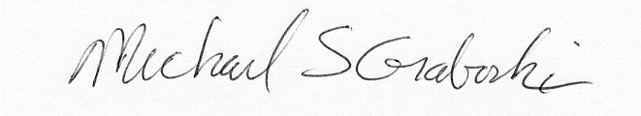
Dr. Michael S Graboski

