 | 1400 K Street, Suite 400 • Sacramento, California 95814  Phone: 916.658.8200 Fax: 916.658.8240  www.cacities.org

September 20, 2011

Mary Nichols
Chair, California Air Resources Board
Sacramento, CA 95814

RE: Board Meeting Item 11-7-3: Update on San Diego’s Sustainable Communities Strategy (SCS), and Update on SCS Development in other Regions in California.

Dear Chair Nichols:

We wanted to take this opportunity to comment in writing on the agenda item 11-7-3 for the Sept 22 Board Meeting relating to the SANDAG sustainable communities strategy. As you know, the implementation of SB 375 is a significant issue for the League. It is therefore unfortunate that we could not be at the hearing in person (due to the fact that it conflicts with our Annual Conference in San Francisco) to express our views and respond directly to issues that may be raised during the hearing.

In lieu of our presence at the hearing, we would make the following points here.

Appreciate CARB Staff Role. One of the issues that was critical to the League’s support of SB 375 was how the bill defines the CARB’s role in reviewing an SCS or APS. We continue to support limiting the Board’s review “to acceptance or rejection of the metropolitan planning organization’s determination that the strategy submitted would, if implemented, achieve the greenhouse gas emission reduction targets established by the state board” (Government Code 65080(b)(2)(J)(ii). SB 375 left the means of achieving the target to each region.

We would also like to comment on the concern that the trend in per capita GHG emissions in the SANDAG SCS is “unexpected.” This is useful information for future planning. The Board and SANDAG will have the opportunity to review this trend many times between now and 2050 information and to adjust public policy as appropriate. In the meantime, we celebrate that SANDAG’s short term goal has been doubled.

How We Plan is Changing. As you know, local governments throughout the state have been leaders in their adoption of local and regional climate action plans. In addition, better land use planning, transit zones, more walkable communities and complete streets are being incorporated into local planning policies. These issues will also be rolled up into future regional forecasts and transportation models.

Walking a Balance. Finally, local planning must always balance important long-tern goals with equally important short-term goals. While we strongly support achieving long term climate goals, we also have to assure the people we serve that we can meet short term food, shelter and work needs. We need the flexibility to balance all these interests in a way that works for our communities and the environment.

Thank you for the opportunity to comment on this item. If you have any questions or would like to discuss these comments further, please do not hesitate to contact me at kross@cacities.org or 916-658-8252.

Sincerely,

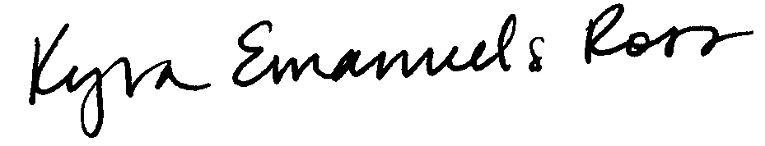

Kyra Emanuels Ross
Legislative Representative
League of CA Cities

