San Diego Chapter
8304 Clairemont Mesa Blvd., Ste 101
San Diego, CA 92111
http://www.sandiego.sierraclub.org
858-569-6005

September 29, 2010

Mary D. Nichols, Chairman
California Air and Resources Board
1001 I Street
P.O. Box 2815
Sacramento, CA 95812
RE: Adoption of Greenhouse Gas Emission Reduction Targets per Senate Bill 375

Dear Chairman Nichols,

The San Diego Chapter of the Sierra Club strongly recommends that the California Air Resources Board (CARB) sets aggressive emission standards for the Metropolitan Planning Organization’s (MPO) implementation of Senate Bill (SB) 375. A dire need exists to reduce the CO₂ levels in California and San Diego specifically. SB 375 has the unique ability to dramatically reduce the current greenhouse gas emission levels and ensure a sustainable climate future if implemented to the fullest potential possible.

The implementation of SB 375 will provide environmental, economic and social benefits. The landmark legislation SB 375 will improve local economies, reduce infrastructure costs and create jobs while reducing air and global warming pollution.

The September 29, 2009 Regional Target’s Advisory Committee (RTAC) report identified numerous environmental benefits from setting aggressive emission standards in the implementation of SB 375. Reduced air and water pollution results from fewer cars on the road and thus having fewer emissions of pollutants.

Other beneficial impacts include increased mobility. Fewer cars on the road plus more transportation choices could lead to a reduced commute time and increased productivity.. Economic impacts include saving money due to less driving, taxpayer savings due to the lower cost of maintaining roads and increased neighborhood development due to increased density.

Positive benefits within the community and environment are possible if CARB sets the strictest standards that can feasibly be accomplished. Setting aggressive and strict emission targets for 2020 and 2035 will result in an increase in the quality of life of California’s citizens and cleaner air. The opportunity exists to prevent climate disaster with the implementation of these standards. It is up to CARB to exemplify strong leadership and ensure that the law reaches its full potential. Now is the opportunity to fully embrace the core principles and intent of this landmark law and make positive changes for our communities. Sierra Club would also like to thank CARB for its dedicated hard work thus far and remind them to set the bar high.

Respectfully Submitted,
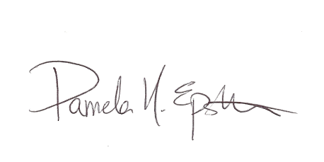
Pamela N. Epstein, Esq., LL.M
Attorney & Legal Director, Law & Policy Clinic
Sierra Club, San Diego Chapter
pepstein@sierraclubsandiego.org
8304 Clairemont Mesa Blvd., Ste 101
San Diego, CA 9211

~~~~~~~~~~~~~~~~~~~~~~~~~~~~~~~~~~~~~~~~~~~~~~~~~~~~~~~~~~~~~~~~~~~~~~~~~~~~
The San Diego Chapter of the Sierra Club is San Diego’s oldest and largest grassroots environmental organization, founded in 1948. Encompassing San Diego and Imperial Counties, the San Diego Chapter seeks to preserve the special nature of the San Diego and Imperial Valley area through education, activism, and advocacy. The Chapter has over 14,000 members. The National Sierra Club has over 700,000 members in 65 Chapters in all 50 states, and Puerto Rico.

CEQA Functional Equivalent Document, SCH# 2010081021, August 9, 2010, p. 11
Ibid.

