

August 12, 2009
Chairman Mike McKeever and Members
Regional Targets Advisory Committee
California Air Resources Board
1001 I Street
P.O. Box 2815
Sacramento, CA 95812
Dear Chairman McKeever and Regional Targets Advisory Committee Members,
The members of the California Transit Association thank you for the opportunity to provide comments to your committee. Our Association appreciates your ongoing work in recommending factors and methodologies for the California Air Resources Board to consider in setting the regional greenhouse gas (GHG) targets over the next year.
Our membership consists of small and large, urban and rural transit agencies, some of which are special districts and/or joint powers authorities, and some that are multimodal agencies which manage additional transportation modes to bus services. Our Executive Committee recently voted unanimously to support a statewide target similar to the reductions estimated in the Climate Change Scoping Plan. While we are supportive of the state’s efforts, our preeminent concern remains that all of our agencies face a lack of state funding for our core transit services.
The Governor and the legislature have eliminated critical state funding for transit operations for the next 5 years. This devastating decision compounds a steady decline in state transit support over the last decade. Over $5 billion in state transit funds have been diverted for other purposes since 2000.
The California Transit Association represents over 80 of the state's public transit operators, as well as nearly 90 private sector suppliers to the transit industry. Statewide, transit agencies are experiencing serious budget constraints and are laying off employees, cutting services, and raising fares. Many agencies have declared a fiscal emergency, and in addition, the recently signed 2009-10 budget shifted city and county funds to fill the state general fund, leaving transit agencies funded by local cities and counties in an even more dire situation.
California’s 18 regions will not be able to reach their targets without incorporating efficient and affordable transit services. In turn, transit cannot fulfill its role in helping the regions reduce their GHG emissions without the appropriate funding.
Whatever methodology framework your committee decides on, it must be informed by the fact that the state has walked away from its transit funding commitment. The “here and now” of the situation is that while transit seeks to contribute its part to reducing GHG emissions, we cannot grow, and in many cases maintain, core services to the public without more resources. While some of our members see that the Sustainable Communities Strategy (SCS) and Alternative Planning Strategy (APS) processes could very well result in useful statements to invest more in public transit, despite the theoretical good outcome of this, the practical challenge of a lack of resources lies in front of us. If the state is to achieve its emissions reductions goals and incent behavior changes to reduce emissions from passenger vehicles, the state must find a way to fulfill its responsibility to provide funding for transit.
In addition to encouraging your committee to recommend factors and methodologies which will garner appropriate state funding for transit, we offer the following points to consider as you develop your recommendations:
Performance Indicators - We appreciate the incorporation of transit in your consideration of performance indicators. An efficient transit system is a proven method of reducing greenhouse gas emissions, and will be a key tool for regions to meet their respective greenhouse gas emission reduction targets. We look forward to working with your committee and ARB staff to develop the best possible framework in this area, taking into consideration the increased demand transit will face in the future as a result of SB 375, and the continued funding constraints that currently exist. Some of our transit members will likely submit more specific recommendations on transit performance indicators for your consideration.
Transit and energy use – Transit’s per capita energy use decreases as the number of people riding a bus increases. This is one way in which transit provides a co-benefit to regions through its services – encouraging more people to ride transit can help to reduce per capita energy use and result in fewer GHG emissions.
Incentives – In order for regions to be innovative in their strategies to reduce emissions, and, as we would hope, to expand the resources dedicated to transit, we recommend that the committee provide ideas for incentivizing regions to meet and exceed their targets.
We thank you for your ongoing work in this process, and stand ready to be an information source to aid you in your task. We support the goal of setting ambitious achievable targets for California’s regions, and look forward to working with you and CARB staff to continue to seek ways in which we can secure future resources for transit to enable us to make achieving the state’s GHG emissions reductions goals a reality.
Thank you for your consideration.
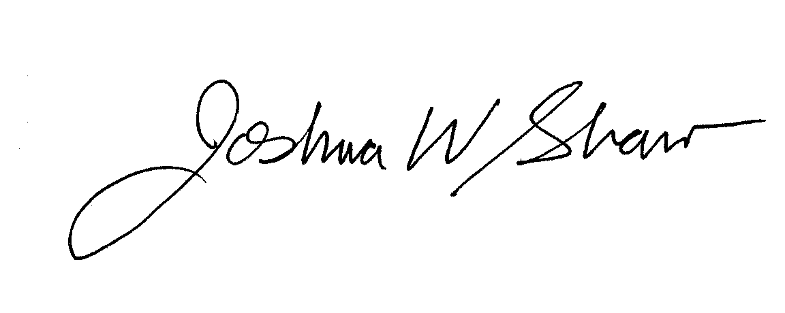
Sincerely,

Joshua W. Shaw
Executive Director

