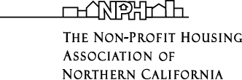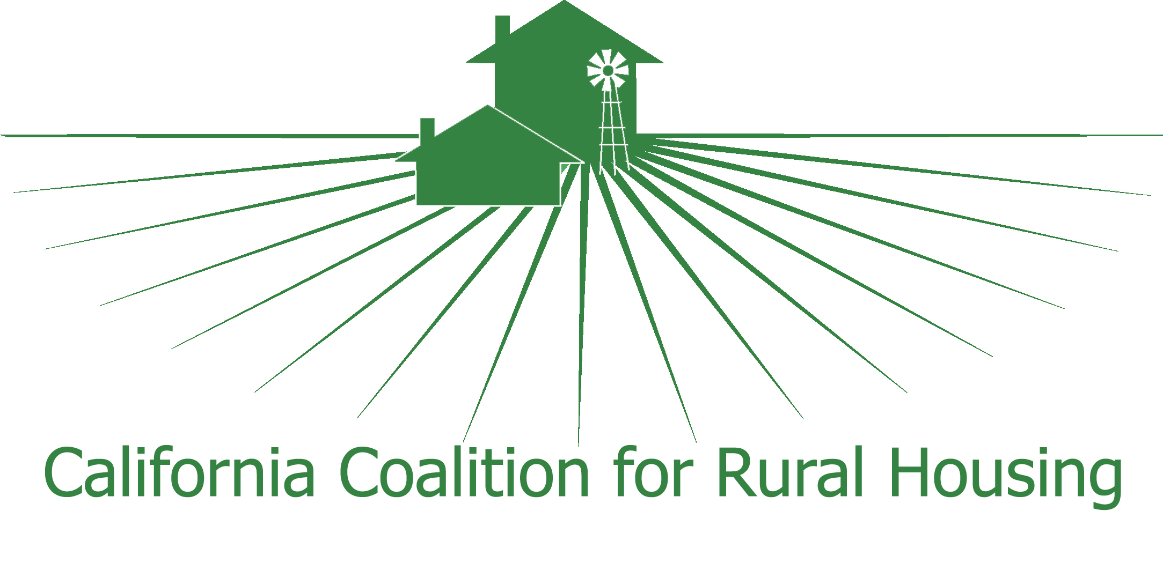

August 10, 2009

Chairman Mike McKeever and members
Regional Targets Advisory Committee
California Air Resources Board
1001 I Street
P.O. Box 2815
Sacramento, CA 95812

Dear Chairman McKeever and members of the RTAC:

We are writing to you as representatives of six statewide and regional coalitions whose members build homes affordable to lower income Californians (apartments and single-family houses). The state’s greenhouse gas reduction targets could significantly impact the development community’s ability to offer affordable rents and mortgages to all Californians. We urge you to adopt recommendations that achieve significant reductions in greenhouse gas emissions and promote the development of affordable, compact homes.

Multiple GHG reduction benefits will accrue if a variety of housing types and affordability levels are part of the development pattern in every Sustainable Communities Strategy. Among them:
- Optimizing the GHG reductions achieved by an improved jobs-housing balance. New developments whose affordability matches the incomes of jobs in the community will give more Californians the option to eliminate their lengthy commutes. Furthermore, avoiding gentrification of lower income neighborhoods will allow those employees to remain near their jobs.
- Increasing the GHG reductions achieved by new transit-oriented developments. A recent study found lower-income households who move into transit-oriented developments shed their cars significantly faster than higher-income households. The VMT-reductions attributable to new TODs, therefore, will correlate with their affordability levels.

To accomplish our mutual social equity and environmental goals, we strongly support Mike Rawson’s July 31, 2009, proposal. Mr. Rawson suggested the RTAC’s recommendations to the ARB should incorporate the following factors and methodologies:

- Quantification of the effect of housing affordability on GHG emissions (including affordability in relation to wage levels);

- Projections, by region, of the relative increase or decrease in homes affordable to households at various income levels (particularly the availability of below-market-rate homes) and attendant effect on GHG emissions over the target period;

- Crediting regions that exceed the housing affordability projections with quantified GHG reductions; and

- Analysis of the potential and actual displacement from compacted development, quantification of the effect of displacement on GHG emissions, and GHG reduction credit to regions that prevent or mitigate displacement.

Additionally, Metropolitan Planning Organizations need a modeling tool to measure the impacts of potential SCS development patterns on their region’s land prices and home affordability. Housing California is working with an MPO to determine how PECAS could be adapted to provide this information to policymakers. With the information, MPOs can more accurately access whether their forecasted development patterns are realistic and will achieve their region’s GHG reduction target.

The benefits of SB 375 – cleaner air, healthier families, more vibrant communities – should be available to Californians at all income levels. We urge you to adopt our recommendations to achieve this social equity – and, in the process, hopefully reduce GHG emissions even further.

Sincerely,

Julie M. Snyder, Policy Director
Housing California

Dianne J. Spaulding, Executive Director
Non-Profit Housing Assoc. of Northern California

Dewey Bandy, Deputy Director
California Coalition for Rural Housing

Shamus Roller, Executive Director
Sacramento Housing Alliance

Paul Zimmerman, Executive Director
Southern California Association of NonProfit Housing

Tom Scott, Executive Director
San Diego Housing Federation

