tel [415] 777-0487
fax [415] 777-0244
nature.org
nature.org/california

California Regional Office
201 Mission Street, Fourth Floor
San Francisco, CA 94105
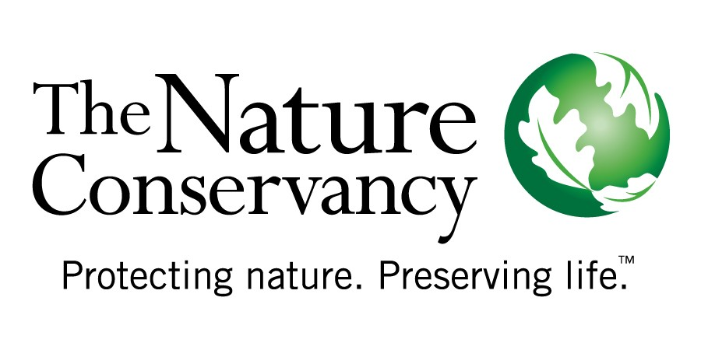
25 August, 2009

Dear Chair McKeever and members of the Regional Targets Advisory Committee,

On behalf of our 130,000 members in California, The Nature Conservancy (TNC) commends the Regional Targets Advisory Committee (RTAC) members for its commitment to develop a clear, credible approach to identify factors and methodologies that will enable the CA Air Resources Board (CARB) to set regional GHG emissions reduction targets required by Senate Bill 375, the Sustainable Communities and Climate Protection Act, 2008. We appreciate the opportunity to provide input to this important process and request that your report to CARB include criteria that lead to strong GHG targets, as well as the recommendation to consider impacts to natural systems as a factor in the establishment of these targets. Strong GHG targets that incorporate considerations of our natural systems will help the state meet the GHG reductions goals of the Global Warming Solutions Act (GWSA) by reducing emissions in the transportation sector. It also provides the opportunity to integrate at a regional scale additional biological GHG benefits associated with land conservation and provide continued protection to the suite of environmental and public benefits that our natural systems provide, including water and air quality, recreation and fish and wildlife habitat.

Strong regional targets are critical to attain GHG reductions from California’s largest source of emissions and foster the climate benefits of our natural landscapes. Vehicle emissions comprise approximately 40% of California’s GHG footprint. California cannot meet the GHG emissions reductions targets identified by the GWSA without significant emissions reductions from this sector. Therefore, TNC urges RTAC to recommend a framework that enables CARB to establish ambitious regional emissions reductions targets. Ambitious targets will provide regions with the incentives necessary to develop and implement the innovative strategies required to reduce emissions and counter the impacts of climate change on our economy, environment and quality of life. The RTAC may wish to consider a structure of tiered targets that establish minimum targets with additional incentives for regions that exceed the minimum target and achieve more ambitious reduction goals.

Ambitious targets will not only reduce transportation related GHG emissions, but will also foster the protection of the critical climate, environmental and public health co-benefits that are provided by our natural landscapes. The effect of strong targets will reduce or avoid development pressure on our remaining natural landscapes in the MPO regions. As a consequence, the reduction or avoidance of this development pressure will reduce biological GHG emissions that are associated with the conversion and disturbance of forests and other natural lands to alternative land uses and help maintain their vital climate regulation function, which is an objective identified in the GWSA Scoping Plan. In addition to climate benefits, the relief or avoidance of development pressure of strong targets will also foster the protection of the many other essential environmental and public benefits that our remaining natural landscapes and systems provide, including water and air quality benefits, recreation, and fish and wildlife habitat. Thus, to optimize GHG emissions reductions and benefits across regions and sectors, TNC requests that RTAC provide recommendations in its report that facilitate strong regional GHG targets and include as a factor for CARB’s target setting process, an assessment of the indirect biological GHG and environmental co-benefits associated with such targets. In the future, the state may wish to provide additional incentives to regions that integrate the protection of biological GHG benefits with regional land use and transportation plans.

Lastly, it is important for the committee to promote the use of the Sustainable Community Strategy (SCS) over the Alternative Planning Strategy (APS) as the best tool for regions to implement and monitor policies and actions to meet their emissions reductions targets. TNC requests that the RTAC report to CARB includes a high level recommendation promoting the development of a SCS over an APS by the large majority of the regions. We also ask that RTAC recommend the inclusion of spatial analyses in each SCS to help monitor progress towards stated goals, provide more accurate forecasting methods and give a clear assessment of the trade offs and impacts of different planning decisions on the ground.

Once again, TNC commends the RTAC for its important work which is central to helping the state meet its GHG emissions reductions goals and protecting California’s environment, economy and quality of life. TNC would be happy to provide additional input to the RTAC in support of its recommendations.

Contacts:

Julia Gardiner, JGardiner@tnc.org
Michelle Passero, MPassero@tnc.org

