

September 8, 2009
Chairman Mike McKeever and Members
Regional Targets Advisory Committee
California Air Resources Board
1001 I Street
P.O. Box 2815
Sacramento, CA 95812
Dear Chairman McKeever and Regional Targets Advisory Committee Members,
Thank you for the opportunity to provide comments on your Working Draft RTAC report. Our Association appreciates the report’s reflection of the severe funding challenges that currently face transit, and encourages you to continue to seek strong support for transit funding in your final draft of the report.
We are appreciative that the report draws notice to the need for state transit funding under the “State Actions to Support Implementation Section.” We recommend that this section be strengthened further to support stable and long term state funding for transit. The latest state budget eliminated funding for transit, and as a result, transit agencies are struggling to maintain core services, and have been forced to raise fares, layoff workers, and cut needed service routes. The members of our Association agree that it is the state’s responsibility to find a way to provide assistance to transit agencies statewide, especially in light of the state’s goals to reduce greenhouse gas emissions as part of the Global Warming Solutions Act of 2006. Transit will play a key role in helping regions to reduce emissions from passenger vehicles by providing an alternative travel option to communities. In order for regions to decrease their emissions contribution, transit's contribution must increase in order to support these modal offsets. Therefore, a reliable source of funding for transit to meet this increased demand in services will be essential. The state must support a balanced transportation network that enables efficient and affordable access to transit.
We recommend that the report address conflicting state policy regarding transit funding in the “Conflicting State Mandates and Policies” section. The state seeks to reduce greenhouse gas emissions while defunding transit, a primary way for these emissions reductions to be achieved. This conflict must be resolved if the state hopes to meet its emissions reductions goals.
Lastly and importantly, we urge your committee to include the need for stable transit funding in your “RTAC Guiding Principles.” This will send a strong message to the state about the pressing need for transit funding to help achieve the goals of AB 32 and SB 375.
We thank you again for your ongoing work. We look forward to continuing to work with you and CARB in this process. Thank you for your consideration.
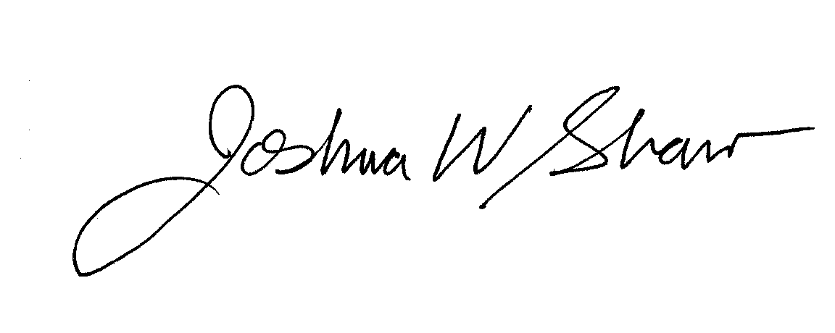
Sincerely,

Joshua W. Shaw
Executive Director

