San Gabriel Valley

Legislative Coalition of Chambers

Representing the businesses of:

Alhambra

Arcadia

Azusa

Duarte

El Monte/
So. El Monte

Irwindale

La Canada Flintridge

La Verne

Monrovia

Regional Chamber
of the San Gabriel Valley
Diamond Bar
Hacienda Heights
La Puente
Rowland Heights
Walnut
Valinda

Rosemead

San Dimas

Sierra Madre

Temple City

West Covina

December 9, 2008

Ms. Mary Nichols, Chair
California Air Resources Board
P.O. Box 2815
Sacramento, CA 95812-2815

Dear Chairperson Nichols:

COMMENTS REGARDING THE CLIMATE CHANGE DRAFT SCOPING PLAN:

The San Gabriel Valley Legislative Coalition of Chambers of Commerce has reviewed the current plan from the perspective of the positive and negative impacts on the business communities in the San Gabriel Valley. Generally we favor any action that considers and evaluates all options as to their economic viability and their environmental footprint on the localities in the State.

This Coalition has sixteen member chambers of commerce from the San Gabriel Valley and Pomona Walnut Valleys that represent the business communities in 21 cities and some county areas. We work with the California Chamber of Commerce and others to assess legislation or regulations that may affect businesses in our area. We make recommendations to the individual Chambers of Commerce on this legislation and any regulations. It is in that role that we review the Draft Scoping Plan.

There may be proposed measures that are voluntary today that become mandates tomorrow. Many of the measures will require incentives, particularly economic. This may necessitate additional charges to businesses for residential programs or charges to residential customers for a system-wide program or a business program. Any financing needs to have a valid nexus to whoever is paying the bill and those being benefitted.

Based on the above we offer the following comments:

- MILLION SOLAR ROOFS PROGRAM: This is a ratepayer funded program that needs to benefit the participating residences or businesses over time. Certainly a grant should be provided to assist the installation. This needs to be followed by a kilowatt rate paid to the participants by the utility that provides an incentive for them to stay with the program. Utility company history has been to start with a high rate and reduce it over time. They also have lowered the starting rate to a level that has discouraged entering a program. This should not be the case here if we really want to diversify our power generation and improve the air quality. Participants should be allowed to recover their investment as soon as possible.

- RECYCLING AND WASTE (LANDFILL METHANE CAPTURE): This is an effort to reduce emissions by increase waste diversion, composting, and commercial recycling and moving toward zero-waste. If you are to achieve the desired ends you need to consider all of the available options, complete a life-cycle analysis and a detailed cost-benefit economic analysis. We also need to avoid unintended consequences. It appears that this proposal relies heavily on mandates with not serious consideration of the consequences.

  - The increase in the “recycling’” rate is, for the most part, only diversion and shipping of collected materials out of state and the country. We need to develop markets here if we are truly going to be “recycling.” Local markets can create jobs and be more cost-effective.

  - Increasing composting volumes actually increase the generation of green house gases and increase the volume of a composting product that has no market for use.

  - Conversion technology may be the solution to this dilemma, but there is no consideration in the Scoping Plan. This technology can use the green wastes diverted from landfills and the organic fraction of the wastes leaving material recovery facilities to create fuels or power with full compliance with air and water quality regulations. This technology is used in Europe and Japan with great success in compliance with strict environmental regulations. Los Angeles Cities and County are taking the steps to demonstrate this technology can work here. This is being done without any State assistance or apparent interest.

In the next 5 years we will be moving into the era of hauling our wastes by rail to remote sites in the desert. It seems to us that is makes sense to reduce the waste volumes as near the source of generation as possible using every means possible that make sense economically, environmentally and as evaluated in a life-cycle analysis. At the same time we can create jobs in the resulting business enterprises.

Bottom line the Scoping Plan needs to:

- Provide long term financial incentives to participants in the solar roof proposal that benefit them.

- Create local markets for the use of diverted green wastes that can create jobs and be more cost-effective.

- Use conversion technology that can use the green wastes diverted from landfills and the organic fraction of the wastes leaving material recovery facilities to create fuels or power with full compliance with air and water quality regulations and increase available jobs in the bargain.

- Give full and complete diversion credit as an incentive to counties and cities to use conversion technology to divert increasing amounts of wastes from landfills as a means to move toward zero-waste.

- Complete a full life-cycle and economic analysis on all options to addressing organic wastes and increasing the diversion of waste from landfills, including composting, conversion technology and recycling.

If there are any questions please call me at (626) 337-1606. Please contact us if we may be of further service.

Sincerely,
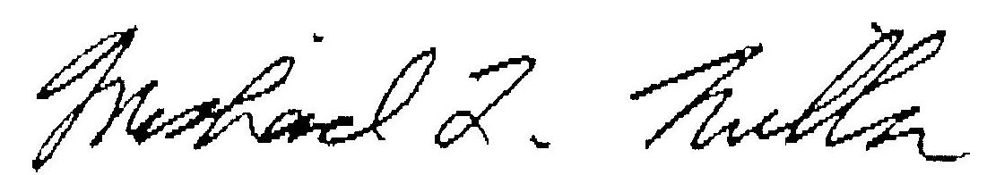
Michael L. Miller
Chairman

