

December 10, 2008

Ms. Mary Nichols
Chair, California Air Resources Board
1001 I Street
P.O. Box 2815
Sacramento, CA 95812

Dear Chair Nichols:

The San Diego Regional Chamber of Commerce and the San Diego Regional Economic Development Corporation believe that San Diego is a community built around quality of life and understand the need for balanced attention to the economy and the environment. For this reason, we have partnered with a diverse group of San Diego industry leaders to participate in the development of the AB 32 compliance program, and to identify business opportunities associated with the global emergence of business practices that reduce greenhouse gas emissions

Our industry coalition believes that, as the Air Resources Board (ARB) is moving forward with AB 32 consideration and regulation, it needs to focus on a fair balance between the need to be socially responsible with regard to Greenhouse Gas Emission (GGE) reductions and how California can achieve the targets for reducing emissions with the lowest negative impact on the economy and loss of jobs. Therefore, a menu of options is desirable which should include viable market-based programs.

The coalition recognizes that many interested parties will be commenting in great detail on the specifics of the Scoping plan. In contrast, the coalition has developed a set of overarching principles around which it will structure more specific comments as it reviews the process and proposed outcomes as we move forward. Those overarching principles are as follows:

- The ARB must consider jurisdictional issues. At what level of government (state vs. regional vs. local) are the objectives best implemented?
- Allowing local jurisdictions to implement varying levels of regulation can create cross-border disputes, and can prove extraordinarily burdensome on businesses operating close to jurisdictional boundaries or businesses located in multiple jurisdictions.
- In addition, significantly higher costs of operating associated with AB 32 regulation will make California businesses less competitive when compared with their out-of-state competitors. The issue of how interstate commerce will be affected needs to be addressed.
Ms. Mary Nichols
Chair, California Air Resources Board
December 10, 2008
Page 2

- The ARB should allow greater room for market-based responses as opposed to regulation.
- Currently the Scoping Plan calls for 80 percent targeted and prescriptive regulatory control and a 20 percent market-based approach. Initially, this percentage should be adjusted to allow for greater opportunity for market-based responses. If those fail, the ARB and other government agencies can always impose stricter regulation later. The cap-and-trade approach, for instance, should be given an opportunity to drive innovation and achieve results before the level of regulatory controls, as specified in the draft Scoping Plan, are imposed. This approach allows businesses to minimize their compliance burdens, where possible, while helping the government achieve its legislated objectives.

- The ARB should implement a fair allocation of compliance proceeds to the areas of the State where the fees and penalties are collected.
- Any fees that are collected should return to the local jurisdiction from where penalties were assessed so that the jurisdictions can ensure that improvements are made. Clearly, if those jurisdictions are penalized for noncompliance, compliance efforts they will be less able to achieve the results the State wants.

- On a going-forward basis, all economic assumptions set forth in the Scoping Plan should be reevaluated at least annually based on actual evidence and experience presented as opposed to theoretical modeling.
- The Scoping Plan’s proposed reductions need to be adequately justified. Targets need to be based upon reasonably achievable technology, and there should be an opportunity to adjust the assumptions and findings during the process if better alternatives appear. Further, it is important that sound scientific and economic principles be applied.

- The ARB must be ever cognizant of actual (versus theoretical) feasibility and the cost effectiveness of all proposals presented.
- The economic analysis set forth in the current Scoping Plan is not adequate to support the conclusions that have been drawn. It is important to analyze the true costs of the Scoping Plan. If California business concerns are not given the full consideration they deserve, the detrimental economic impacts could be significant.

Thank you for providing us an opportunity to comment on the Scoping Plan. We look forward to working with you on this important issue.

Sincerely,

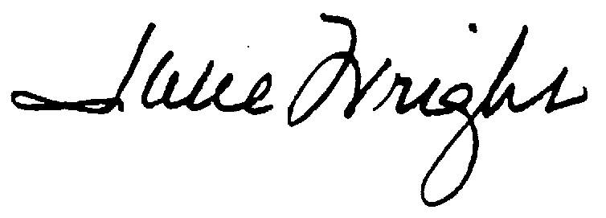


Phil Blair Julie Meier Wright
Chairman President & CEO
San Diego Regional Chamber of Commerce San Diego Regional
Economic Development Corporation
PB:av

